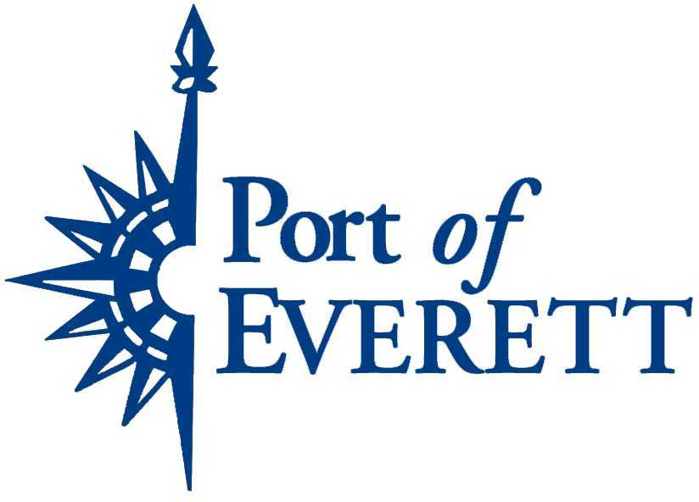
Lease Policy

A. Policy Statement
Exhibit “A” to Resolution 1094 (2018), commonly known as the “Delegation Resolution,” Section C requires the Executive Director to establish a lease policy addressing accepted lease practices and guidelines of the Port. The purpose of this policy is to (1) Ensure compliance with the Delegation Resolution; (2) Increase operational efficiencies; and, (3) Reduce transactional risk by standardizing certain provisions in Port leases. It is not the intent of this Policy to prohibit deviations from standardized terms in all cases, nor require certain terms under all circumstances.

B. Application and Construction
This Policy shall apply to all leases of lands, wharves, docks, real and personal property of the Port district property, hereafter known as “Port Property.” Unless otherwise stated, this policy applies to both leases for a term of one (1) year or more and to Short Term Arrangements. The terms of this Policy shall be construed consistently with the Delegation Resolution, the policy concerning Special Use Permits, and other actions of the Board of Commissioners, as currently stated and as may be amended. To the extent the Delegation Resolution or Special Use Permit policy conflicts with the terms of this policy, the former shall control.

C. Anti-discrimination, Americans with Disabilities Act and Political Affiliation
It shall be the policy of the Port of Everett that it does not discriminate in its leasing on the basis of race, color, sex, marital status, sexual orientation, political ideology, age, creed, religion, ancestry, national origin, or presence of any sensory, mental or physical handicap. The Port endeavors to comply with the Americans with Disabilities Act (ADA), which is more specifically covered by separate policy. Nor shall any consideration be given to the political affiliation, support of a candidate, or ballot measure when leasing decisions are made.

D. Essential Provisions of Lease
Every lease of Port property shall contain certain essential provisions. The essential terms are:

- Term of Lease
- Rent or other consideration
- Termination
- Rental Adjustments (Not requiring further Commission action)
- Assignability
- Use of Premises
- Savings Clause
- Joint Several Liability (for two Lessees or more of same property on same lease)
- Lease Security pursuant to RCW 53.08.085
- Leasehold Taxation Provision
- Compliance with Federal, State and Local law required
- Use of Hazardous Waste & Substances
- Environmental Clean-Up: Duty of Leasing Party
- Indemnification of Port by Lessee
- Insurance Provision
- Utilities & Taxes: Imposing duties for payment
- Liability to Third Parties
- Default & Remedies
- Signature Warranty
- Survival of Terms following expiration

E. Board of Commission Approval Required
The Board of Commissioners shall approve, and authorize the Executive Director to execute, all leases of Port Property, the term of which consists of one (1) year or more and the terms of which call for the indemnification by the Port.

F. No Board of Commission Required for Approval for Short Term Arrangements
“Short Term Arrangements” shall mean those leases in which the Port makes no promise to indemnify, makes no financial obligation for improvements that are not already within the Commission approved budget, and are for a term less than one (1) year, such as but not limited to Temporary Use Agreement, Easements, Licenses, and permits ancillary to the operation of the Port.

Short Term Arrangements shall (1) be in a proper written instrument reviewed by Port counsel; (2) provide for the indemnification of the Port in connection with the contemplated use of Port Property; and, (3) shall not require rental security nor authorization by the Commission prior to the execution or extension of an existing lease by the Executive Director. PROVIDED, however, that such extension shall not lease Port Property continuously for more than a twelve (12) month period.

Other examples of Short Term Arrangements include, but are not limited to:

- Temporary easements with a term of than twelve (12) months or less in duration for purposes of utility installation and maintenance, access, rights of entry and signage.
- Leases with the Army Corps of Engineers for the purposes of dredge spoils storage, where no indemnification by the Port is required.
- Changes in name of counter-parties to the lease if all other conditions, including primary ownership, remain the same.
- Lease assignments when assignments of rights and delegation of duties are authorized under the Lease.
- Response to estoppels and attornments.
- Temporary Use Permits or Agreements
- Rental and Storage Agreements.
- Temporary Construction Access Easements.
- Temporary Access Easements for Environmental Testing and / or compliance or other proper due diligence.

- Security Recommendation under RCW 53.08.085
For leases, the term of which is more than a one (1) year or more, the appropriate lease surety must be in place consistent with statutory requirements under RCW 53.08.085 and the Port’s standard form of lease, with the exception of a lessee that is the State, Federal or tribe which may require the use of the tenant’s lease form as long as the content of the lease form does not materially change the Port’s intent in its standard lease form. The Executive Director shall provide his or her recommendation of appropriate rent security when seeking authorization of a lease arrangement to the Board of Commissioners. Such recommendation shall be based on risk posed to the Port in securing the rental security. Factors which shall be considered in making such a recommendation are: (1) The level of rent security in the rental market for like-kind property. (2) Credit-worthiness of the Lessee. (3) The term of the lease. (4) Whether there is a long-standing relationship with Lessee under other lease agreements with the port without default by the Lessee. (5) The risk that the amount of security deposit presents in light of the anticipated return in Lease payments. (6) Port vacancy rates at the time of the execution of the Lease. (7) The need to increase economic activity by based on the return consideration. (8) And other factors, taking into consideration the economic climate at the time of execution.

- Rental Revenue and Return Consideration Standards
Each lease of Port property shall require return consideration in connection with the leasing of Port Property. Such consideration may vary depending on the circumstances and in the Commission’s sole discretion, but shall be the product of rational standards by which to value Port Property rental revenue or other consideration. The amount of the rental revenue or other consideration should be consistent with that amount dictated by the real estate, or cargo market and shall be based upon certain factors that lead to setting the acceptable consideration and minimum price. The Commission has duly considered those factors in public session and they include such things as, by way of example, quantity of land, location of land, environmental considerations (e.g. impacts and clean up allocation/risk), improvements, property use, economic development, construction timelines/costs/risks, indemnity, risk and insurance allocation, other risks associated with the lessee (e.g. individual, corporate formation, and legal/financial/technical expertise) and those factors listed above in Section D. PROVIDED, however, that other consideration such as, but not limited to, the port’s role in advancing economic development, may be sufficient rationale for reduced rent or no return consideration. In making such a determination, the Executive Director may consider those factors upon which he / she makes his / her recommendation for rental security as outlined in Section G above.

- Assignments, Subleases, Options and Modifications – Procedure
To the extent assignments, subleases, options or modifications are permitted in the basic Agreement, the same may be approved by the Executive Director without prior Commission approval. PROVIDED, however, (1) other substantive terms of the Agreement are unchanged; (2) terms, such as but not limited to options, lessee operations, rental adjustments, etc., are consistent with this Policy; and, (3) any amendment is otherwise within authority of the Executive Director under the Delegation Resolution.

- Term Limitation of Fifty Years plus Options
No lease of Port Property shall be for a period longer than fifty years with option for extensions for up to an additional thirty years, except where the property involved is or is to be devoted to airport purposes the Port Commission may lease said property for such period as may equal the estimated useful life of such work or facilities, but not to exceed seventy-five years: PROVIDED FURTHER, That where the property is held by the Port under lease from the United States government or the state of Washington, or any agency or department thereof, the Port Commission may sublease said property, with option for extensions, up to the total term and extensions thereof permitted by such lease, but in any event not to exceed ninety years.

- Insurance Requirements and Approval
Leases may conform to this section by substantially conforming to the following insurance requirements:

- Proof of Insurance. A Lessee or Permittee, at no expense to the Port, shall obtain and file with the Port of Everett not later than sixty (60) calendar days prior to the event in the case of a Special Use Permit, and not later than the time specified in the basic Agreement for other leases, evidence of insurance policies sufficient to reasonably manage the Port’s risk.

The following documents must be provided as evidence of insurance coverage:
- A Certificate of Insurance, showing the policy effective dates, limits of liability, names and dates of the event.

- A copy of the additional insured endorsement naming the Port of Everett as an Additional Insured, showing the policy number and signed by an authorized representative, on Form CG2010 (ISO) or equivalent.

- Primary Coverage and Port Approval. Such policies shall be (1) Primary to coverage held by the Port. (2) Subject to approval by the Port’s legal counsel or Chief Financial Officer after considering the insurance company, form, coverage, risk posed by the activity to be held on Port Property. (3) Consistent with Lessee’s duty to indemnify, defend and hold the Port harmless against any claim arising out of the use of the leased Port Property.

- Commercial General Liability Insurance. A policy of Commercial General Liability Insurance is generally required, written on an insurance industry standard occurrence form, (CG 00 02) or equivalent, including all the usual coverage known as:
- Premises/Operations Liability
- Products/Completed Operations
- Personal/Advertising Injury
- Contractual Liability
- Owners and Contractors Protective Liability
- Stop Gap or Employers Contingent Liability
- Liquor Liability/Host Liquor Liability (if applicable)
- Watercraft (owned and non-owned) (if applicable)
- Any deductible or self-insured retention must be disclosed and is subject
to approval by the Port’s Risk Manager

- Business Automobile Liability. A policy of Business Automobile Liability on an insurance industry standard form (CA 00 01) or equivalent, including coverage for owned, non-owned, leased or hired vehicles.

- Coverage Amounts. If applicable to the Lessee’s proposed use, the policies must provide the following minimum limit:

- Bodily Injury and Property Damage

$1,000,000 per occurrence/accident
$2,000,000 annual aggregate

- Liquor Liability & Pyrotechnic Only

$1,000,000 per occurrence/accident
$2,000,000 annual aggregate

- Modified Coverage. Coverage and/or limits may be altered or increased as necessary at the discretion of the Executive Director, to reflect type of exposure to risk the activity on the leased premises poses. Insurance policies and subsequent renewals must be maintained in full force and effect, at no expense to the Port, throughout the entire period of the Special Use Permit.

In order to accommodate constitutional rights to assemble peaceably for political and religious purposes, the insurance requirement for gatherings (such as rallies, demonstrations, and outdoor religious services) purely for political or religious expression may be waived by the Port’s Executive Director for good cause in its sole discretion. Liability insurance will be required in connection with a political or religious event when the proposed activity presents a risk of injury.

- Lease Enforcement and Lease Terminations
The Executive Director is authorized to enforce all terms and conditions of Port leases. The Executive Director is authorized to issue all appropriate notices of default and/or notices of termination with regard to Port leases. The Executive Director is authorized to terminate any lease under the terms and conditions therein. Upon termination, the Executive Director is authorized to take all steps necessary to retake possession of the leasehold and recover for the Port all sums due the Port pursuant to the lease and the law. The Executive Director shall keep the Commission informed with respect to lessees that are issued default notices or termination notices.

