America’s Marine Highway Update
Seaports Delivering Prosperity
American Association of Port Authorities - Maritime Economic Development Committee
MEDC/America’s Marine Highway Work Group | November 7, 2014 – Volume 2/2014

This edition of the America’s Marine Highway Update is brought to you by the American Association of Port Authorities Maritime Economic Development Committee (MEDC) and is intended to provide the latest published news and information from around the America’s Marine Highway and Short Sea Shipping industry.
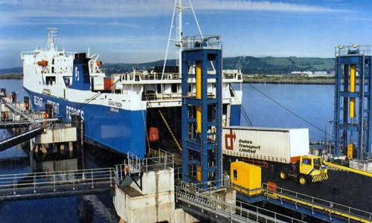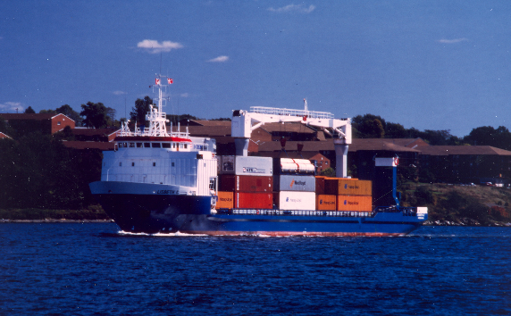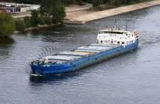

CONTENTS
(Control + Click on top of page number to follow link to each Section)
CONTENTS 1
SECTION 1 – CURRENT AMH CORRIDOR SERVICES 2
SECTION 2 - MARAD: AMERICA’S MARINE HIGHWAY PROGRAM 12
SECTION 3 - FUNDING MATTERS 17
SECTION 4 - LEGISLATIVE UPDATES 21
SECTION 5 - GET CONNECTED: AMH ONLINE LINKS 34
SECTION 6 - AMH ADVOCACY GROUPS AND ASSOCIATIONS 35
SECTION 7 - HISTORICAL REFERENCES AND PROGRAMS DEVELOPMENT 41
SECTION 8 – CURRENT EVENTS 44
SECTION 9 - INTERNATIONAL SHORT SEA SHIPPING NEWS 61
SECTION 10 - PAST EVENTS 77
SECTION 11 - APPENDICES 83
ADDITIONAL INFORMATION 83

AMH Update Issue Highlights:
- New player enters US-Mexico short-sea market, October 19, 2014, Section 8
- Profit motive behind oil refiners ’Jones Act attack: US maritime leader, October 8, 2014, Section 8
- Weekly Stockton-Oakland container barge service to end, August 8, 2014, Section 1
- MARAD - Open Season in June for Marine Highway Projects, June 5, 2014, Section 1
- A major victory for short sea shipping in Norway, October 22, 2014, Section 9
- Commission clarifies EU rules on cabotage and reports on developments in this sector, April 22, 2014, Section 9

SECTION 1 – CURRENT AMH CORRIDOR SERVICES

Current AMH Corridor Services:
- James River Barge Line between Norfolk and Richmond, VA now advertises three sailings per week (M-64 AMH Corridor)
- Tidewater Barge Lines between Ports of Lewiston, ID, Pasco, WA, and Boardman, OR, to Port of Portland, OR. Container on Barge Service, Port of Lewiston, Idaho is looking to expand the existing service along the Colombia River. (M-84 AMH Corridor)
- Green Trade Corridor between Stockton and Oakland, CA began operations on June 9, 2013 (M-580 AMH Corridor). Current stats for the M580 Container on Barge service: Port of Stockton Transitions its M-580 Marine Highway to “as needed service”.
- As part of the M-10 corridor a new service between Ports of Freeport and Houston initiated tests runs on May 21, 2013 (M-10 AMH Corridor)
- Couch lines operates a container-on-barge service carrying up to 2,000 containers per month on newly designated M-146 AMH Corridor, Cedar Bayou and the Houston Ship Channel, TX, connecting to the M-10 at the Port of Houston. (M-146 AMH Corridor)
- Port Itawamba, MS is on track to begin its container-on-barge service in FY2014 (M-65 AMH Corridor)
- Chesapeake Service, Columbia Coastal Transport Barge Service between Norfolk, VA to Baltimore, MD (M-95 AMH Corridor)
- Maine Port Authority has selected McAllister Towing as their operational partner and is planned for service among the New England states. Columbia Coastal Transport Barge Service between Baltimore, MD and Philadelphia, PA and Philadelphia, PA and Norfolk, VA (M-95 AMH Corridor)

The above listing of current AMH Corridor Services will be expanded as information becomes available to the author of this document. This Section is intended to present information and news on current AMH Corridor Services operating within the MARAD designated AMH Corridors as depicted on the following figure.
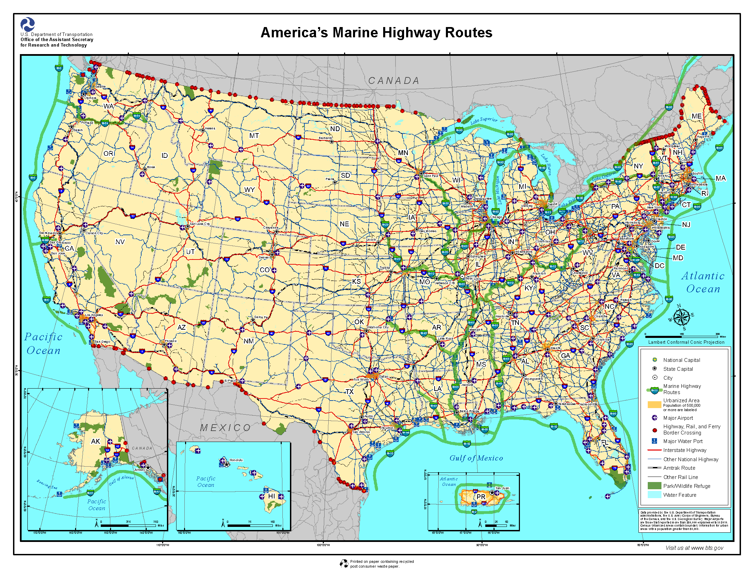
Source: October 29, 2014, http://www.marad.dot.gov/image_library/Maps/AMH_Route_Map.png

AMH Corridor Updates:
- Green Trade Corridor between Stockton and Oakland, (M-580 AMH Corridor). A weekly container-on-barge service between the California ports of Stockton and Oakland ended on Sept. 1, 2014. Ending one of the three inland waterway container services on the U.S. marine highway network.

Information and Recent News - Current AMH Corridor Services:
- Port of Stockton Transitions its M-580 Marine Highway
- Weekly Stockton-Oakland container barge service to end
- MARAD - Open Season in June for Marine Highway Projects
- Secretary Foxx Designates Two New Marine Highways
- Linking River, Rails and Roads at America’s Central Port
- Linking East Coast cities, McAllister tug does the work of hundreds of trucks
- Tidewater Announces Partnership with New Equity Investors
- Richmond Barge Service Adds Third Sailing: Tuesday, Thursday and Saturday
- The James River Barge Line, 64 Express
- Tidewater Barge Lines, Ports of Lewiston, ID, Pasco, WA, and Boardman, OR. and Port of Portland, OR.
- Expanding Port of Lewiston strengthens Idaho's connection to world markets
- Cross Gulf service between Brownsville, Texas and Manatee, Florida
- Columbia Coastal Transport Barge Services (Norfolk, Baltimore and Philadelphia)

Port of Stockton Transitions its M-580 Marine Highway
By: AJOT | Aug 11 2014 at 08:44 AM | Channel(s): Intermodal Liner Shipping Ports & Terminals
Effective Sept. 1, 2014, the Port of Stockton will be transitioning the M-580 Marine Highway demonstration project from a weekly service to an “as-needed” service. The M-580, which has been in operation as a demonstration project for the last 14 months, is a viable alternative to trucking containers to and from the Central Valley and the Bay Area.
“This project has demonstrated tremendous air quality benefits, reducing air emissions by 80 percent and truck trips by nearly 25,000, making highways safer,” stated Port Director Richard Aschieris. “The M-580 has significantly reduced associated maintenance costs as well. However, challenges remain as the Port of Stockton is the only operating underwriter of this regional project. During this initial period, we learned that the time it takes to build sustainable volumes was longer than anticipated.”
During the past several months, the port met with numerous state and federal agencies to identify possible financial partners to assist in keeping the current level of service viable and thus continue to see the significant emission reductions and associated health benefits. As of today, no state or federal agency has made a financial commitment toward the weekly operation of the project.
Port Commission Chairman Victor Mow commented on the value of the M-580. “What has been established during this successful phase is that this project needs to be a part of the goods movement system in California,” Mow said. “With the congestion we experience on I-580, as well as the air quality and safety benefits of the M-580, we look forward to the day we can bring the weekly service back to benefit our communities.”
The project has created 45 new jobs in the maritime terminal alone, with wages and benefits exceeding $4.5 million. The Port of Stockton will continue to look for future partners in the public and private sectors during the next year and looks forward to continuing its relationship with the U.S. Department of Transportation, the Maritime Administration, California Air Resources Board, San Joaquin Valley Air Pollution Control District and the Bay Area Air Quality Management District.
The Port of Stockton already has invested more than $8 million of its own, non-tax supported, funds in order to support this demonstration project.
To date the service has achieved the following milestones:
116 voyages between the ports of Oakland and Stockton
24,629 truck trips eliminated
7,259 containers transported
Reduced the following pollutants from the San Joaquin and Bay Area air basins:
- 0.3 tons of Reactive Organic Gases (ROG)
- 28.1 tons of Nitrogen Oxides (NOx)
- 2.4 tons of Particulate Matter (PM2.5 and 10)
- 5,947 tons Carbon Dioxide/Greenhouse Gas Emissions (GHG)
- Total Emission Reduction: 5,977.8 tons
Weekly Stockton-Oakland container barge service to end
Mark Szakonyi, Senior Editor | Aug 08, 2014 4:35PM EDT JOC
A weekly container-on-barge service between the California ports of Stockton and Oakland will end Sept. 1, dealing a blow the creation of a U.S. marine highway network by ending one of the three inland waterway container services.
The service via the San Joaquin River will still be available on an “as-needed” basis, and the Port of Stockton is looking for state and federal agencies to help shoulder the costs of a relaunch of the weekly service, Richard Aschieris, the port’s director, said. The port had hoped to move near 900 containers monthly but only achieved half that volume, he said. To date, the service has handled about 7,260 containers via 116 voyages.
Many of the roughly 50 shippers that used the service — ranging from agriculture producers to finished goods makers — were unwilling to shift more of the freight to barge without a guarantee of how much longer the service would last.
“The start-up period was longer than we anticipated,” Aschieris said. “Instead of a period of a year, it needs to be four to five years.”
Even with $13.5 million in federal aid for equipment, Stockton couldn’t continue to keep rates artificially low to draw shippers. Although the service wasn’t competitive with trucks, it did allow shippers to avoid truck lines at terminals and secure over-the-road capacity, Aschieris said.
“It came down to an inability with barge to compete with trucking,” said Jock O’Connell, international trade advisor at Beacon Economics, a Los Angeles-based research and consulting firm. “It’s just amazing to the amount how little [the service] was thought through.”
Oakland terminal operators’ reluctance to adapt their operations to the barge service also hurt. Longshoremen were sometimes pulled from handling the barge to load or unload an oceangoing vessel, Aschieris said. Besides, the volume hauled by a barge “was a speck of sand” compared to the international traffic handled by Oakland terminals, he said.
There was some hope that Mediterranean Shipping Co. would take over the service, giving it a better shot of securing better Oakland terminal service. MSC’s letter of intent to do so holds until the end of August, but Aschieris isn’t that confident the second-largest global container line will step in now.
From an environmental standpoint, the service was a success, with 25,000 truckloads taken off the road since its June 2013 launch, he said. That saved trucks from pumping out roughly 6,000 tons of pollutants, Aschieris said.
With Stockton having one of the highest unemployment rates in the country, the port jumped at the federal grants, which it used to install two cranes and buy two used construction barges, O’Connell said. The port spent $8 million of its own on the service.
O’Connell doesn’t think port did enough research on the demand for such service, pointing out that a lack of reefer plugs ruled out attracting perishable shippers. He also noted that the port was undertaking a market study to identify potential customers after the service had been launched.
“They put the barge before the containers,” O’Connell said.
The end-of-service announcement coincides with the Maritime Administration’s calling for Marine Highway project applications. There isn’t any money appropriated for the program, but Marad hopes to secure funding for projects via Transportation Investment Generating Economic Recovery (TIGER) grants and other federal programs.
“Since beginning operation along the M-580 corridor, this container-on-barge service has shown that moving freight by water can benefit area businesses, alleviate highway congestion and improve air quality,” Marad said in a statement. The agency "remains supportive of the partners and shippers using the Green Trade Corridor and will work with them to provide a long term viable service to the region.”
The agency noted that the equipment and infrastructure at the Port of Stockton continue to be used to handle freight.

MARAD - Open Season in June for Marine Highway Projects
AAPA News Alert: June 05, 2014
The Maritime Administration (MARAD) announced in the Federal Register this week (Vol. 79, No. 105 / Monday, June 2, 2014) that it is now Open Season on Marine Highway Projects. Applications will be accepted through June 30 and project review will complete by September 30.
MARAD’s Notice states that the purpose of the open season is to to “seek eligible Marine Highway projects that may establish new or enhance existing Marine Highway services.” Eligible projects may be designated as Marine Highway Projects by the Secretary of Transportation, allowing Department of Transportation resources to be used to assist public project sponsors, ports, and other local transportation or economic development agencies in the development. While there is currently no money available for grants, MARAD is taking applications for possible future funding, which may also be useful with a TIGER grant.
To be eligible for Marine Highway Project status, the proposed project must (1) use U.S. documented vessels, (2) transport passengers, containerized freight, or trailer-based freight, and (3) operate on a designated Marine Highway Route.
Since the last call for Marine Highway projects on April 15, 2010, the scope of the Marine Highway Program has been expanded to include all of the United States domestic marine transportation system. Previously, the Program only included waterways that paralleled landside transportation routes, and thus, excluded routes between the mainland and non-contiguous ports.
The Federal Register Notice provides full eligibility and application details.

Secretary Foxx Designates Two New Marine Highways. Maritime Administration News Release USDOT MARAD , DOT 80-13, Kim Strong, September 13, 2013
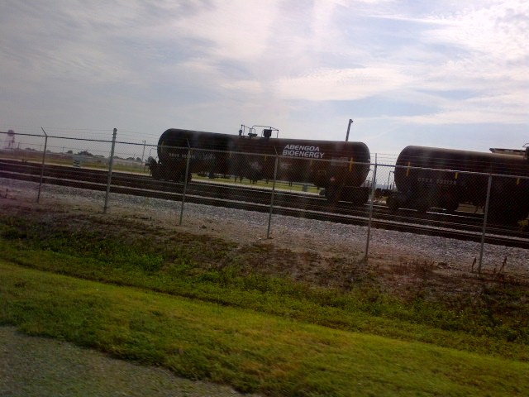
U.S. Transportation Secretary Anthony Foxx has designated two new Marine Highways. The Occoquan, Potomac, and Anacostia Rivers make up the “M-495 Marine Highway Crossing,” and is sponsored by the Northern Virginia Regional Commission and This marine highway connects ports in the District of Columbia, Northern Virginia, and Maryland for passenger services. The upper Missouri River is designated as the “M-29 Marine Highway Connector,” and is sponsored by the Port Authority of Kansas City, Missouri. It connects the upper Missouri River between Kansas City, Missouri, and Sioux City, Iowa. A marine highway is a designated route for transporting cargo on water, reducing pollution and congestion on roads. Since 2009, the Department of Transportation has designated 21 Marine Highway routes, and invested $130 million in projects supporting Marine Highway services. In addition to highlighting the role waterways play in moving freight throughout the region, designated Marine Highways receive preferential treatment for any future federal assistance from the Department or MARAD. Contact: Kim Strong – Tel: 202-366-5807

Linking River, Rails and Roads at America’s Central Port
Posted by Paul "Chip" Jaenichen USDOT Fast Lane blog, 8 19 2013
Modern infrastructure is a vital component of a thriving economy. However, re-building America’s highways, railroads and ports work more effectively when they are integrated with each other. A brand new interstate, for example, moves freight more efficiently when it connects to a port or rail facility.
That’s why it’s exciting to see what can happen when transportation planners get it right, like the new Southwest Regional Intermodal Freight Transportation Hub at America’s Central Port in Granite City, Illinois. This new facility will link six rail lines and four interstate highways to the M-55 and M-70 marine highways to capture and transport cargo from Chicago and other northern regions to the Gulf of Mexico and international markets.
Funded in part by a $14.5 million TIGER grant, this seamless connection of river, rail and road is a win-win for regional businesses and a model for the rest of the country. When completed, the hub will reduce shippers' costs, promote economic growth, and provide agricultural producers and manufacturers in America’s heartland better access to global markets. That means improved economic competitiveness for hardworking Americans.
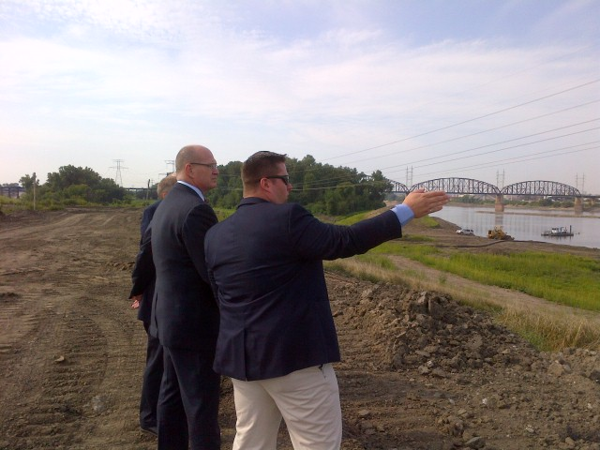
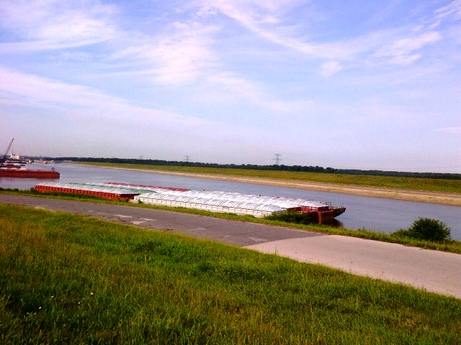
Infrastructure investment has always been one of President Obama’s top priorities, and a major component of his proposal to support middle class jobs. Projects like America’s Central Port’s Intermodal Freight Transportation Hub create a foundation for a 21st Century economy that expands opportunities for all Americans.
As the President knows, modern economic growth relies on modern infrastructure.
Chip Jaenichen is Acting Administrator of the Maritime Administration.

Linking East Coast cities, McAllister tug does the work of hundreds of trucks
John Gormle, Nov 8, 2012, Professional Mariner December/January 2013
Columbia Coastal Transport was recently covered in the December / January 2013 issue of Professional Mariner. The article shows how container barge services can vastly reduce damage to the highway infrastructure and reduce greenhouse gas emissions. The article can be read at http://www.professionalmariner.com/December-January-2013/Linking-East-Coast-cities-McAllister-tug-does-the-work-of-hundreds-of-trucks/

Tidewater Announces Partnership with New Equity Investors
Press Release - Vancouver, WA – December 14, 2012
New partnership positions Tidewater management for growth.
Dennis McVicker, president & CEO of Tidewater Holdings, Inc., announced today new joint ownership with Stonepeak Infrastructure Partners, in which Tidewater Holdings remains operating partner for its two subsidiaries, Tidewater Barge Lines and Tidewater Terminal Company. Stonepeak, a middle-market infrastructure investment firm with a focus on power, renewable energy, utilities, transportation and water, replaces Portland based Endeavour Capital as the major equity investor in Tidewater. The terms of the transaction were not disclosed. “The Tidewater management team is excited about our new partnership with Stonepeak,” said Dennis McVicker. “When considering investment partners and strategic plans for the company, the management team’s top priority is to ensure our customers continue to see the same high-quality service that Tidewater has delivered for 80 years.” He added, “Not only will our employees have continued job security, but we also expect this partnership will allow us to pursue new business opportunities that will benefit both the company and the region.”
Tidewater, founded in 1932, has evolved into a multi-commodity transportation and terminal company serving the diverse and evolving transportation needs of the Pacific Northwest. Headquartered in Vancouver, WA, the company’s operating area spans 465 miles on the Columbia & Snake River system extending from the Port of Astoria on the Oregon coast to the inland Port of Lewiston in Idaho.
“Tidewater is the premier inland marine transportation company in the Pacific Northwest,” said Michael Dorrell of Stonepeak Partners. “This partnership provides us with a unique and exciting opportunity to add an outstanding company to our investment portfolio. We look forward to being a part of Tidewater’s legacy and growth.” The Tidewater management team envisions this partnership as an opportunity to maintain its longstanding priorities and guiding principles while also pursuing new business opportunities resulting from the growing export market. “Tidewater remains committed to a high level of business ethics and integrity and our focus on safety, environmental protection, regulatory compliance and customer service,” added McVicker. Today’s announcement marks the end of a successful seven-year business relationship between Endeavour Capital and Tidewater. During this partnership, Endeavour supported management’s plans to reinvest in the fleet, transport new commodities, and make a strategic acquisition. “Tidewater is a company with a tradition of leading customer service on the Columbia-Snake River system,” said Stephen Babson, Managing Director of Endeavour Capital. “We have been proud to be partners with their management and employees as the company went through a period of significant growth and renewal. Tidewater is well positioned now to grow as bulk inland commodities try to find their way to the coast, providing employment and opportunity for people in our region.” “It’s been a pleasure working with Stephen Babson and the entire Endeavour team for the past seven years,” said Dennis McVicker. “We thank them for positioning the company to continue its long-standing tradition of serving the Pacific Northwest for many years to come.” Wells Fargo Securities served as exclusive financial advisor and Tonkon Torp LLP served as legal advisor to Tidewater in conjunction with this transaction.

Richmond Barge Service Adds Third Sailing: Tuesday, Thursday and Saturday
10/2/2012 www.Port of Virginia.com
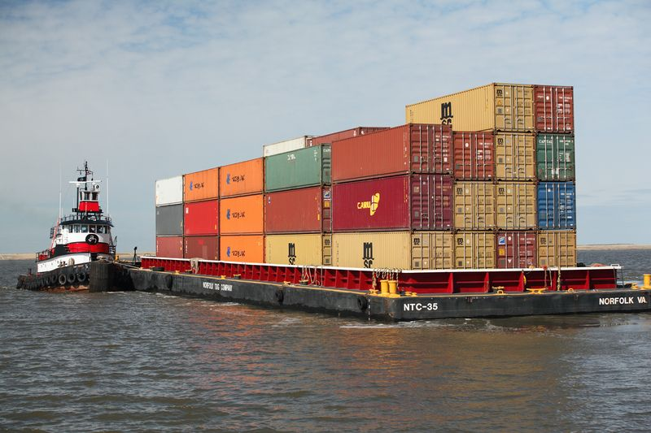
Norfolk – Virginia Port Authority (VPA) officials are confident that a third sailing of the container-on-barge service that connects the Hampton Roads Harbor with the Port of Richmond will be a factor in doubling the volume of cargo moved by the service. This week a third trip will be added to the weekly barge service; the service will call the Port of Richmond Tuesday, Thursday and Saturday. The barges can carry between 80 and 100 containers, depending on their lengths. "Adding a third sailing along with an overall increase in customers that are considering the barge as a means of transporting their cargo sets it up for success going forward," said Rodney W. Oliver, the VPA's interim executive director. "This started out very small: one time a week and a few containers at a time. The next step is to get it to five days a week." So far this year (through August), 6,227 containers have moved on the twice-weekly barge service, compared with last year's total of 4,386 containers. Barge traffic was off in 2011 because a major user temporarily scaled back its use of the service. The barge service was the result of a larger effort to reduce truck traffic on Interstate 64, reduce carbon emissions and to better utilize the Port of Richmond, which lost its two last ocean carriers as a result of the recession. "If you look at it in terms of roundtrip truck trips, thus far in 2012 we've taken nearly 12,500 trucks off the road and the emissions that go with that figure as well as a reduction in the wear and tear on the roads," said Heather W. Wood, the VPA's director of environmental affairs. "Next year we expect to remove more than 20,000 truck trips from I-64." An increase in barge traffic and greater utilization of the Port of Richmond could serve as a catalyst for economic growth and development around that facility.
Major Richmond port customers include MeadWestvaco, Altria, Equistock and TFC Recycling. Besides container traffic, the port also handles dry bulk and break-bulk cargos. "Given its location right on I-95 and the connection it has to The Port of Virginia, we see a lot of upside on multiple fronts for the Port of Richmond," Oliver said.

The James River Barge Line, 64 Express
10/16/12 64express@norfolktug.com
The James River Barge Line, 64 Express, offers a cost effective, environmentally friendly, congestion relieving, and reliable alternative to all truck freight shipments to and from Hampton Roads. We are - for all intents and purposes - a trucker on the water and provide seamless container service to and from your door. Our truck/barge service - offered via partnerships with high quality trucking companies throughout central Virginia, is competitive with all truck rates. The 64 Express allows direct and convenient access to shipping lines calling PMT and NIT. We've brought the ports of Hampton Roads 100 miles west! James River Barge Line initiated tug/barge container service on December 1, 2008 with weekly calls between the Port of Richmond and the Port of Hampton Roads. Importers and Exporters across central Virginia may now leapfrog the many congested roadways around Hampton Roads that delay their international cargo. We are competitive, environmentally friendly and do our part to reduce this country's consumption of oil. We believe we offer the most environmentally sensitive transportation solution for your international cargo to/from the port.
Schedule and Rates
Eastbound - The 64 Express sails every Tuesday and Thursday from Richmond to Hampton Roads. Cargo is discharged at VIT (APM and/or NIT) every Wednesday and Friday.
Westbound - we sail every Monday from Hampton Roads - VIT for cargo to discharge in Richmond every Tuesday and Thursday morning. Door delivery cargo may be seamlessly dispatched by our operations staff.
Barge/truck rates are comparable to all truck moves throughout Virginia, southern Maryland and northern North Carolina.

Ports of Lewiston, ID, Pasco, WA, and Boardman, OR. to Port of Portland, OR. Container on Barge Service
10/15/12 www.tidewater.com, http://www.portofportland.com/cntner_brgng_home.aspx, and www.portofmorrow.com
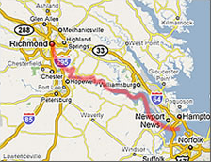
Tidewater is engaged in both the terminaling and transportation of export containers from the upriver Ports of Lewiston, ID, Pasco, WA, and Boardman, OR through the Port of Portland, OR.
The most economical transportation mode, Columbia River barges put cargo within 24 hours of ocean-going freighters in Portland. Tidewater Terminal in the Boardman Industrial Park is the largest container terminal upriver from Portland.

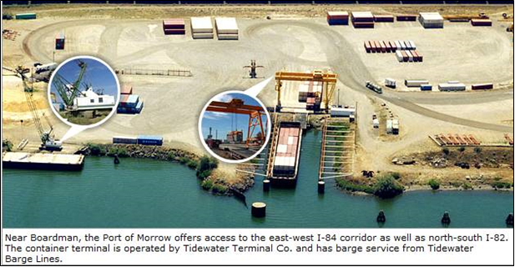
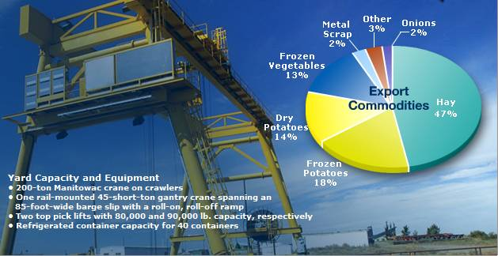

Expanding Port of Lewiston strengthens Idaho's connection to world markets
August 23, 2012, USDOT Fast Lane blog
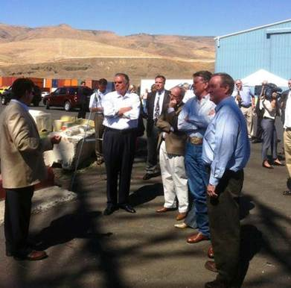
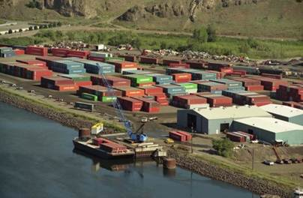
For farmers and other businesses in the West, the Port of Lewiston, Idaho, provides a critical link--through the Snake and Columbia rivers--to the Port of Portland and the Pacific Ocean. In 2011, cargo exported from the port reached 17 different countries, including 85 percent of the soft white wheat, peas and lentil grown in the region. Yesterday, with Governor C.L. "Butch" Otter, U.S. Senator Jim Risch, and U.S. Senator Mike Crapo, I had the opportunity to tour the port, and it was clear to see how important its container pier is to this community, to the state, and to the region. It was also clear to see how important it is to expand the port's capacity.
The Lewiston-Clarkston Valley is one of few American communities with more than 50,000 residents that also lies more than an hour's drive from the nearest interstate highway, which makes the Port of Lewiston even more essential to the region's economy and explains why the port is one of the primary inland export terminals in the nation. Expanding and upgrading this key port will allow farmers and other businesses even greater access to global markets. And that's exactly what a $1.3 million grant from DOT's TIGER program will help the Port of Lewiston accomplish.
While it may surprise readers to learn that this interior port is so important to the Gem State, Idahoans and Montanans have long understood that this isolated port facility is an economic lifeline. In fact, 200 years ago the Lewis and Clark expedition recognized the value of the river system connecting the region to the Pacific Ocean and the world. The current size of the dock restricts the movement of the port’s unloading crane to a relatively small area. Currently, the barge or crane must be repositioned several times to reach cargo, a long and cumbersome procedure. TIGER funding will be used to more than double the port’s existing 120 foot dock by adding another 150 feet. Extending the dock will allow the crane to move along the entire face of the dock and provide access to two barges simultaneously.
Maritime transportation is an economic engine for the entire nation, moving more than 18 billion tons of freight each year. President Obama understands the economic importance of the maritime industry. For the first time ever, this Administration put maritime on an equal footing with the other transportation modes when it came to funding, making this and many other good projects possible.
For example, in the first four rounds of TIGER grants, we awarded $354 million to support 25 maritime-related projects. And just last month, the White House announced that as part of the We Can’t Waitinitiative, the review and approval process for five major ports across the country will be expedited to get workers quickly back on the job rebuilding our maritime infrastructure. The Port of Lewiston is a perfect example of how America's interior ports and Marine Highways open up access to the world. The port already provides a critical economic link for this region. With targeted investments from TIGER, DOT is helping to strengthen that link, in Lewiston and across the nation.

Cross Gulf Service between Brownsville, Texas and Manatee, Florida
October 2012, Port of Brownsville, Port of Manatee and MARAD
The Cross Gulf Service intent is to expand inter-port and regional shipping over the U.S. D.O.T.-designated M-10 Marine Highway Corridor. The service consists of an integrated system of strategically connected projects on the Gulf of Mexico’s eastern and western shores which will provide the capacity to complete the link and expand container operations between the Port of Brownsville (POB) and Manatee County Port Authority (MCPA. See the Figure below. (expected start date Spring 2013)
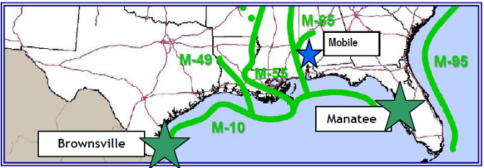
Columbia Coastal Barge Services (Norfolk, Baltimore and Philadelphia)
October 17, 2012 http://columbia-group.com/solutions/coastal-transportation/services/barge-transportation and American Shipper March 13, 2012
Columbia Coastal Transport currently offers container on barge services between the following Ports.
- Norfolk, VA and Baltimore, MD (twice weekly) - Chesapeake Service
- Baltimore, MD and Philadelphia, PA
- Philadelphia, PA and Norfolk, VA
Columbia Coastal Transport is improving its coastal container-on-barge service between Norfolk, Va., and Baltimore by doubling the frequency of service to two sailings per week and adding a weekly call in Philadelphia. "We want to provide our customers with more flexibility in these ports by increasing weekly sailings and expanding service into Philadelphia," said Bruce Fenimore, president and chief executive officer of the Columbia Group of Cos. "By utilizing our green all-water alternative, we can improve highway safety by taking more trucks off the road, lessen emissions, and reduce the carbon footprint in the areas we serve, all expressed goals of the Marine Highway Program." The company's largest barge, the 912-TEU Columbia Elizabeth, will be used in the new tri-port rotation. The new expanded service will have the rotation of Sunday-Norfolk; Monday-Baltimore, Tuesday/Wednesday-Norfolk, Thursday-Baltimore, Friday-Philadelphia, and Sunday-Norfolk. Columbia Coastal has offered container feeder service since 1990. The group also provides logistics, trucking, container and chassis repair, and warehousing to complement its carrier operations.

SECTION 2 - MARAD: AMERICA’S MARINE HIGHWAY PROGRAM

Current Highlights:
- The AMH Projects and Initiatives Updates, June 2013
- Multi-purpose American Marine Highways Series Production Ship (Dual-Use Vessel Development Program) Final Report, January 12, 2012

List of articles which follow:
- MARAD Unveils Ship Designs for Marine Highway Use
- MARAD Listening Sessions: Panama Canal Expansion & America's Marine Highway, San Francisco, CA, September 22, 2011 and New York, NY, September 27, 2011
- The AMH Projects and Initiatives FY2010 and FY2011
- DOT sends marine highways report to Congress
- Environmental and Energy Benefits of Short Sea Shipping
- Department of Transportation Announces Selection of Marine Highway Corridors, Projects, Initiatives, and Grants as Part of America’s Marine Highway Program
The AMH Projects and Initiatives Updates include:
The James River Container Expansion Project (Sponsored by: The Virginia Port Authority). The Maritime Administration awarded $1.1 million to assist with expanding an existing marine highway service between Norfolk and Richmond, Virginia. Since the award of the grant, the service has expanded from once weekly, partially loaded service to twice weekly, fully loaded service soon to be expanded to thrice weekly service. Customers who utilize the barge service to ship their goods have also been able to take advantage of tax incentives provided by the State of Virginia aimed at rewarding shippers who use “green” methods of freight transportation. Additionally, each barge movement removes 100 trucks off of I-64 resulting in reduced congestion, air emissions, and road maintenance, greatly improving the quality of life for the surrounding community.
The Cross Gulf Container Expansion Project (Sponsored by: The Ports of Brownsville, Texas and Manatee, Florida). The Maritime Administration awarded $3.34 million to assist with the re-establishment and expansion of a marine highway service across the Gulf of Mexico between the Ports of Brownsville, Texas and Manatee, Florida along the M-10 Corridor. The grantee for the funds are the two public port authorities. The service is expected to restart in 2013 and will result in substantial fuel, emissions, and road maintenance savings along the I-10 corridor. Open houses were held on April 24th and May 14th in Brownsville and Manatee, respectively to reengage stakeholders and initiate negotiations with interested operators.
The Tennessee-Tombigbee Waterway Pilot Project (Sponsored by: The Port of Itawamba, Mississippi). The Maritime Administration awarded $1.76 million to establish a new marine highway service along the Tennessee-Tombigbee Waterway between Port Itawamba, Mississippi and the Port of Mobile, Alabama. This new service is intended to reduce congestion and provide more efficient shipping alternatives to major manufacturers in the region, and is expected to eliminate more than 4,400 truck trips each year. Open Houses were held in Mobile, AL and Tupelo, MS on November 14 and 15, respectively. The ports are working with a selected service provider to initiate a service in 2013.
Marine Highway Corridor Studies: In order to identify potential markets for new services, the Maritime Administration is in the process of completing comprehensive studies of the M-5 (West Coast), M-55 (Mississippi River), and M-95 (East Coast) Marine Highway Corridors. Each study discusses market analysis, operations and business plans which are intended to help expand activity in this emerging industry. MARAD conducted a workshop on M-5 Study on October 10 at the CAPA meeting in San Diego. The final reports for the M-55 and M-95 studies were released and are available at www.marad.dot.gov/documents/2012_Marine_Highway. .

Multi-purpose American Marine Highways Series Production Ship (Dual-Use Vessel Development Program) Final Report
January 12, 2012, Center for the Commercial Development of Transport Technologies

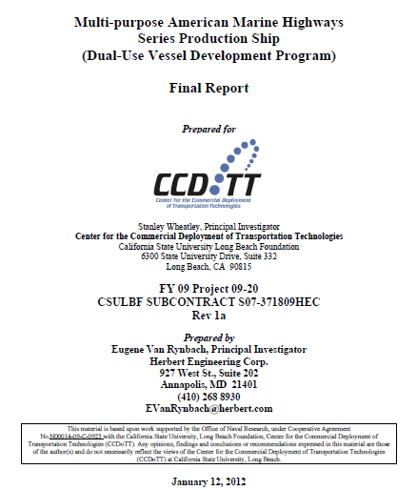

MARAD Unveils Ship Designs for Marine Highway Use
R.G. Edmonson, Associate Editor, Dec 1, 2011, The Journal of Commerce Online - News Story
Vessels could provide shippers an alternative to highway transportation The Maritime Administration on Thursday released a set of 11 ship designs that could provide shippers an alternative to highway transportation. The list includes six roll-on, roll-off vessels, three combination container ro-ro vessels, one small container ship and one ship to transport trucks and passengers. MARAD last year identified 18 marine highways corridors along coastal and river routes where water transport of trucks or containers could relieve highway congestion. Waterway services are mainly handled by tugs and barges, and self-propelled ships could provide faster delivery. The Navy also has an interest in marine highways designs that could provide auxiliary military sealift capacity during a national emergency, and is providing $800,000 to further develop two or three of the basic ship forms.

MARAD Listening Sessions: Panama Canal Expansion & America's Marine Highway
San Francisco, CA, September 22, 2011 and New York, NY, September 27, 2011
September 2011, US. Department of Transportation, Maritime Administration
The U.S. Department of Transportation’s Maritime Administration presented two events for supply-chain stakeholders, shippers, and port operators as well as governmental agencies joined MARAD in discussions regarding the expansion of the Panama Canal and America’s Marine Highways:
Panama Canal Expansion Study Listening Sessions
The sessions addressed the Panama Canal Expansion Project and its anticipated impacts on U.S. Ports and infrastructure.
Discussion topics included:
- U.S. Trade Patterns Post-Expansion
- Anticipated Effects on East/West/Gulf
- Coast/Inland Ports
- Infrastructure Development/Future
- Bottlenecks
- Impacts on the Cost of Doing Business: Who Pays/Who Benefits
- Conducting Business in the Post-Canal
- Expansion Economy
America’s Marine Highway Corridor Workshops. The workshops focused on the incorporation of Marine Highways into the National Transportation System.
Discussion topics included:
- Corridors, Connectors, and Crossings
- Projects and Initiatives
- Intermodal Connectivity
- Public/Private Partnerships
- The Path Forward

DOT sends marine highways report to Congress
American Shipper: 4/6/2011
U.S. Transportation Department on Tuesday released a report that it said would serve as a roadmap to the future in creating and further strengthening the nation’s marine highways. Prepared by the DOT’s Maritime Administration, the 84-page report, America’s Marine Highways, highlights the benefits of using coastal and river transportation as part of America’s new “clean energy economy.” Congress requested the report to show how water transportation can help move the country to a more environmentally sustainable transportation system, reduce highway congestion and cut down on the maintenance and replacement costs of the nation’s roads and bridges. “When we finish America’s fully integrated national marine highway system, our legacy will be more than routes on water,” said Transportation Secretary Ray LaHood, in a statement. “It will be a country less dependent on foreign oil.” The report highlights DOT’s accomplishments in supporting the development of America’s marine highway system. Since starting the program last year, LaHood designated 18 Marine Highway Corridors that will support economic growth and create jobs in communities across the country. In addition, DOT awarded $215.3 million from the TIGER I and TIGER II (Transportation Investment Generating Economic Recovery) programs to jumpstart or expand marine highway projects. Finally, the department commissioned a study of new ship design to serve the marine highway markets and to be useful to the military if needed. “America’s new clean energy economy will rely on a green, efficient transportation system that means making better use of our underutilized marine highways,” said Maritime Administrator David Matsuda. “This report is a valuable instrument in helping chart our course toward better energy security, reduced highway congestion and more balanced transportation networks.”

Environmental and Energy Benefits of Short Sea Shipping:
MARAD’s America’s Marine Highway Report to Congress, April 2011
AMH offers a more ENVIRONMENTALLY SUSTAINABLE TRANSPORTATION SYSTEM and is often the most energy-efficient means of moving cargo between two points, with:
- corresponding reductions per ton-mile in greenhouse gas emissions; and
- reduce noise and air pollution with minimal impacts on water quality.
Energy Conservation – Reduced Reliance on Imported Oil
It reports, though not all studies agree in their estimates, collectively, research supports the inherent fuel efficiencies of marine transportation services. It reports one recent study found that while trucks, on average, can carry one ton of freight for approximately 155 miles on a gallon of diesel fuel (i.e., 155 ton-miles of freight per gallon, equivalent to 842 BTU per ton-mile55), rail achieves 413 ton-miles of freight per gallon (316 BTU per ton-mile), and a tug-and-barge operation can get as much as 576 ton-miles of freight to a gallon of fuel (227 BTU per ton-mile). As such, shifting cargoes from pure long-distance land movements to water transportation in certain corridors would result in energy savings.
Reduced Greenhouse Gas Emissions
It reports, the greater use of water transportation could generally reduce emissions of carbon dioxide (CO2), an important GHG, relative to other transportation modes. Reference is made to International Maritime Organization data reflecting general values ranging from 117 grams up to 264 grams of CO2 per ton-mile of freight for trucks, 15 grams up to 73 grams of CO2 per ton-mile for U.S. railroads, and from less than 10 grams to up to 88 grams of CO2 per ton-mile for self-propelled oceangoing ships.
Cleaner Air and Other Environmental Impacts
It reports, in addition to energy and carbon benefits, AMH removes freight traffic from land-based modes and thereby reduces the air pollution, noise, and vibration caused by heavy vehicles moving through urban and rural residential areas with the actual impact dependent on the extent to which Marine Highway services are used and a number of other factors.
It also points out at the same time, expanding the use of our nation’s waters as “marine highways” for freight and passengers can also be expected to increase potential water-related environmental risks and consequences from marine transportation activities, operations, and accidents. Reporting that accordingly, EPA, USCG, U.S. Army Corps of Engineers, MARAD, and other government agencies continue to work with the maritime transportation industry to implement responsible regulations and practices to mitigate these potential environmental risks to our water resources.
Environmental Leadership
The report address how MARAD is working in partnership with EPA to provide incentives for shippers and Marine Highway service providers to consider environmental factors when planning their freight moves. MARAD will also formally involve EPA in the new America’s Marine Highway Advisory Board.
The full DOT’s Maritime Administration, the 84-page report, America’s Marine Highways can be found at:
http://www.marad.dot.gov/documents/MARAD_AMH_Report_to_Congress.pdf
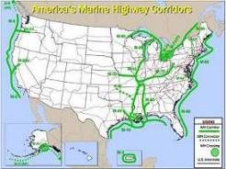
Department of Transportation Announces Selection of Marine Highway Corridors, Projects, Initiatives, and Grants as Part of America’s Marine Highway Program
On August 11, 2010, U.S. Transportation Secretary Ray LaHood identified 18 marine corridors, and designated 8 projects, and 6 initiatives for further development as part of "America's Marine Highway Program."Designated projects were eligible to apply for up $7 million in grants, per the Maritime Administration's Notice of Funding Availability in the August 12, 2010 edition of the Federal Register. Please see the entire press release at www.marad.dot.gov
Marine Highway Corridors: These all-water routes consist of 11 Corridors, 4 Connectors and 3 Crossings that can serve as extensions of the surface transportation system. These corridors identify routes where water transportation presents an opportunity to offer relief to landside corridors that suffer from traffic congestion, excessive air emissions or other environmental concerns and other challenges.
Marine Highway Projects: The Secretary has also selected eight Marine Highway Projects for designation under the program. These projects represent new or expanded Marine Highway Services that offer promise of public benefit and long-term sustainability without future Federal operational support. These projects will receive preferential treatment for any future federal assistance from the Department and MARAD. The projects will help start new businesses or expand existing ones to move more freight or passengers along America’s coastlines and waterways. The services have the potential to reduce air pollution and traffic congestion along surface corridors as well as provide jobs for skilled mariners and shipbuilders. The projects were selected from among 35 applications from ports and local transportation planning agencies received by the Department’s Maritime Administration (MARAD).
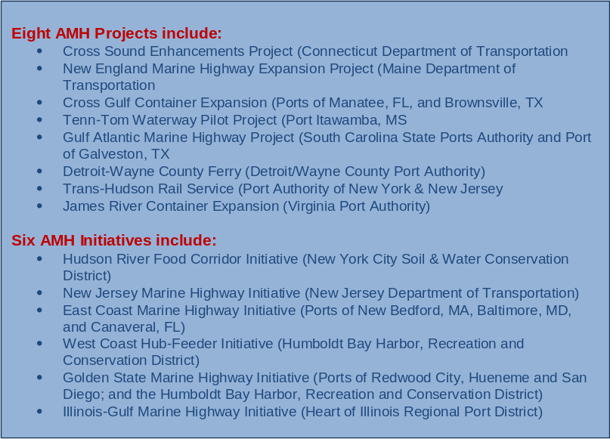
Marine Highway Initiatives: In addition to Projects, the Secretary has selected six applications that, while not developed to the point of proposing specific services and routes required of Project designation, they offer promise of potential in the future. While not eligible to compete for upcoming Marine Highway Grants, these “Marine Highway Initiatives” will receive support from the Department of Transportation in the form of assistance in further developing the concepts through conduct of research, market analysis and other efforts to identify the opportunities they may present.

SECTION 3 - FUNDING MATTERS

Current Highlights:
- MARAD - Open Season in June for Marine Highway Projects, June 5, 2014
- Senate committee holds hearing on MAP-21 reauthorization, February 13, 2014

List of articles which follow:
- MARAD - Open Season in June for Marine Highway Projects
- Senate committee holds hearing on MAP-21 reauthorization
- New Appropriation Act supports US ports
- Surface Transportation Act
- Title XI Federal Ship Financing Program – USDOT/MARAD
- Capital Construction Fund – USDOT/MARAD

TIGER (Transportation Investments Generating Economic Recovery) Discretionary Grants focused on Marine Highway Services:
For more information, including a brief on all TIGER grants awarded, click onto www.dot.gov/tiger .
Source: MARAD

MARAD - Open Season in June for Marine Highway Projects
AAPA News Alert: June 05, 2014
The Maritime Administration (MARAD) announced in the Federal Register this week (Vol. 79, No. 105 / Monday, June 2, 2014) that it is now Open Season on Marine Highway Projects. Applications will be accepted through June 30 and project review will complete by September 30.
MARAD’s Notice states that the purpose of the open season is to to “seek eligible Marine Highway projects that may establish new or enhance existing Marine Highway services.” Eligible projects may be designated as Marine Highway Projects by the Secretary of Transportation, allowing Department of Transportation resources to be used to assist public project sponsors, ports, and other local transportation or economic development agencies in the development. While there is currently no money available for grants, MARAD is taking applications for possible future funding, which may also be useful with a TIGER grant.
To be eligible for Marine Highway Project status, the proposed project must (1) use U.S. documented vessels, (2) transport passengers, containerized freight, or trailer-based freight, and (3) operate on a designated Marine Highway Route.
Since the last call for Marine Highway projects on April 15, 2010, the scope of the Marine Highway Program has been expanded to include all of the United States domestic marine transportation system. Previously, the Program only included waterways that paralleled landside transportation routes, and thus, excluded routes between the mainland and non-contiguous ports.
The Federal Register Notice provides full eligibility and application details.

Senate committee holds hearing on MAP-21 reauthorization
Progressive Railroading, Thursday, February 13, 2014
The U.S. Senate Committee on Environment and Public Works (EPW) held a hearing yesterday on reauthorization of the surface transportation law known as MAP-21 and the economic impact of maintaining federal investments in the nation's transportation infrastructure, including the Highway Trust Fund's solvency. MAP-21 is scheduled to expire on Sept. 30.
"It is critical for our nation to continue investing in our aging infrastructure. Therefore, preserving the Highway Trust Fund needs to be our number one priority in this committee, in other committees, and in the Senate and the House," said U.S. Sen. Barbara Boxer (D-Calif.), EPW's chairman, in her opening statement.
Witnesses testifying yesterday included Thomas Donohue, president and chief executive officer of the U.S. Chamber of Commerce, and Mike Hancock, president of the American Association of State Highway and Transportation Officials (AASHTO).
Donohue urged the Senate to identify ways to maintain and increase transportation infrastructure investment.
"The chamber believes that Congress should maintain a user-fee based Highway Trust Fund to support a strong federal role and enable multi-year funding commitments by the federal government to states and metropolitan planning organizations," he said in a prepared statement. "Raising user fees to cover the [trust fund's] shortfall and allow for increased investment should not be dismissed."
AASHTO's Hancock said the impending insolvency of the Highway Trust Fund poses a threat to state budgets, the construction industry and overall economy.
The Congressional Budget Office recently estimated that the Highway Trust Fund, which is funded by the federal gas tax, is facing a $77 billion deficit through 2019. In January, U.S. Transportation Secretary Anthony Foxx announced that the fund's Highway Account is likely to run out of money in August.
"We could face serious economic disruptions as early as this summer if USDOT delays reimbursements to the states for projects already completed," said Hancock in a prepared statement. "Unless Congress acts to either increase Highway Trust Fund revenues or provide additional General Fund support, the states will be unable to obligate virtually any new federal funds starting in fiscal-year 2015."

New Appropriation Act supports US ports
PortStrategy, 21 Jan 2014
The increased funding will support the international competitiveness of US ports like Los Angeles
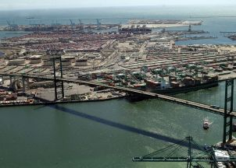
The recently introduced US$1.1 trillion Consolidated Appropriation Act of 2014 will support US seaport infrastructure and enhance US international competitiveness, says the American Association of Port Authorities (AAPA).
The new bill includes a 20% increase in funding for US DOT’s Transportation Infrastructure Generating Economic Recovery (TIGER) discretionary grants and US Corps of Engineers’ navigation-related programmes. It also covers FEMA State and Local Programmes grants that include dedicated funds for port security, EPA’s Diesel Emissions Reduction Act (DERA) grants, and funding for several of NOAA’s sub-programmes that aid navigation.
A spokesperson for the Port of Long Beach (POLB), told Port Strategy: “Like the AAPA, we are pleased that Congress understands the need to continue to fund critical transportation, environmental, civil works and security programmes that will allow US ports to stay competitive.”
“Depending on our project readiness and needs, we likely would apply to programmes like TIGER and DERA for funding, as we have in the past,” the spokesperson added.
POLB secured US$17m TIGER grant funding for the Green Port Gateway rail improvement project now under construction to improve the efficiency of rail traffic. The port has also received four DERA grants in the past for US$8.3m for projects to reduce air pollutants from harbour craft and terminal equipment.
While the increased funding is seen as a vital step forward in keeping US ports competitive, the POLB told PS “that would need to be evaluated on a long-term basis”, but “it’s clear that the federal government understands the need to reinvest in infrastructure that facilitates trade”.
The AAPA says it will continue to support the use of Harbour Maintenance Tax collection, which netted around US$1.8bn last year, as well as more equity for donors, and hopes that the new bill will allow for the “full use” of those revenues.

Surface Transportation Act
Surface transportation is defined as the highways, transit systems, railways, and waterways that comprise the intermodal transportation network in the United States. Seaports are the trade gateways and critical interchange points for cargo being imported and exported every day as part of the growing global economy. Ensuring that ports have adequate, congestion-free landside access to the broader transportation network has always been a priority for AAPA and its member ports. Surface transportation authorization, or the "highway bill" as it is more commonly known, establishes funding levels and enables programs which carry out this federal responsibility. This authorization is taken up by Congress and the Administration every six years. The Highway Trust Fund, which is supported primarily by federal fuel taxes, is the mechanism by which surface transportation programs are funded. The main programs of interest to Ports include the National Highway System (NHS) connectors program, the Surface Transportation Program (STP), and the Congestion Mitigation and Air Quality (CMAQ) program.
NHS Connectors. National Highway System (NHS) connectors are the public roads leading to major intermodal terminals. Although they account for less than 1 percent of NHS mileage, NHS Connectors are key conduits for the timely and reliable delivery of goods. Hence it is important to evaluate the condition and performance of connectors and related investment needs. The Office of Freight Management and Operations undertook two studies to evaluate the condition of NHS connectors and identify needed improvements.
Surface Transportation Program. The Surface Transportation Program provides flexible funding that may be used by States and localities for projects on any Federal-aid highway, including the NHS, bridge projects on any public road, transit capital projects, and intercity bus terminals and facilities.
Congestion Mitigation and Air Quality (CMAQ) Improvement Program – UDSDOT/Federal Highway Administration - The Congestion Mitigation and Air Quality (CMAQ) Improvement Program, provides a flexible funding source to state and local governments to fund transportation projects and programs to help meet the requirements of the Clean Air Act (CAA), and its amendments. Projects that address congestion issues, such as improvements to access routes, bridges, and tunnels serving intermodal rail and port terminals. At-grade road and rail crossings near port terminals can create congestion and emissions hot spots. Therefore, grade-separation projects may be eligible for CMAQ funding. Port and terminal operations can be pollution hot spots due to the operation of older diesel powered trucks and locomotives, and extensive idling. There are a growing number of active diesel retrofit programs around the country at ports. An example of a CMAQ marine funded project is the “64 Express/Marine Highway Project, Virginia. The Virginia Port Authority and Norfolk Tug Company, along with a coalition of public and private supporters launched a new container-on-barge service between Norfolk and Richmond, Virginia”. The 64 Express operated its maiden voyage on December 1st, 2008. It is a regular weekly service that can operate more frequently as customer needs dictate. The project was made possible by the concerted efforts of a team of public and private interests including the Richmond Metropolitan Planning Organization, the Maritime Administration, the Virginia Port Authority, Port of Richmond, Virginia DOT, Federal Highway Administration, and the private sector. CMAQ funding was part of the financing plan. The team’s vision is to provide an economically feasible service that accomplishes several key objectives. Firstly we hope to provide an alternate avenue to/from Hampton Roads and the central part of Virginia. In that effort we want to reduce highway, bridge & tunnel congestion and lessen the environmental impact created by trucks in Hampton Roads and along the I-64 corridor that results from that congestion.

Title XI Federal Ship Financing Program – USDOT/MARAD
The Federal Ship Financing Program provides for a full faith and credit guarantee by the United States Government to promote the growth and modernization of the U.S. merchant marine and U.S. shipyards.
The program, established pursuant to 46 USC Chapter 537, provides for a full faith and credit guarantee by the U.S. Government of debt obligations issued by (1) U.S. or foreign ship-owners for the purpose of financing or refinancing either U.S. flag vessels or eligible export vessels constructed, reconstructed or reconditioned in U.S. shipyards and (2) U.S. shipyards for the purpose of financing advanced shipbuilding technology and modern shipbuilding technology of a privately owned general shipyard facility located in the U.S. The Program is administered by the Secretary of Transportation acting by and through the Maritime Administrator.
Capital Construction Fund – USDOT/MARAD
The Capital Construction Fund (CCF) program was created to assist owners and operators of United States-flag vessels in accumulating the large amounts of capital necessary for the modernization and expansion of the U.S. merchant marine. The program encourages construction, reconstruction, or acquisition of vessels through the deferment of Federal income taxes on certain deposits of money or other property placed into a CCF. CCF vessels must be built in the United States and documented under the laws of the United States for operation in the Nation's foreign, Great Lakes, Short-Sea Shipping or noncontiguous domestic trade or its fisheries. Participants must meet U.S. citizenship requirements.
Operators of American-flag vessels are faced with a competitive disadvantage in the construction and replacement of their vessels relative to foreign-flag operators whose vessels are registered in countries that do not tax shipping income. The CCF program helps counterbalance this situation through its tax-deferral privileges.

SECTION 4 - LEGISLATIVE UPDATES

Current Highlights:
- AAPA presented the port industry’s freight priorities to a top U.S. Department of Transportation (USDOT) official., September 2014

List of articles which follow:
- AAPA presented the port industry’s freight priorities to a top U.S. Department of Transportation (USDOT) official
- House panel recommends ways to improve nation's freight transportation efficiency
- Major Waterways Bill Making Its Way Through Congress Stuck in Stalemate
- Dual Use Vessel Update
- Defense Authorization Bill Calls U.S. Shipping Industry “Critical” to National Security
- Lautenberg Bill Signed into Law to Reauthorize American Maritime Program
- Coast Guard and Maritime Transportation Act of 2012 - H. R.

AAPA presented the port industry’s freight priorities to a top U.S. Department of Transportation (USDOT) official, AAPA, September 2014
This week, AAPA presented the port industry’s freight priorities to a top U.S. Department of Transportation (USDOT) official. AAPA President Kurt Nagle and staff met with John Drake, Deputy Assistant Secretary for Transportation Policy and lead staffer on the National Freight Advisory Committee (NFAC). USDOT will release a series of freight infrastructure initiatives in the coming months, and the meeting focused on AAPA opportunities to participate in these efforts. AAPA emphasized the following priorities in the meeting:
- Need for Federal and State Planning
  - Designating gateways and corridors
  - Identifying connectors on Primary Freight Network
  - Ensuring expertise in maritime planning is a part of every state DOT
  - Incentivizing short sea shipping and America’s Marine Highways
- Necessity of Dedicated Freight Funding
  - Making port authorities eligible to apply directly for funding
  - Providing funding for connectors, intermodal projects and “first and last mile” projects
  - Providing funding for Projects of National & Regional Significance (PNRS)
- Importance of Transportation Infrastructure Finance and Innovation Act (TIFIA) and Strong Financing Options
AAPA committed to serve as a resource for USDOT on these efforts. Ports can support AAPA’s efforts by
- Providing examples of ports’ role in the freight system and people’s everyday lives;
- Participating in an upcoming AAPA freight infrastructure survey to identify examples and numbers of projects for future communication efforts with the Administration, Congress and media outlets; and
- Sharing any communication tools used to showcase how goods move from manufacturer to market, especially those tools that can help illustrate to policymakers how efficient connections with ports ensure the availability of goods on store shelves and help make America’s exports more price competitive overseas.
Staff Contact: John Young (jyoung@aapa-ports.org)

House panel recommends ways to improve nation's freight transportation efficiency
Progressive Railroading, Wednesday, October 30, 2013
The House Transportation and Infrastructure Committee's Panel on 21st Century Freight Transportation yesterday released a final report on the current state of U.S. freight transportation and recommendations for improvement.
Led by U.S. Rep John Duncan Jr. (R-Tenn.), who serves as chairman, and ranking member Jerrold Nadler (D-N.Y.), the panel recommended the following to help meet freight movement needs in the 21st century:
- The U.S. Department of Transportation (USDOT), in coordination with the U.S. Army and Coast Guard, should establish a comprehensive national freight transportation policy, designate a national, multi-modal freight network, and identify sustainable sources of revenue across all modes for necessary freight investments;
- Robust public investment in all modes should be ensured and additional private investment in freight transportation facilities should be incentivized;
- The development and delivery of freight projects and activities should be promoted and expedited;
Dedicated, sustainable funding for multi-modal freight projects should be authorized through a grant process and clear benchmarks for project selection should be established; and
- The USDOT's freight funding and revenue recommendations should be reviewed, working through the House Committee on Transportation and Infrastructure and Committee on Ways and Means, and specific funding and revenue options for freight transportation projects should be developed prior to Congress' consideration of a surface transportation reauthorization bill in 2014.
"Because bottlenecks at any point in the transportation system can seriously impede freight mobility and drive up the cost of the goods, improving the efficient and safe flow of freight across all modes of transportation directly impacts the health of the economy," said Duncan in a press release.
The House Transportation and Infrastructure Committee established the panel in April. To examine freight-movement issues, the panel held six public hearings and three roundtable discussions, toured various freight facilities, and held numerous briefings with freight industry professionals and other interested parties.
The Coalition for America's Gateways and Trade Corridors (CAGTC) hailed the panel and its recommendations. Panel members did a "tremendous job" by consulting with the nation's foremost freight experts and "synthesizing recommendations that, if executed properly, will drive our nation's global trade competitiveness for decades to come," said CAGTC Chair Sharon Neely, the Southern California Association of Governments' executive director, in a press release.
"The thoughtful and on-point recommendations represent six months of exhaustive research and tours of freight-related infrastructure that took place across the country," she said.
American Chemistry Council (ACC) officials also commended the panel and its recommendations, primarily for enabling shippers to offer their perspectives on key freight transportation issues.
"As an important transportation stakeholder along with other shippers, we have serious concerns about the lack of rail competition and its impact on U.S. manufacturers," ACC officials said in a press release. "As the members of the committee review the recommendations of the report, we urge them not to overlook the issue of rail competition as they examine an array of freight rail policies."

Major Waterways Bill Making Its Way Through Congress Stuck in Stalemate
Mark Szakonyi, Senior Editor, Oct 14, 2013, The Journal of Commerce
There’s little good news coming out of Washington these days. The federal government partially shut down at the beginning of the month after a stalemate in Congress over funding President Obama’s health care reform law. Congress and the Obama administration failed to address long-term fiscal issues, allowing the federal budget sequestration — the proverbial gun pointed to its own head — to fire.
And the blasts could keep coming because lawmakers already are digging in for a fight over whether to raise the nation’s $16.7 trillion debt ceiling. Failure to raise the ceiling by Oct. 17 would cause the U.S. to default on its loans and, some say, trigger another recession.

In the midst of this larger Beltway impotence, a major bipartisan port and inland waterways authorization bill is making its way through Congress. Aside from authorizing long-delayed projects, the final bill likely will free up more money for inland waterways and port construction, and speed up the project cycles. The water resources bill ultimately could help reduce export and import costs. But whatever form the final bill takes, it would only be the start to the investment needed in the nation’s ports and inland waterways.
Prospects for the passage of an authorization bill appear good, considering the House and Senate versions have so much in common. The Senate overwhelmingly passed the Water Resources Development Act in May, and the House is expected to vote on its own version this month, paving the way for a potential conference between the two chambers. Before that can happen, however, the House will have to deal with the spending and debt ceiling controversies swirling through Washington, allowing the government to, well, govern.

Key Port Projects Await Go-Ahead
The bill is long overdue — Congress last passed a WRDA in 2007. Until the last law expired, a bill was passed roughly every year until recession-era tightening banned earmarks for specific projects. The delay stalls projects ranging from flood management work, navigational fixes and harbor deepening.
The passage of the bill, for example, would authorize the deepening of the Port of Savannah’s 29-mile channel to 47 feet from 42 feet. The $652 million project, which previously won federal authorization, must go through the approval process again because environmental protection measures have inflated the project cost. Savannah, like other East and Gulf Coast ports, wants to deepen its harbor to handle heavily loaded, larger vessels able to traverse the expanded Panama Canal. Shippers and container lines are watching closely to see who will be ready after the $5.25 billion canal expansion project opens in mid-2015.
The deepening of the ports of Savannah and Charleston will allow International Paper to continue to ship the majority of its exports out of those gateways. “If the ports of Charleston and Savannah cannot handle the larger ships in 2015, we will be forced to redirect our exports to other U.S. ports that can accommodate the larger ships, or sharply reduce our exports,” said Thomas Kadien, senior vice president of consumer packaging for International Paper (Asia).
Shipping out of the ports of Baltimore and Virginia would increase rail and trucking costs for the paper and packaging exporter, which spends $2 billion on logistics annually, Kadien told Congress on Oct. 1.
The other major port project awaiting authorization is a $38 million fix to a navigational problem preventing large, heavily loaded container vessels from calling at the Port of Jacksonville nearly two-thirds of the day. Jacksonville also wants authorization to dredge its 40-foot-deep channel to 47 feet, but the Army Corps of Engineers’ chief report isn’t due until next year, meaning the project risks not being included in the current bill.
TraPac, operator of the MOL container terminal at Jacksonville, already has lost out on cargo because of the navigational issue and warns that business will get worse if a deeper draft isn’t authorized soon. Rep. Corrine Brown, D-Fla., wants to include an amendment that would add Jacksonville and Port Everglades deepening projects in the authorization bill, but her attempt in a House subcommittee failed.
“I think everyone, including TraPac, is looking to see some commitment that this project will advance,” Jaxport CEO Brian Taylor said.

Giving Ports Their Fair Share
If passed, the water resources bill will do more than just allow projects to move forward. Both the Senate bill and the House version — the Water Resources Reform Development Act — aim to speed up the construction of Army Corps projects.
The bills also aim to use give more money collected through the Harbor Maintenance Tax back to ports, instead of using the dollars to plug general budget holes. About 65 percent of the $1.8 billion collected is estimated to head back to ports for maintenance dredging and jetty upkeep in fiscal 2014. Ports have received only about half of collected HMT in previous years.
The aggressiveness of proposed Harbor Maintenance Trust Fund Reform differs by chamber, however. The House bill would return to ports at least 80 percent of collected taxes by fiscal 2020, while the Senate bill aims to return all HMT dollars to ports within the same period.
Despite pushes for HMT reform from both chambers, it’s uncertain whether appropriators will skirt language blocking them from siphoning dollars from the fund, said Ray Bucheger, a federal policy and legislative consultant with FBB Federal Relations. “If there are going to be any sparks (in the bill debate), it’s going to be over full-use versus 80 percent,” he said.
Both bills also would free up inland waterways dollars for work other than the behind-schedule, over-budget Olmstead Lock and Dam project on the Ohio River between Illinois and Kentucky. The House bill would have the federal government pay for a quarter of the project, estimated to cost $3.1 billion, while the Senate version would put the entire burden on Uncle Sam.

DC Spots Ports’ Economic Potential
The long overdue legislation comes as Washington awakens to the economic impact of U.S. ports, and the funding challenges they face. The Obama administration is trumpeting the need to deepen East and Gulf Coast ports — the president made his case at the TraPac terminal in Jacksonville in July and on “The Tonight Show With Jay Leno” in August. More recently, Vice President Joe Biden toured the ports of Baltimore, Charleston and Savannah.
“Unless we expand ports on the East Coast, we’re going to fall behind,” Biden said on Sept. 16 at the Port of Baltimore, one of two U.S. East Coast ports with harbors deep enough to handle fully loaded post-Panamax vessels. The Port of Virginia is the other.
Congress is giving ports their due as well. The House Transportation Infrastructure Committee is pushing a whiz-bang campaign involving Twitter and YouTube to educate legislators and their constituents on why ports are integral to economic growth. In the Senate, the two top members of the Environment and Public Works Committee — Sens. Barbara Boxer, D-Calif., and David Vitter, R-La. — haven’t let a nasty ethics feud dampen their joint chorus for infrastructure investment.

Divisions Among Ports Persist
Behind the rousing calls for port investment lurk divisions. Ports that have naturally deep harbors want to be able to use federal dollars collected through harbor maintenance taxes for work other than maintenance dredging. The ports of Los Angeles and Long Beach, for example, generate 28 percent of total HMT revenue but get back only about 6 percent, while the Port of Seattle gets about a penny for every dollar it kicks into the Harbor Maintenance Trust Fund. The final water resources bill likely will have language addressing some ports’ desire for more equitable HMT use, but it’s unlikely to end the debate.
Others would rather scrap the HMT entirely. Sens. Patty Murray and Maria Cantwell, both Democrats from Washington, have introduced a bill that would replace the 0.125 percent levy on the value of imported cargo with a Maritime Goods Movement User Fee. The fee would be assessed on all containers that originate internationally, including those that arrive by rail or truck.
“Unfortunately, shippers have been able to avoid the harbor maintenance tax by shipping goods through ports in Canada and Mexico and then transporting those goods into the United States via truck and rail,” Murray and Cantwell said in a joint written statement. “This growing cargo diversion reduces the funds available to keep our ports in operating condition.”
The passage of a water resources bill won’t fix the funding challenges ports and inland waterways face. The House bill would authorize 23 projects over the next two years, including flood prevention and other non-freight-related projects, equating to $10 billion in construction. The Senate bill authorizes $7.7 billion worth of water-related projects over five years.
The challenges look even steeper, considering many U.S. ports struggle to maintain their authorized channel depths, largely because of the siphoning of HMT funding. Robust private investment helps, but marine ports and inland waterways still face an investment gap of nearly $16 billion over the next seven years, according to the American Society of Civil Engineers.

What Ports Deserve Funding
With limited funding, East and Gulf Coast harbor-deepening projects should be prioritized using market-based metrics, including potential economic impact and trade flows, said J. Stanley Payne, who has held leadership positions at the Virginia Port Authority and the Canaveral Port Authority. The Corps of Engineers judges the feasibility of proposed deepening projects and considers trade flows and the impact of competing ports, but Payne, a maritime consultant, says they often don’t drill down deep enough. This could result in Congress “viewing water development projects through a pork barrel lens,” resulting in projects with limited merit draining resources better spent on stronger ports. “It’s No Child Left Behind for ports,” he said.
The deepening of all or most of the major East and Gulf Coast container ports likely wouldn’t give taxpayers the economic short-term impact promised, but shippers and carriers would benefit, Payne said. Both will have improved gateways for cargo and be able to play ports off each other. “Something has gone wrong with the entire system,” Payne said. “Ports have known for decades that they need deeper drafts, but they still don’t have enough money for future deepening work and maintenance.”
Central planning from the federal level stifles innovation, and the 35 years of deregulation in transportation and logistics industries has created “astonishing improvements” to the U.S. supply chain, said James Burnley, who served as transportation secretary during President Reagan’s second term. The government doesn’t have a good record of “picking winners and losers,” he said.
Besides, central planning “would still be an intensely political process,” and the idea that it wouldn’t be is “naïve,” said Burnley, co-chair of the transportation practice at Venable, a global law firm.
Just because there isn’t central planning doesn’t mean there isn’t a federal port policy. The corps calculates cost-benefit ratios for potential projects, and Congress and the executive branch still determine which ones get final authorization, said Paul Bea, principal of maritime consultant PHB Public Affairs. “I think the political process is an imperfect one, but it’s more democratic than the other way of going about it,” he said. “We are not set up as government for centralized planning where the state or regional authority has little or no role.”
Central port planning isn’t a surefire solution, either, as China, a major political meddler in business, has shown. Beijing has had to discourage port investment in favor of inland waterways development after coastal gateways added too much container terminal capacity.
With less federal help on the way, ports need more aid from local and state backers, and the private sector. Florida, Georgia and South Carolina are a few of the states that have invested aggressively in their ports and are ready to help out with future deepening costs. The adage that “all politics is local” is increasingly becoming the case for port funding, too.

Dual Use Vessel Update
MTS Matters, Paul Bea, July 3, 2013
Before Under Secretary of the Navy Bob Work left the Navy in March, he signed a letter to USDOT saying that the Navy was interested in working with Transportation on developing Dual Use Vessels (DUV) on America's Marine Highway (AMH). Those of you who have followed this initiative know it is based on a business case analysis that indicated that such an approach could be a cost effective means of recapitalizing the Ready Reserve Force (RRF) if certain legislative and policy changes, such as those in the process of being recommended by the Marine Transportation System National Advisory Council's Shipbuilding Subcommittee, were made. After changes were enacted, the thinking goes, the Navy would consider funding appropriate incentives to jump start AMH/DUV services when appropriate based on need. More recently, Secretary Porcari replied that his department would work under an existing MOA with the Navy on legislative and policy ideas .
Meanwhile, the annual defense authorization legislation, which is the principal vehicle for authorizing MARAD's program, includes mention of AMH and the DUV initiative. In the House's National Defense Authorization Act (on page 713) is "sense of Congress" language that highlights the need to recapitalize the aging RRF and maintain America's capacity to build and crew such vessels of value to the national defense. Here is the reference to the DUV approach -
(4) investment in recapitalizing the Ready Reserve Force may include--
(A) construction of dual-use vessels, based on need, for use in the America's Marine Highway Program of the Department of Transportation, as a recent study performed under a cooperative agreement between the Maritime Administration and the Navy demonstrated that dual-use vessels transporting domestic freight between United States ports could be called upon to supplement sealift capacity...
(5) the Department of Transportation, in consultation with the Navy, should pursue the most cost-effective means of recapitalizing the Ready Reserve Force, including by promoting the building of new vessels that are militarily useful and commercially viable.

Defense Authorization Bill Calls U.S. Shipping Industry “Critical” to National Security
June 13, 2013, American Association of Port Authorities, 1010 Duke Street, Alexandria, VA 22314-3589, T: 703.684.5700 F: 703.684.6321 E: info@aapa-ports.org
The National Defense Authorization Act (NDAA) for FY 2014 includes language supporting the construction of vessels primarily designed for short sea shipping that also have the “dual use” capability of being called upon to support military objectives.
According to the bill, the U.S. maritime industry is critically important in times of war and national emergency, and the maintenance and enhancement of the Maritime Administration’s (MARAD) Ready Reserve Force is vital to American national security.
The bill suggests that MARAD and the Navy should work together in constructing vessels that are both “militarily useful and commercially viable.” Construction of short sea shipping vessels that transport freight from one U.S. port to another along America’s marine highways are specifically given as examples because, when necessary, they can be called upon to supplement military sealift capacity. Additionally, the bill states that the government could construct tankers that meet military transport needs and ships able to transport potential new energy exports.
This language is part of a “Sense of Congress” section of the bill that serves as a signal of the position lawmakers have taken on this issue and does not necessarily direct agencies to take any particular action.
The NDAA is the annual law that defines the scope of the Department of Defense budget; the House of Representatives has begun debate on it and is expected to take a final vote on Friday.

Lautenberg Bill Signed into Law to Reauthorize American Maritime Program
Lautenberg Press Office, 202-224-3224, Friday, January 04, 2013
WASHINGTON, DC—Earlier this week, U.S. Senator Frank R. Lautenberg's bill to authorize the Maritime Security Program for the Maritime Administration (MARAD) was signed into law when President Obama signed the National Defense Authorization Act. The remainder of Senator Lautenberg's provisions to reauthorize federal maritime programs carried out by MARAD were signed into law in December when President Obama signed the Coast Guard and Maritime Transportation Act. Lautenberg is Chairman of the Commerce Subcommittee on Surface Transportation and Merchant Marine Infrastructure, Safety, and Security, which has jurisdiction over the MARAD. “Federal maritime programs are critical to our nation's economy and security, and I am pleased that Congress has reauthorized and strengthened these programs,” said Senator Lautenberg. “These laws move our maritime industry forward by expanding critical programs and ensuring a strong merchant marine to supply our troops with the equipment and supplies they need.”
The provisions that Lautenberg authored in the National Defense Authorization Act and the Coast Guard and Maritime Transportation Act that will authorize MARAD funding include:
- Providing certainty to the Armed Services and ship owners by reauthorizing the Maritime Security Fleet Program through 2025;
- Promoting and strengthening short sea shipping in the Marine Highways Program to move more cargo on the sea rather than on crowded highways; and
- Fostering innovation in the maritime sector and providing infrastructure and workforce to make sure our system is prepared for the future.
MARAD administers the U.S. merchant marine support programs, including operation of the U.S. Merchant Marine Academy, to promote the development and maintenance of an adequate, well-balanced U.S. merchant marine sufficient to carry the nation’s waterborne freight and capable of service as a naval and military auxiliary in time of war or national emergency.

Coast Guard and Maritime Transportation Act of 2012 - H. R. 2838
December 20, 2012

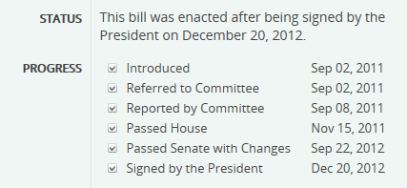

Title IV – Maritime Administration Authorization sections which address short sea shipping follow.

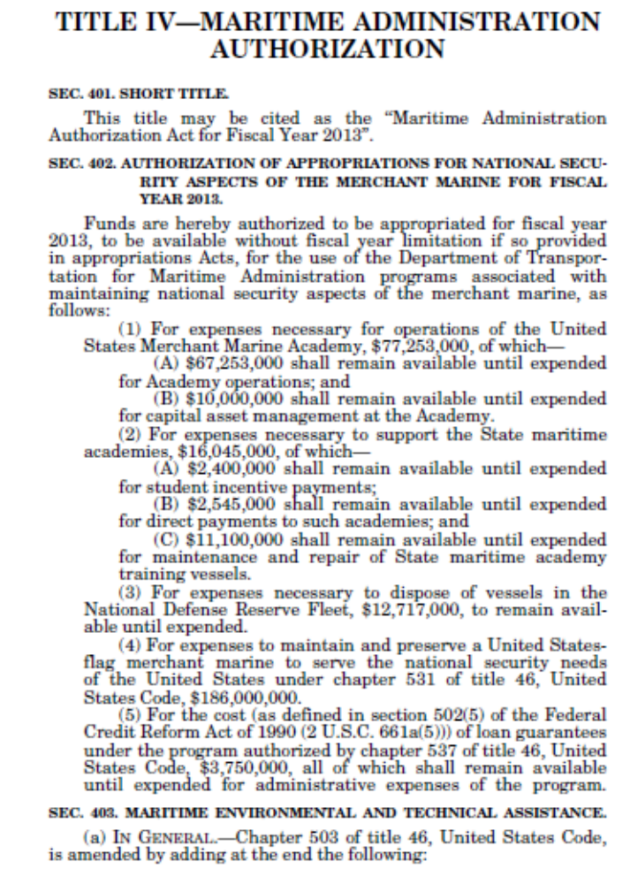
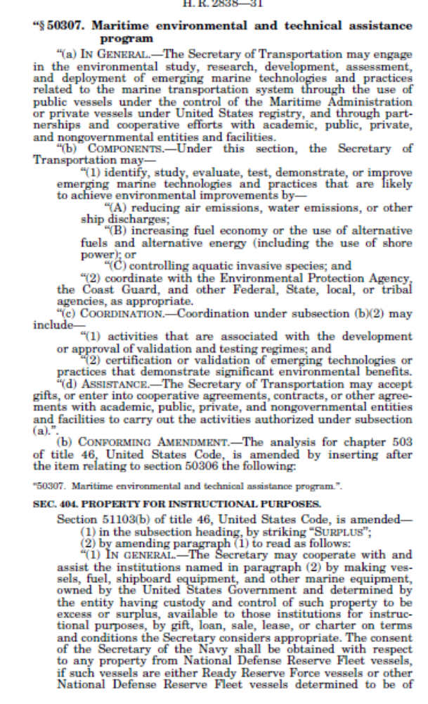
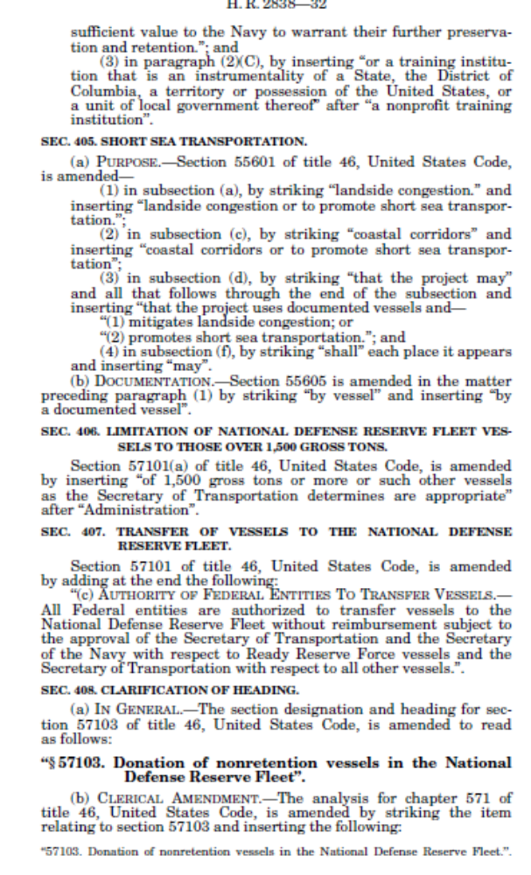
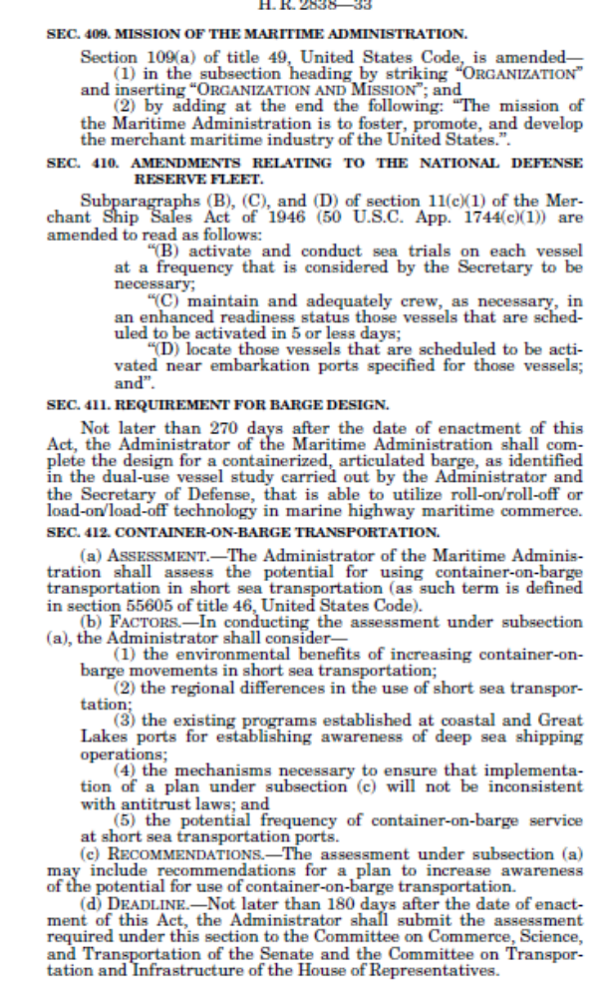
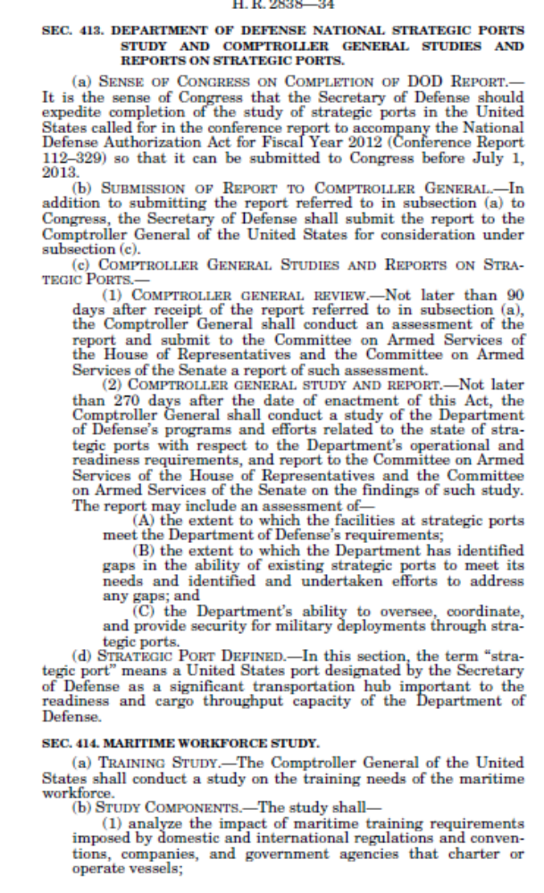
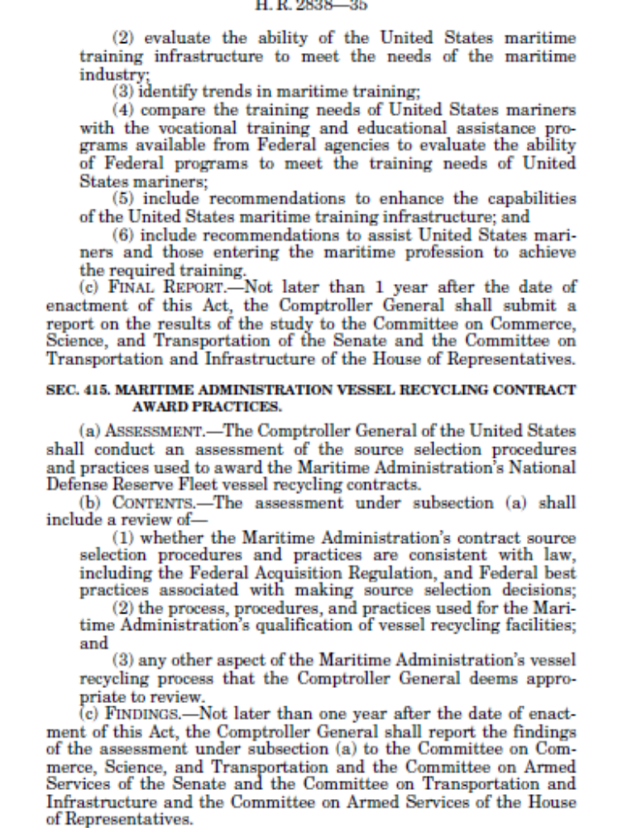

SECTION 5 - GET CONNECTED: AMH ONLINE LINKS

Current Highlights:
- Active online links, October 2014

List of online links which follow:
- MARAD news link
- Committee on the Marine Transportation System (CMTS) website
- Marine Highways Cooperative
- Maritime Industry Congressional Sail-In, Wayne McCormick
- MTS Matters, Paul Bea’s Blog on AMH and other MTS Topics
- America's Marine Highway Reference Library, MARAD
MARAD news link: http://www.marad.dot.gov/ships_shipping_landing_page/mhi_home/mhi_home.htm
Committee on the Marine Transportation System (CMTS) website
http://www.cmts.gov/Default.aspx
Marine Highways Cooperative:
http://www.marinehighways.org/index.php?page=contact_us
Maritime Industry Congressional Sail-In, Wayne McCormick
http://maritimeindustrysailin.com/Default.aspx.
MTS Matters, Paul Bea’s Blog on AMH and other MTS Topics
www.mtsmatters.com
America's Marine Highway Reference Library, MARAD
This MARAD site contains a listing and summary of reports and publications on America’s Marine Highways. The “Top Shelf” reports are primary sources of information for the benefits offered by the marine highways. The other reports contain important information that is also vital to understanding America’s Marine Highways and the benefits they offer.
http://www.marad.dot.gov/ships_shipping_landing_page/mhi_home/mhi_reference_library/MHP_Reference_Library.htm

SECTION 6 - AMH ADVOCACY GROUPS AND ASSOCIATIONS

Current Highlights:
- MTSNAC met on Port-Related Issues, February 13, 2014

List of Advocacy Groups and Associations which follow:
- SOCP Marine Highway Committee
- I-95 Corridor Coalition
- George Mason University
- Coastwise Coalition
- North Atlantic Ports Association Short Sea Shipping Committee
- North American Short Sea Shipping Steering Committee - MARAD
- MTSNAC Committee
- AAPA Maritime Economic Development Committee
- Transportation Research Board (TRB)
- MTS Matters

SOCP Marine Highway Committee
The Marine Highway Cooperative (formerly known as SCOOP), has merged with the Ship Operations Cooperative Program (SOCP), establishing the SOCP Marine Highway Committee.

SOCP SPRING 2013 MEETING held February 20-21, 2013, STAR Center - Dania Beach, Florida
Theme: RECRUITMENT / RETENTION & CRITICAL INCIDENT IMPACTS

Information on SOCP and their meeting schedule can be found at www.socp.us

I-95 Corridor Coalition
Marine Highway Working Group – Intermodal Freight and Passenger Movement Committee
The I-95 Corridor Coalition Marine Highway Working Group under the leadership of Barbara Nelson, Principal Planner, Richmond MPO and project lead for the MPO on the James River Barge project; and Scott Douglas, Maritime Program Manager, NJDOT, facilitate discussion regarding the development of marine highway activities within the M-95 corridor. This diverse leadership team combines expertise and provides Port, MPO, and DOT perspective to the ongoing efforts of the Working Group which seeks to advance America’s Marine Highway program. The Working group currently convenes stakeholders periodically via webcast to address issues and promote information exchange. For information on the I-95 Corridor Coalition/M-95 Marine Highway Working group, contact Marygrace Parker, I-95 Coalition Freight Program Coordinator at i95mgp@ttlc.net
M-95 AMH Corridor Designation
The I-95 Corridor Coalition submitted a comment on the AMH Program and a corridor application for I-95 which was designated by the USDOT Secretary as AMH Corridor M-95 on August 11, 2010. The comment and corridor application was prepared under the leadership of its Intermodal Freight and Passenger Movement Committee’s Marine Highway working group. Both the comment and corridor application are posted on http://www.newbedford-ma.gov/PortofNewBedford/ShortSeaShipping.html As M-95 Designee, the Coalition is continuing to support work on Marine Highway by participating in the management committee for the MARAD-designated East Coast Marine Highway Initiative (Ports of New Bedford, Baltimore and Canaveral and State of New Jersey) For additional information on the I-95 Corridor M-95 Highway Corridor please visit their website @ http://www.i95coalition.org/i95/Home/tabid/36/Default.aspx
Phase I Short Sea Shipping Study
Through its work on the Multi-Modal Port Access Project, the Coalition identified opportunities for increased utilization of the region’s inland and coastal waterways, including short- sea and coastal shipping The Coalition's Short-Sea and Coastal Options Study provided an opportunity for the Coalition to engage shippers, carriers, manufacturers, and industry groups in identifying the issues surrounding short-sea/coastal shipping and passenger ferry services and begin to evaluate the feasibility of employing such strategies on the East Coast. The results of this study are found at http://www.i95coalition.net/i95/Projects/ProjectDatabase/tabid/120/agentType/View/PropertyID/61/Default.aspx
Phase II Short Sea Shipping Study
Due to funding constraints the Coalition has had to defer work on additional Short Sea/Marine Highway Phase II studies. The Coalition is continuing to provide staff and programmatic support to the Marine Highway Working group and will be working with membership to identify future activities, next steps and potential funding sources for mutual initiatives.

George Mason University
The DOT project has now been completed and the final report submitted and posted at the GMU web site ".eastfire.gmu.edu/Marine_Highway_Freight_System/"
The project results show that advanced remote sensing technologies using satellite images can cost effectively be applied to plan port infrastructure planning both for long-haul and short-haul marine highways . The study also shows that significant reductions in freight traffic can be achieved by rerouting freight to marine highways. The freight rerouting scenario shows significant cost savings by reduced fuel use, decreased emissions, lower highway maintenance cost and savings of highway incident cost.
The Advisory Committee for the project has recommended to DOT for continuing the project to examine potential application of marine highways for congestion reduction in I-95 corridor. A continuation concept proposal was submitted to DOT/RITA RS program for developing much needed data on alternate transportation for a national freight policy. The project was not approved by RITA .
Contact:
Dr. K. Thirumalai - Research Professor
Director, Marine Highways and Multimodal Systems Research
Dept. of Civil, Environmental & Infrastructure Engineering
Volgenau School of Engineering
George Mason University MSN-6C1
Fairfax, VA 22030
kthirum2@gmu.edu ; kt.sti@comcast.net;
Telephone: 703 910 7439;Cell 202 361 0712
Coastwise Coalition
- What’s All This About Marine Highways? Northeast Diesel Collaborative Group Port Working Group, May 19, 2010 presentation can be found at http://www.northeastdiesel.org/pdf/workgroup/CoastwiseCoalitionMARAD.pdf
- EDF Paper (Source: Coastwise Coalition). The Environmental Defense Fund released a paper, “The Good Haul – Innovations That Improve Freight Transportation and Protect the Environment.” The Transportation for America coalition, a large organization that is lobbying for new transportation policy—mostly transit and community oriented—provided some support for the paper. The paper points to existing services, operations and projects that offer examples of goods movement operations and technology that is friendlier to the environment than more traditional freight activity. Included is a chapter on “coastal shipping” with three examples: The EU’s Marco Polo program, the 64 Express container barge service on the James River in Virginia, and the SeaBridge Freight container barge TX-FL service on the Gulf. Our compliments go to coalition friends involved in those two operations. With a quick nod to future prospects the paper also mentions Coastal Connect’s planned RoRo service. Find the paper at: http://www.edf.org/documents/10881_EDF_report_TheGoodHaul.pdf
North Atlantic Ports Association Short Sea Shipping Committee
- Short Sea Committee, for details contact the North Atlantic Ports Association ATTN: Thomas Valleau, Executive Director, 65 Rockland Avenue, Portland, ME 04102, Tel. 207-774-3600, email: tvalleau@maine.rr.com . The Short Sea Shipping Committee’s chairman is John Henshaw at the Maine Port Authority, john.h.henshaw@maine.gov
- Semi-Annual Meeting, December 4 & 5, 2014, Alexandria, VA, www.northatlanticports.org
- Future action items included building a tool for ports to advocate that funding for America’s Marine Highway be folded in the reauthorization of the Surface Transportation Act.

North American Short Sea Shipping Steering Committee - MARAD
The Maritime Administration's Office of Marine Highways & Passenger Services continues to work in Canada and Mexico through the North American Short Sea Shipping Steering Committee. Contact: Lauren K. Brand, Director Office of Marine Highways and Passenger Vessels, Tel. 202-366-7057.

MTSNAC Committee
MTSNAC met February 13, 2014 on Port-Related Issues
The Marine Transportation System National Advisory Council (MTSNAC) will hold a meeting on Thursday, February 13, to discuss integration of marine highways into the national transportation system, options to provide a steady and reliable funding mechanism for port infrastructure development, methods to mitigate the impact of cargo diverted as a result of natural disasters, and surface transportation reauthorization issues.
Public comments will be accepted from February 13 through February 17, 2014, and may be sent to Richard Lolich, Maritime Administration, MAR-540, Room W21-310, 1200 New Jersey Ave. SE, Washington, DC 20590-0001; richard.lolich@dot.gov; (202) 366-0704.
Anyone who wishes to speak at the meeting or participate via teleconference should contact Richard J. Lolich by February 7, 2014. Copies of oral comments must be submitted in writing at the meeting.
The meeting will be held on Thursday, February 13, 2014, from 8:30 a.m. to 5:00 p.m., in the Media Center at the U.S. Department of Transportation Headquarters, 1200 New Jersey Ave. SE, Washington, DC 20590.

Marine Highway Subcommittee Develops Objectives and Recommendations Summary
February 15, 2013
The Subcommittee has taken on the task to develop a formal statement of Objectives and Recommendations to the Secretary of Transportation for the purpose of further advancing and improving the integration of U.S. Ports and Marine Highways into the national surface transportation planning process. The Summary document has been developed in draft and is under review by Subcommittee members. The objectives and recommendation are to provide suggestions to address the current focus of the planning process on funding for landside transportation improvements, including taking advantage of opportunities presented by the recently passed transportation and reauthorization bill MAP-21, by encouraging the States and Territories with maritime freight capabilities to further integrate water transport into they're planning, and additionally to look at legislative means, existing and future, to have Ports and Marine Highways included within the working definition of the surface transportation system thereby clarifying their eligibility for DOT programs.
For additional information contact Frances Bohnsack at Frances.Bohnsack@dot.gov

Marine Highway Subcommittee “Asks” of Policy Advisor Summary
August 29, 2012
As recommended follow-up to a meeting held between Secretary LaHood and the Marine Transportation System National Advisory Committee (MTSNAC) leadership in June of 2012, MTSNAC leadership has scheduled a meeting with the Assistant Secretary for Transportation Policy to 1) advance concepts supported by Secretary LaHood in the June meeting toward policy enactment, and 2) to discuss the supported recommendations in greater detail. These concepts have been translated into three specific requests, or “Asks,” that fall under the Marine Highway subcommittee’s original stated objective to Integrate America’s Marine Highway into the Surface Transportation System. To meet this objective, the Marine Highway Subcommittee has explored ways to make definitive policy language more inclusive through numerous deliberations and research efforts, and through analysis and study of MAP-21’s reauthorization legislation.
MTSNAC Committee
A new website has been established for the organization at www.mtsnac.org
AAPA Maritime Economic Development Committee
September 25, 2012, PORT SURVEY: The AAPA Maritime Economic Development Committee’s Short Sea Shipping Work Group, in coordination with the U.S. Maritime Administration and the Marine Transportation System National Advisory Council’s (MTSNAC) Short Sea Shipping Subcommittee, has established a series of goals and objectives for development and funding of short sea shipping opportunities at U.S. ports. The goals and objectives includes conducting a survey of all U.S. ports to collect information that would help the U.S. Maritime Administration make critical decisions in planning, funding and infrastructure development. Survey follows.

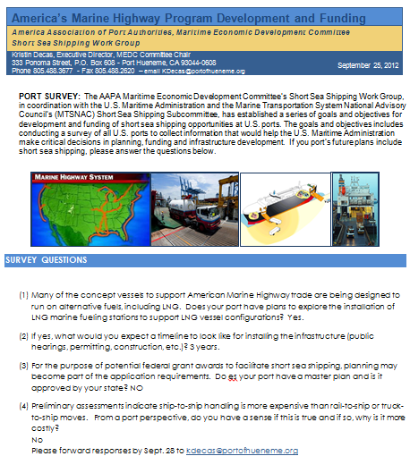

Transportation Research Board (TRB)
Phase II efforts in follow-up to the TRB NCFRP Report 5, North American Marine Highways - Texas Transportation Institute, September 2012
Scope: The objective of the research is to develop a business case for transporting a larger share of chlorine and anhydrous ammonia shipments via the marine highway system than is currently shipped via water. The business case should consider at least the following issues: market definition; return on investment; obstacles; impacts on other modes and their likely reactions; labor issues; environmental concerns and benefits directly related to the transport of the two commodities; risks; regulatory, security, infrastructure, and vessel requirements; transportation congestion impacts; and lessons learned from international experience (e.g., Marco Polo/Smart Rivers). Funding Level: $199,720. The report has been approved and published. You can access it at http://onlinepubs.trb.org/onlinepubs/ncfrp/ncfrp_rpt_018.pdf.

NCFRP Report 5, North American Marine Highways, August 2010. “TRB’s National Cooperative Freight Research Program (NCFRP) Report 5: North American Marine Highways explores the potential for moving intermodal containers on chassis, non-containerized trailers, or rail cars on marine highways in North America. The report includes an assessment of the conditions for feasibility; an analysis of the economic, technical, regulatory, and logistical barriers inhibiting greater use of the marine highway system; and potential ways to eliminate these barriers. One of the more interesting findings from this research effort is that marine highway ventures of varying distances have the potential for viability. Thus, the conventional wisdom that marine highway operations are viable only at distances equal to, or greater than, those that are viable for intermodal rail is not correct. On the contrary, successful operations have been carried out on routes as short as “across the bay” and as long as more than 1,000 mi. More importantly, the researchers concluded that there is no critical distance for determining whether a particular venture will be successful. The specific geographic features of each service must be considered, including the alternative landside distances and connections.” The full report is available at the following link: http://www.trb.org/MarineTransportation1/Blurbs/North_American_Marine_Highways_163938.aspx

NCFRP 34 [RFP], Evaluating Alternatives for Landside Transport of Ocean Containers. Funds: $300,000, Contract Time: 15-months. RFP Due: 12/9/2010
BACKGROUND: An efficient and robust freight transportation system is essential to the continued economic well-being of the United States. One vital segment of the system is the deep-water ocean port, which, according to the U.S. Maritime Administration, handled 25 million loaded import or export containers in 2009. Both the highway and rail systems at deep-water ocean ports are congested in peak periods, as few were designed to handle current container volumes, much less future growth. Various projections show a doubling of containers by 2030, and this has led to a call for more freight infrastructure capacity. However, port expansion and cargo growth depends, to a large degree, on community acceptance, which in turn depends on reducing current adverse impacts from container transportation and mitigating future impacts. As a result, communities around the ports have called for alternative ways to move containers, especially ways that are perceived to be more environmentally friendly than diesel, or approaches that lessen highway congestion by separating freight transport from passenger transport. However, many have questioned whether some of the proposed alternatives are technically feasible, and if so, can they serve multi-site networks and mesh with the legacy port, highway, and rail operations? Research is needed to develop an objective methodology that compares the various alternatives to transport ocean containers to and from port terminals that is unbiased, provides equitable benefit/cost measurement factors (including port efficiency), and considers the entire container drayage scenario, from or to an inland location up to 100 miles distant from the deep-water ocean port.
OBJECTIVE: The objective of this research is to develop a systematic methodology that can be used to evaluate alternatives for ocean container transport to or from deep-water ocean ports and inland destinations within 100 miles. The full RFP can be found at http://apps.trb.org/cmsfeed/TRBNetProjectDisplay.asp?ProjectID=2922
HMCRP HM-12 [Pending], Hazardous Materials Transportation Risk Assessment: State of the Practice. Funds: $200,000, Contract Time: 12-months.
BACKGROUND: Hazardous materials transportation risk assessments are often designed for different purposes and used in different ways by government agencies and the private sector. There are a number of models/methodologies used in each sector, from simplified to extremely complex, that have varying data needs and make varying degrees of assumptions. Different assessment tools and approaches may be applicable to only specific transportation scenarios, activities, or purposes. In addition, many of the assessments address single modes of transportation, and there are few published methods to adequately compare risk across modes or in combinations of modes. There is a need for the government sector to better understand how the private sector performs and uses risk assessments and risk management and for the private sector to appreciate government needs in regulating hazardous materials in transport.
OBJECTIVES: The objectives of this project are to (a) identify existing tools, methodologies, approaches, and key sources of data for assessing hazardous materials transportation risks in the public and private sectors; (b) characterize the capabilities and limitations of each; (c) identify where there are significant gaps and needs in the available tools and approaches; and (d) recommend paths forward. Transportation risks of particular concern relate to acute releases of significant quantities of hazardous materials for all modes of transportation. This report has been completed and published. And can be found at http://onlinepubs.trb.org/onlinepubs/hmcrp/hmcrp_rpt_012.pdf

MTS Matters
Contact Paul Bea at pbea@phbpa.com
Dear Friends of the Marine Highway... July 3, 2013". Dear Friends of the Marine Highway..." arrives gratis from Paul Bea and PHB Public Affairs, a government relations and policy advisor on port and other marine transportation system matters. PHB Public Affairs

SECTION 7 - HISTORICAL REFERENCES AND PROGRAMS DEVELOPMENT

Current Highlights:
- U.S. Senator Frank R. Lautenberg's bill to authorize the Maritime Security Program for the Maritime Administration (MARAD) was signed into law when President Obama signed the National Defense Authorization Act, January 4, 2013
- Coast Guard and Maritime Transportation Act of 2012 - H. R. 2838 Amendments to Title IV – Maritime Administration Authorization, December 20, 2012

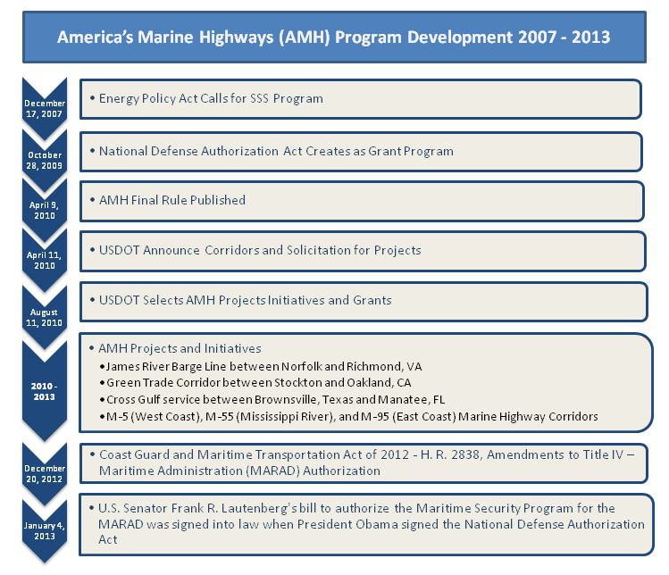

List of articles which follow:
- Energy Independence and Security Act of 2007 – December 17, 2007
- National Defense Authorization Act for Fiscal Year 2010, H.R. 2647 – October 28, 2009
- AMH Program Development – April 9, 2010
- Department of Transportation Announces Selection of Marine Highway Corridors, Projects, Initiatives, and Grants as Part of America’s Marine Highway Program – August 11, 2010
- Coast Guard and Maritime Transportation Act of 2012 - H. R., December 20, 2012
- Lautenberg Bill Signed into Law to Reauthorize American Maritime Program, January 4, 2013
Energy Independence and Security Act of 2007 – December 17, 2007
The Energy Independence and Security Act of 2007 (Pub.L. 110-140), originally named the CLEAN Energy Act of 2007) was signed into law on December 17, 2007. The stated purpose of the act is “to move the United States toward greater energy independence and security, to increase the production of clean renewable fuels, to protect consumers, to increase the efficiency of products, buildings, and vehicles, to promote research on and deploy greenhouse gas capture and storage options, and to improve the energy performance of the Federal Government, and for other purposes.”
Under this law, Short Sea transportation is defined as commercial waterborne transportation that originates at a port in the United States and ends at another port in the United States or at a port in Canada located in the Great Lakes Saint Lawrence Seaway System. The same definition applies for the case where origination and end points are reversed. The law directs DOT to establish a short sea transportation program and designate short sea transportation projects to be conducted under the program to mitigate landside congestion. Short sea shipping activities are made eligible for support from DOT’s capital construction fund.

National Defense Authorization Act for Fiscal Year 2010, H.R. 2647 – October 28, 2009
Legislation written by Sen. Frank R. Lautenberg (D-NJ) to reduce congestion on America's roads and to reauthorize the Maritime Administration (MARAD) was signed into law on October 28, 2009 by President Obama as part of the FY 2010 Defense Department Authorization Act, H.R. 2647 (http://frwebgate.access.gpo.gov/cgi-in/getdoc.cgi?dbname=111_cong_bills&docid=f:h2647enr.txt.pdf)
The new law creates a grant program for 'America's Marine Highways' to encourage shipping by sea or inland waterway and establishes a new program to modernize port facilities. SEC. 3512. PORT INFRASTRUCTURE DEVELOPMENT PROGRAM, SEC. 3515. AMERICA’S SHORT SEA TRANSPORTATION GRANTS FOR THE DEVELOPMENT OF MARINE HIGHWAYS and SEC. 3516. EXPANSION OF THE MARINE VIEW SYSTEM all addresses aspects of marine transportation.

AMH Program Development – April 9, 2010
On April 9, 2010, the Department of Transportation announced, "Federal Officials Announce Program to Expand Use of America’s Marine Highways - Government to Promote Waterways to Cut Emissions and Reduce Highway Traffic." Potential sponsors and marine highway operators can view the Final Rule (MARAD2-2010-0035) on Regulations.gov.
This final rule is effective April 9, 2010. Potential sponsors and marine highway operators can view the Final Rule (MARAD2-2010-0035) on Regulations.gov. For further information contact: Michael Gordon, Office of Intermodal System Development, Marine Highways and Passenger Services, at (202) 366-5468, via e-mail at michael.gordon@dot.gov, or by writing to the Office of Marine Highways and Passenger Services, MAR-520, Suite W21- 315, 1200 New Jersey Avenue, SE., Washington, DC 20590.
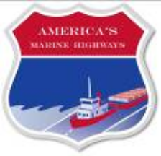

Department of Transportation Announces Selection of Marine Highway Corridors, Projects, Initiatives, and Grants as Part of America’s Marine Highway Program – August 11, 2010
On August 11, 2010, U.S. Transportation Secretary Ray LaHood identified 18 marine corridors, 8 projects, and 6 initiatives for further development as part of “America’s Marine Highway Program.”
Coast Guard and Maritime Transportation Act of 2012 - H. R. 2838
December 20, 2012 (See Section 4 – Legislative Updates for details)
Lautenberg Bill Signed into Law to Reauthorize American Maritime Program
Lautenberg Press Office, 202-224-3224, Friday, January 04, 2013
WASHINGTON, DC—Earlier this week, U.S. Senator Frank R. Lautenberg's bill to authorize the Maritime Security Program for the Maritime Administration (MARAD) was signed into law when President Obama signed the National Defense Authorization Act. The remainder of Senator Lautenberg's provisions to reauthorize federal maritime programs carried out by MARAD were signed into law in December when President Obama signed the Coast Guard and Maritime Transportation Act. Lautenberg is Chairman of the Commerce Subcommittee on Surface Transportation and Merchant Marine Infrastructure, Safety, and Security, which has jurisdiction over the MARAD. “Federal maritime programs are critical to our nation's economy and security, and I am pleased that Congress has reauthorized and strengthened these programs,” said Senator Lautenberg. “These laws move our maritime industry forward by expanding critical programs and ensuring a strong merchant marine to supply our troops with the equipment and supplies they need.”
The provisions that Lautenberg authored in the National Defense Authorization Act and the Coast Guard and Maritime Transportation Act that will authorize MARAD funding include:
- Providing certainty to the Armed Services and ship owners by reauthorizing the Maritime Security Fleet Program through 2025;
- Promoting and strengthening short sea shipping in the Marine Highways Program to move more cargo on the sea rather than on crowded highways; and
- Fostering innovation in the maritime sector and providing infrastructure and workforce to make sure our system is prepared for the future.
MARAD administers the U.S. merchant marine support programs, including operation of the U.S. Merchant Marine Academy, to promote the development and maintenance of an adequate, well-balanced U.S. merchant marine sufficient to carry the nation’s waterborne freight and capable of service as a naval and military auxiliary in time of war or national emergency.

SECTION 8 – CURRENT EVENTS
I
Current Highlights:
- New player enters US-Mexico short-sea market, October 19, 2014
- Low-sulfur mandate brings carrier surcharges, service closures, September 19, 2014
- MARAD - Open Season in June for Marine Highway Projects, June 5, 2014
- Key Senator pledges to defend 1920 law on domestic shipping industry; April 9, 2014

List of articles which follow:
- DOT faces cross-border trucking decision as US-Mexico trade grows
- New player enters US-Mexico short-sea market
- Profit motive behind oil refiners’ Jones Act attack: US maritime leader
- Low-sulfur mandate brings carrier surcharges, service
- Aker Philadelphia Shipyard and Financial Sponsors, Including American Shipping Company and Funds Affiliated with Apollo Global Management, Create Pure Play Jones Act Shipping Company, Philly Tankers
- Reefers on Barges? You Bet, in California
- Senate Appropriations Passes THUD Bill
- MARAD - Open Season in June for Marine Highway Projects
- Reefers on Barges? You Bet, in California
- AAPA Speaks at MARAD Strategic Plan Symposium
- Key Senator pledges to defend 1920 law on domestic shipping industry
- U.S. Transportation Secretary Foxx Names New Members to Maritime Industry Advisory Panel
- President Obama, DOT Secretary Foxx Announce $600 Million for Sixth Round of TIGER Funding
- Busy Week in Washington for Transportation Infrastructure Investment
- Totem Ocean chooses Wärtsilä technology for largest LNG ship conversion in North America
- Marad Says It Identified US-Flag Vessels for Salt Transport to NJ
- USDOT preps for TIGER VI funding round
- Maritime law holding up crucial salt supply for New Jersey highways

DOT faces cross-border trucking decision as US-Mexico trade grows
William B. Cassidy, Senior Editor | Oct 21, 2014 10:22AM EDT JOC
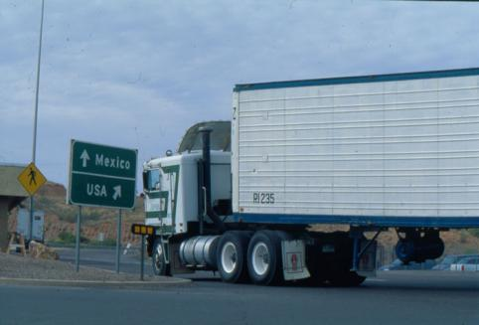
The book is closed on a three-year cross-border trucking pilot project with Mexico but the debate over the project and its findings is far from finished. The question hanging over the increasingly busy U.S.-Mexican border is what steps the U.S. will take next to meet its North American Free Trade Agreement obligations and avoid a renewed economic conflict with its second-largest trading partner.
Federal regulators will meet with a trucking industry advisory committee Oct. 28 in Alexandria, Virginia, to discuss the results of the pilot project, which began in 2011 and ended Oct. 10. The pilot replaced an earlier Bush-era test program shut down in 2009 and led to the lifting of more than $2.4 billion in punitive tariffs Mexico imposed on U.S. goods.
However, the pilot project attracted very few Mexican carriers. For now, the tractor-trailers operated by the 13 Mexican trucking companies that participated in the program will continue to roll across the border and operate within the U.S. beyond the border commercial zone, as the Federal Motor Carrier Safety Administration decides whether to grant the carriers permanent U.S. authority.
“Prior to making any additional determinations regarding cross-border trucking issues or specific carriers, the Department of Transportation will await expected reports on the pilot program from the Motor Carrier Safety Advisory Committee and the DOT Inspector General,” a spokesperson for the federal trucking safety agency said in an e-mail. Until then, the Mexican carriers in the pilot project will have provisional or standard U.S. authority, she said.
Through the project, those carriers received authority to carry freight beyond the border commercial zone to destinations throughout the U.S. and to haul freight back to Mexico, but not U.S. destinations. However, the trucking firms that enrolled in the project were hardly a drop in the proverbial bucket when it comes to total cross-border truck traffic between the U.S. and Mexico.
The pilot project carriers operated a total of 55 vehicles and employed 53 drivers, according to FMCSA data. In 2013, commercial trucks made 5,194,867 border crossings between the Mexico and the U.S., a 1.8 percent increase over 2012, according to the U.S. Bureau of Transportation Statistics. From 2011-2013, the BTS logged a total of 15,167,166 truck crossings.
In a 36-month period, the 13 carriers in the pilot project made 27,915 border crossings, according to the FMCSA — less than two-tenths of one percent of the total number of truck crossings logged by the BTS for 2011-2013. What’s more, one of the carriers, Servicio de Transporte Internacional, accounted for 72 percent of the pilot project border crossings.
Should more Mexican carriers be allowed to apply for U.S. authority under terms comparable to those in the pilot project? That question will be hotly debated. The Teamsters union and the Owner-Operator Independent Drivers Association opposed the pilot project strenuously, though they weren't able to block it. The Mexican trucking association, Canacar, threatens to seek billions of dollars in damages from the U.S. government for not fulfilling its NAFTA obligations, according to Transporte.mx.
There’s a clear need for a better way to move freight across the U.S.-Mexican border, where shippers, carriers and logistics companies face both congestion and short capacity, thanks to the imbalance in northbound and southbound loads. That imbalance, however, may be one reason few Mexican carriers were willing to join the pilot project and haul freight well beyond U.S. border states to destinations where Mexican-bound freight might be scarce.
If only one southbound load is available for two to three or even four northbound loads from Mexico, Mexican carriers aren’t likely to send drivers too far into El Norte without guarantee of a backhaul. “They don’t have sales forces in the U.S.,” who could find those southbound loads, and they can’t haul domestic freight within the U.S., said Troy Ryley, managing director of Transplace de Mexico, the Mexican arm of U.S. third-party logistics provider Transplace.
“I’ve also heard that there was a huge concern about U.S. liability exposure,” Ryley said. “They had and continue to have more than enough business in Mexico, why would they venture into U.S. markets at this time?” he said. “This is a good time to be a Mexican trucker.”
The U.S. and Mexico hope to speed cargo across the border through an agreement that seeks to increase collaboration between the nations’ customs agencies. The agreement, signed last week, would benefit shippers and carriers recognized as “trusted traders” — such as such as members of the Customs-Trade Partnership Against Terrorism in the U.S. The U.S. and Mexican customs agencies expect to implement the plan in 2015.
Truck traffic, however, is increasing now. The number of truck crossings in July rose 5.8 percent and the value of goods carried by truck rose 8.8 percent, BTS data show.
More of that congested cross-border truck freight may shift to intermodal rail. Kansas City Southern Railway is investing in cross-border expansion as intermodal and carload traffic across the Mexican border increases. In the third quarter, KCS intermodal and carload revenue hit a $167 million record, the company said Friday. That’s a 14 percent increase, the company said. Automotive business accounted for 79 percent of KCS cross-border traffic.
There’s even a new short-sea shipping service connecting the Mexican Gulf Coast Port of Coatzacoalcos, in the state of Veracruz, and Port Manatee, Florida. Starting this month, World Direct Shipping will offer weekly, 2 1/2 day transit time service using an 862-TEU ship.
As more automotive and white goods manufacturers locate production facilities in Mexico, the need for more diverse cross-border transportation options will only increase.

New player enters US-Mexico short-sea market
JOC Staff | Oct 19, 2014 12:54PM EDT JOC
Growing U.S.-Mexico trade has attracted a new player into the sparse short-sea market connecting the two countries, with a service aimed at the U.S. Southeast market for northbound cargo.
The service being introduced by World Direct Shipping will offer weekly, 2 1/2 day transit time service between the Port of Coatzacoalcos, in the southern part of the Mexican state of Veracruz, and Port Manatee, Florida. Beginning on Oct. 18, the service will commence using a single-geared 862-TEU ship with 204 refrigerated plugs.
World Direct Shipping, based in Palmetto, Florida, is banking on the idea that a relatively fast transit time and accessible connections from Manatee into the eastern U.S. will attract a range of cargoes including pineapples, avocados, limes, mangos and bananas that can better move by water versus rail or truck.
The service “builds upon Port Manatee’s long history of successfully handling refrigerated products ― with the largest such capacity on the west coast of Florida ― as well as Port Manatee’s cross-Gulf closeness to Mexico,” said Carlos Buqueras, Port Manatee’s executive director, in a statement.
“Our short transit times and frequency is ideal for perishable cargo and for those customers that need more reliability and less handling than conventional over the road trucks can provide,” World Direct Shipping says on its website.
The carrier says advantages to the service include ability to ship with more cargo weight, more consistent reefer temperatures than refrigerated trailers use in overland movements and inland trucking distances minimized, thus reducing potential risks to cargo and weekly frequency that is “more consistent than even the most reliable over land truckers.”
U.S.-Mexico waterborne transport has an inconsistent history. International Shipholding Corp. offers a rail-ferry service moving railcars between Mobile, Alabama, and Coatzacoalcos departing every four days on a three-day transit. The trade is “primarily driven by commodities such as forest products, sugar, metals, minerals, plastics and chemicals,” ISC says on its website.
Höegh Autoliners offered a weekly service in the early 2000s but it was discontinued. “The history of short sea services between the U.S. and Mexico is complex and inconsistent, with a series of starts and stops over the last decade or more,” the company said in a 2003 article in Automotive Logistics.
But near-shoring and the growing U.S. economy are generating growing freight volume between the two countries moving by truck and rail. Charts on the JOC.com NAFTA dashboard show the expanding volumes this year.

Profit motive behind oil refiners’ Jones Act attack: US maritime leader
Joseph Bonney, Senior Editor | Oct 08, 2014 8:16PM EDT JOC
U.S. oil refiners want to eliminate the Jones Act’s U.S.-flag requirements for domestic shipping “for only one reason – so refiners can make even larger profits,” said Tom Allegretti, president of the American Waterway Operators.
Allegretti, chairman of the American Maritime Partnership, which represents U.S. domestic maritime companies, defended the 1920 law in a speech to TradeWinds’ Jones Act Forum.
He said comparisons of U.S. domestic and non-U.S. shipping rates are “apples to oranges.”
“American companies are subject to different, more expensive and extensive laws than foreign shipping companies,” Allegretti said. “Once you start adding in the cost of complying with U.S. regulations like wage and hour laws, immigration laws, and tax laws, suddenly the cost differential between U.S. and foreign vessels starts to disappear,”
He disputed criticism of the Jones Act by Charles T. Drevna, president of the American Fuel & Petrochemical Manufacturers. Drevna said in a recent interview with Platts that “after 94-plus years now it’s time to take a look at this thing and see how the Jones Act… and the economic realities of 1920, fit in with the economic realities of 2014.”
Allegretti said the average retail cost of a gallon of gasoline attributable to use of a Jones Act vessel “is one cent or less per gallon.” He questioned why “the American maritime industry, alone among domestic industries, should be outsourced to foreign interests and foreign workers that would not be subject to U.S. laws.”
He said Drevna seemed to be suggesting that, “We’ll replace all the American workers with foreign workers, pay them third-world wages, and see if we can’t reduce the cost of domestic shipping. And when we are done with shipping, perhaps we can do the same with Drevna’s refineries. Then eventually we can replace all American workers with cheaper foreign workers.”

Low-sulfur mandate brings carrier surcharges, service closures
Bruce Barnard, Special Correspondent | Sep 19, 2014 12:26PM EDT JOC
DFDS, one of Europe’s largest short sea-shipping and logistics operators, this week announced plans to close a second route in response to tougher environmental regulations that will sharply increase the cost of ships’ fuel from 2015.
This was followed by the decision of Unifeeder, a leading container feeder line, to impose a surcharge of 65 euros ($84) per container to recoup the extra cost of switching to low-sulfur fuel.
Further route closures and surcharges are expected in the coming weeks as carriers prepare to comply with an International Maritime Organization regulation compelling ships to burn fuel with a maximum 0.1 percent sulfur content, compared with the current 1 percent ceiling when they sail through emission control areas (ECAs) covering the Baltic Sea, the North Sea and the English Channel.
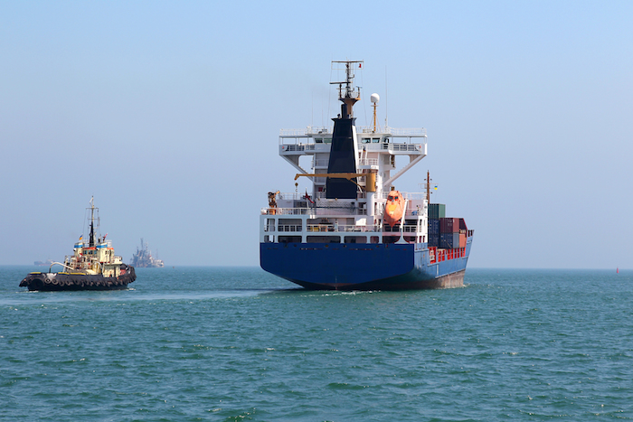
The regulation, which comes into effect Jan. 1, will also impact North Atlantic traffic, as the ECAs also stretch 200 nautical miles from the U.S. and Canadian coasts.
The 0.1 percent low-sulfur marine gas oil is around $300 a tonne, or 50 percent, cheaper than 1 percent sulphur fuel.
DFDS said it intends to close the Le Havre-Portsmouth (U.K.) service at the end of the year because it “does not have a viable future” because of the tougher sulfur emission limits. The service has been losing money since DFDS took it over in 2012, and cost-cutting measures have had a limited effect.
The closure of the U.K.-France route follows the shuttering of a service this month between Esbjerg, Denmark, and Harwich, U.K. DFDS said it is weighing the future of up to seven routes ahead of the new low -sulfur limits, which it claims will lead to bankruptcies of carriers and the loss of cargo to road transport.
Unifeeder told shippers its planned sulfur surcharge will be independent of its existing bunker adjustment factor. “In northern Europe, Unifeeder vessels operate exclusively in the sulfur emission control area, and the new legislation will therefore have a direct impact on the type of fuel that we can use,” the company said.
Earlier this week, Mediterranean Shipping Co became the first deep-sea carrier to publish low-sulfur charges, with shippers on the Canada-Baltic route facing the highest charge of $165 per 20-foot container. MSC, which deploys the largest trans-Atlantic fleet by capacity, will impose a $130 per TEU surcharge for U.S.-Baltic shipments.
Maersk has said its surcharges will vary between $50 and $150 per container depending on the trade. Hapag-Lloyd also is planning to unveil surcharges closer to the implementation of the low-sulfur regulation.
The North Atlantic and North Europe surcharges are considerably higher than analysts’ forecasts. Drewry Maritime Research in London put the cost of compliance at $29 per TEU for a North Europe-U.S. East Coast voyage, $49 per TEU for shipments on the Europe-U.S. Gulf Coast route and $21 per TEU for a typical round-trip voyage between Hamburg and St.Petersburg.
The low-sulfur surcharges are the latest financial hits to short-sea shippers who have faced congestion surcharges for containers transported to and from Rotterdam and trucking surcharges in Hamburg.
The Baltic trade, in particular, has suffered the most with traffic on key Russian routes slumping because of tit-for-tat sanctions imposed by the European Union and the Kremlin over the Ukraine crisis.
DFDS suspended a route between Travemunde, Germany, and Klaipeda, Lithuania, in early August, just months after it launched the service.

Aker Philadelphia Shipyard and Financial Sponsors, Including American Shipping Company and Funds Affiliated with Apollo Global Management, Create Pure Play Jones Act Shipping Company, Philly Tankers
June 10, 2014 1:00 AM EDT StreetInsider.com | Aker Philadelphia Shipyard - Kelly Whitaker
Highlights
- Philly Tankers established to provide pure play exposure toward Jones Act shipping market with firm contracts for two eco-design product tanker newbuilds and options for two additional vessels
- Vessels will be built by Aker Philadelphia Shipyard with deliveries of the initial two vessels in Q4 2016 and Q1 2017 and deliveries of the two option vessels in Q3 2017 and Q4 2017
- Philly Tankers has ambitions to grow through a combination of additional newbuilds, acquisitions of existing vessels, and participation in expected market consolidation
- Corporate structure suitable for future transformation to a Master Limited Partnership (MLP), potentially offering significant value enhancement
- Philly Tankers to be listed on the Norwegian OTC by mid-July 2014 with goal of a U.S. listing by mid-2016
- Aker Philadelphia Shipyard to invest USD 58.5 million in Philly Tankers for 54% of the company, gaining additional shipping exposure in-line with Aker Philadelphia Shipyard’s previously communicated strategy
- Philly Tankers’ sponsors to invest USD 59.0 million in Philly Tankers for the remaining 46% of the company, and include American Shipping Company (OSE: AMSC), funds managed by affiliates of Apollo Global Management, LLC (NYSE: APO) and other U.S. institutional investors
OSLO, Norway--(BUSINESS WIRE)-- Aker Philadelphia Shipyard ASA (OSE: AKPS) is pleased to announce the planned establishment of Philly Tankers AS, a Norwegian limited liability company, and its wholly-owned subsidiary, Philly Tankers LLC, a Delaware limited liability company (together “Philly Tankers”). Philly Tankers has successfully secured equity commitments necessary to finance the purchase of two product tankers from AKPS with deliveries in 2016 and 2017 (the “Transaction”), and will have a post-money market capitalization of USD 127.5 million. Together with best-in-class partners, Philly Tankers will operate and charter the vessels in the Jones Act market.
“We are delighted to see so much interest in Philly Tankers. The company offers pure-play exposure to an increasingly strong market and is targeting growth through a combination of newbuilds, acquisitions of existing vessels, and potentially through market consolidation,” says Kristian Rokke, Chairman of AKPS. “There are two key trends currently shaping the Jones Act market – the tight oil revolution, which has increased demand for product tankers, and a surge in containership orders, which has constrained shipyard capacity. Philly Tankers is well positioned to benefit from the effects of these trends by offering customers modern tonnage in a supply constrained market, as well as reliable operations and substantially improved fuel-efficiency versus the existing fleet.”
As part of the Transaction, AKPS will invest USD 58.5 million for 54% of the shares, which AKPS expects to fund through existing cash and proceeds from operations. The remaining sponsors will invest USD 59.0 million for 46% of the shares at a subscription price of USD 1,000.00 per share.
AKPS and Philly Tankers, through their U.S. subsidiaries, will enter into binding shipbuilding contracts for the first two product tankers, designated as AKPS Hulls 025-026. The total contract value is approximately USD 250 million, excluding construction period financing, initial owner expenses, G&A, and transaction costs. The anticipated profitability of the shipbuilding project for AKPS is in-line with previous guidance for AKPS Hulls 021-030. An option agreement will also be signed for two identical product tankers with deliveries in 2017, designated as AKPS Hulls 027-028, on substantially the same terms and conditions as AKPS Hulls 025-026.
The vessels will be 50,000 dwt product tankers based on a proven Hyundai Mipo Dockyards (HMD) design that incorporates numerous fuel efficiency features, flexible cargo capability, and the latest regulatory requirements. The vessels will be constructed with consideration for the use of LNG for propulsion in the future. The vessels will be identical to the vessels currently under construction at AKPS that will be included in the AKPS-Crowley joint venture.
Philly Tankers expects to hire a best-in-class technical operator prior to delivery of the first vessel to arrange for maintenance and crewing of the vessels, and to ensure that the vessels satisfy all regulatory requirements, among other things. Philly Tankers has a number of attractive options for commercial management and will consider all its alternatives when seeking and arranging employment for the vessels.
Prior to delivery of the first vessel, Philly Tankers will have an ownership and corporate structure that is fully compliant with all applicable Jones Act requirements. Philly Tankers will explore value-enhancing initiatives such as the establishment of a Master Limited Partnership. Philly Tankers will have a Board of Directors comprised of independent and investor-designated members. Philly Tankers will initially list its shares on the Norwegian OTC, with a target of a U.S. listing by mid-2016.
Closing of the Transaction remains subject to satisfaction of customary conditions precedent, including the execution and delivery of satisfactory definitive documentation, and the approval by the general meeting of American Shipping Company of its participation in the Transaction. It is expected the Transaction will be closed in mid-July 2014.
Arctic Securities and Pareto Securities have acted as Joint Lead Managers for the Transaction. Advokatfirmaet BA-HR DA and Blank Rome LLP have acted as legal adviser to AKPS in connection with the private placement. Wiersholm has acted as the legal adviser to the Joint Lead Managers.
Aker Philadelphia Shipyard is a leading U.S. commercial shipyard constructing vessels for operation in the Jones Act market. It possesses a state-of-the-art shipbuilding facility and has earned a reputation as the preferred provider of oceangoing merchant vessels with a track record of delivering quality ships. Aker Philadelphia Shipyard is listed on the Oslo Stock Exchange and is majority-owned by Converto Capital Fund, which in turn is majority-owned by Aker ASA. Aker is a Norwegian industrial investment company that creates value through active ownership. Aker's investment portfolio is concentrated on key Norwegian industries that are international in scope: oil and gas, fisheries and biotechnology, and marine assets. Aker's industrial holdings comprise ownership interests in Aker Solutions, Kvaerner, Det norske oljeselskap, Aker BioMarine, Ocean Yield and Havfisk.

Important information about this release
This information is subject to disclosure under the Norwegian Securities Act, Section 5-12.
This release includes and is based, inter alia, on forward-looking information and statements that are subject to risks and uncertainties that could cause actual results to differ. Such forward-looking information and statements are based on current expectations, estimates and projections about global economic conditions, the economic conditions of the regions and industries that are major markets for Aker Philadelphia Shipyard ASA and its subsidiaries and affiliates (the "Aker Philadelphia Shipyard Group") lines of business. These expectations, estimates, and projections are generally identifiable by statements containing words such as "expects”, "believes”, "estimates" or similar expressions. Important factors that could cause actual results to differ materially from those expectations include, among others, economic and market conditions in the geographic areas and industries that are or will be major markets for the Aker Philadelphia Shipyard Group’s businesses, oil prices, market acceptance of new products and services, changes in governmental regulations, interest rates, fluctuations in currency exchange rates and such other factors as may be discussed from time to time.
Although Aker Philadelphia Shipyard ASA believes that its expectations and the information in this press release were based upon reasonable assumptions at the time when they were made, it can give no assurance that those expectations will be achieved or that the actual results will be as set out in this press release. Neither Aker Philadelphia Shipyard ASA nor any other company within the Aker Philadelphia Shipyard Group is making any representation or warranty, expressed or implied, as to the accuracy, reliability or completeness of the information in the press release, and neither Aker Philadelphia Shipyard ASA, any other company within the Aker Philadelphia Shipyard Group nor any of their directors, officers or employees will have any liability to you or any other persons resulting from your use of the information in the press release.
Aker Philadelphia Shipyard ASA undertakes no obligation to publicly update or revise any forward-looking information or statements in the press release, other than what is required by law.

Senate Appropriations Passes THUD Bill
AAPA News Alert: Thursday, June 05, 2014 2:02 PM
This morning the Senate Committee on Appropriations passed its FY 2015 Transportation, Housing and Urban Development and Related Agencies (THUD) Appropriations Bill.
The bill includes $550 million for TIGER grants. Chairwoman Barbara Mikulski (D-MD), Chairwoman of the full Appropriations Committee, reiterated her intent to move the appropriations bill in regular order (13 appropriation bills without a continuing resolution). The Senate THUD bill could be on the Senate Floor as early as the week of June 15th, Chairwoman Mikulski said.

MARAD - Open Season in June for Marine Highway Projects
AAPA News Alert: June 05, 2014
The Maritime Administration (MARAD) announced in the Federal Register this week (Vol. 79, No. 105 / Monday, June 2, 2014) that it is now Open Season on Marine Highway Projects. Applications will be accepted through June 30 and project review will complete by September 30.
MARAD’s Notice states that the purpose of the open season is to to “seek eligible Marine Highway projects that may establish new or enhance existing Marine Highway services.” Eligible projects may be designated as Marine Highway Projects by the Secretary of Transportation, allowing Department of Transportation resources to be used to assist public project sponsors, ports, and other local transportation or economic development agencies in the development. While there is currently no money available for grants, MARAD is taking applications for possible future funding, which may also be useful with a TIGER grant.
To be eligible for Marine Highway Project status, the proposed project must (1) use U.S. documented vessels, (2) transport passengers, containerized freight, or trailer-based freight, and (3) operate on a designated Marine Highway Route.
Since the last call for Marine Highway projects on April 15, 2010, the scope of the Marine Highway Program has been expanded to include all of the United States domestic marine transportation system. Previously, the Program only included waterways that paralleled landside transportation routes, and thus, excluded routes between the mainland and non-contiguous ports.
The Federal Register Notice provides full eligibility and application details.

Reefers on Barges? You Bet, in California
Stephanie Nall, Cool Cargoes Editor | May 14, 2014 10:57AM EDT JOC
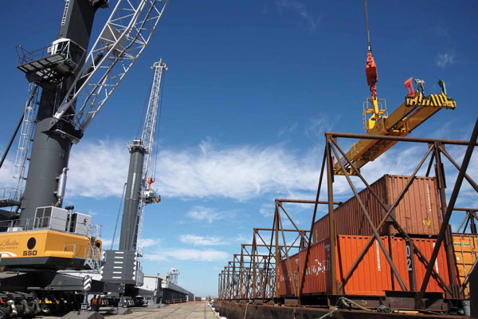
Meat and produce exporters looking to bypass California’s 22-metric-ton weight limit on over-the-road shipments soon may be able to ship overweight containers to the Port of Oakland by barge.
A businessman who owns a cold storage facility at the Port of Stockton says he’s prepared to pay for reefer plugs on two river barges that serve the ports of Oakland, Stockton and West Sacramento.
Mike Girdner, director of M&L Commodities, said the port handles a considerable volume of exports. M&L’s 5 million-cubic-foot warehouse, which opened in April 2009, is operated by Lineage Logistics.
“Lineage is anxiously awaiting the time when we can put refrigerated containers on the barge and send them down to Oakland and not dray them down,” Girdner said.
Barge service began last May, but no refrigerated cargoes can be loaded because there are no reefer plugs to maintain proper temperatures during the eight-hour river voyage.
The ports of Oakland, Stockton and West Sacramento received a total of $30 million from the federal government in March 2010 for the service and used the funds to strengthen docks, buy and rebuild the barges, and install container cranes in terminal yards. The Port of Stockton was designated as the operator of the joint project.
“When we looked at the cost of setting up the plugs in the terminal yard and to energize the terminal, we decided to focus on the dry cargo aspect,” said Mark Tollini, Stockton’s senior deputy port director.
The port used part of its $13.5 million federal grant to install two cranes and buy two used construction barges. The port spent another $2 million to convert them into container barges but didn’t include reefer plugs on any of the container slots. One barge can carry 216 40-foot boxes, the other, 140 40-foot boxes.
“When we started that process, there were no known opportunities for refrigerated cargo,” Tollini said. “The cold side was not large and looming. We do have M&L Commodities here at the port, and I think they would like to have the service option, but at the time we were setting up the barge program, the line to use the service was admittedly very short.”
Port officials were quoted in 2010 and 2011 as saying the barge service would benefit produce growers in California’s Central Valley as an export tool. They also touted the on-port warehouse facility and how meat exporters could use it to export containers without worrying about highway weight restrictions. But in an April interview, Tollini said refrigerated service was never considered as part of the barge service start-up.
He said the port doesn’t have funds available to install reefer plugs on the barges, but noted there is an even bigger hurdle to adding refrigerated service. “Right now, it’s more the cost of putting plugs in the yard than on the barge,” Tollini said.
Girdner said the lack of plugs in the port’s container yard isn’t a factor that should hold up service. His warehouse is on port property next to the docks and he already has installed 50 reefer plugs in the warehouse portion of the terminal yard. “Our plan is to go up to 200 plugs at the Lineage facility. The 50 is just the first phase of plugs,” he said.
Retrofitting the barges would involve a fairly simple process of putting a generator or power pack inside a container, Girdner said. Power cords could be threaded through the cell rack to each reefer. In addition to the container with the generator, there would have to be a tank for diesel fuel. The reefer containers could be clustered near the power pack.
“I’m prepared to take care of putting the generator on the barge and pay for that expense,” Girdner said. “But first we need stabilization of regular service to and from the Port of Oakland. What we want is a service to Oakland terminals more than once a week — multiple times a week so we can have some confidence in making the investment.”
For now, the barge is on a weekly schedule with volume of 120 to 180 containers a week, Tollini said. “It’s a mix of imports and exports; and imports have started to pick up,” he said. “That’s been a little bit of a surprise because we always thought it would be more export-driven.”
In addition to the warehouse facility itself, Girdner has paid for a rail track extension and 50 reefer plugs in the container yard. He declined to discuss the value of the investments.
Union Pacific and BNSF railroads serve the port, and Girdner financed a rail spur that connects the mainline to the refrigerated warehouse and, in turn, to the container terminal.
The rail connection would allow shippers exporting poultry, beef or pork to send rail boxcar loads of product. It could be blast-frozen at the warehouse, transloaded into containers and taken directly to the barge without having to get on nearby roads. That allows the export containers to be loaded with significantly more product than if they must be trucked on public roads. Tollini estimates it would require five truck trips to haul to Oakland what could be placed in four containers on the barge.
Girdner said he lobbied from the beginning for the port to equip the barges with reefer plugs, but wasn’t surprised that they did not. “It’s expensive to put plugs on a barge, and refrigerated shipments are just a part of the port’s traffic,” he said. “The cargo mix in Stockton is pretty broad.”
In addition to reefer boxes moving on the barge service, Girdner said he expects to see direct calls at the port by conventional reefer vessels within the next five to 10 years. “There is potential and capacity here with deep water and plenty of room,” he said, adding that he hopes service frequency will increase within the next year, allowing reefer service to begin.
Marketing his port’s marine highway barge service has been a challenge because the idea is so new, Tollini said. “Trucking to the port is what people have done for years, and getting them to change is difficult,” he said. “No one wanted to be the first.”
But the cost of trucking is “starting to escalate, and I think the barge service will become more of an option with shippers,” Tollini said.
The barge rate is $350 each way per dry box, and it costs as much to reposition empties. “We think a $350 rate is sustainable, but of course that assumption is based on having enough volume, and right now the volumes are not high enough,” Tollini said.
The dray rate for reefer cargo from Stockton to Oakland is $630, including fuel charges, according to Steve Gardner, director of Trucking Operations at 3 Rivers Trucking. The drayage carrier specializes in produce and other perishable commodities, operating around the ports of Oakland, Los Angeles and Long Beach.
Gardner is skeptical about the barge service and said he doesn’t think it will be successful. “For the barge users, there are repositioning fees. Another factor is that import cargo is so time-dependent. Using the barge instead of the highway can add 24 to 48 hours to delivery times. Green is great, but time is more important. And trucking is cheaper.”
Another factor that could nudge some shippers off the highway and onto the river is the congestion and lengthy wait times for truckers at the Port of Oakland.
While overall truck turn times are long in Oakland, Gardner said turn times are even longer for reefer loads than dry box loads. “The situation there is terrible,” he said. “But I really think Chris Lytle has done a great job. From his very first day as executive director (last summer), there has been nothing but issue after issue after issue. “He is very accessible and really gets involved. I applaud his efforts and can’t imagine what the situation would be like if he wasn’t there.”
He said terminal operators have a different definition of turn times than truckers have. “The terminal operators say it is from pedestal to pedestal. But that doesn’t count the three hours we are in a line out in the street,” Gardner said. “For reefers, it’s two hours to six hours — that’s load in, empty out. Turn times that long are what is driving port trucker misery.”

AAPA Speaks at MARAD Strategic Plan Symposium
American Association of Port Authorities | Wednesday, May 07, 2014 2:24 PM
Yesterday, AAPA and ports throughout the country participated in a one-day meeting organized by the Maritime Administration (MARAD) that included a focus on port issues. Named the National Maritime Strategy Symposium on Domestic Shipping Opportunities, MARAD’s event was organized as part of a meeting of the Marine Transportation System National Advisory Council (MTSNAC).
The three main areas for discussion were ports, shipbuilding and domestic shipping. AAPA's Vice President of Government Relations Susan Monteverde was part of the morning panel on ports along with AAPA members Gary Lee Moore, Interim Executive Director of the Port of Los Angeles, and Vanta Coda, Executive Director of the Duluth Seaway Port Authority. Other speakers on the port panel included representatives from the American Trucking Association and the International Longshoremen's Association.
Ms. Monteverde emphasized the importance of ensuring that any national maritime strategy developed by MARAD be part of the larger national freight policy currently under development by DOT. Primary challenges identified by the panel included inadequate funding at the federal level on both the land and water sides, getting DOT and states to incorporate freight port issues as a priority in highway and TIGER funding, coordination between port, state and local officials on infrastructure needs in order to avoid outside-the-gate congestion, and community and environmental concerns.
DOT Secretary Anthony Foxx noted during his address that he is a strong supporter of ports and can guarantee the Maritime Sector that maritime will be part of the National Freight Strategic Plan.
The afternoon session offered discussion groups on ports, domestic cargo/short sea shipping, and shipbuilding, with group participants making suggestions on challenges and solutions. MARAD plans to publish the recommendations in the Federal Register to allow for further industry comment.

Key Senator pledges to defend 1920 law on domestic shipping industry
By: AJOT | Apr 09 2014 at 02:58 PM | Channel(s): Ports & Terminals
Reuters 2014.04.09: Key Senator pledges to defend 1920 law on domestic shipping industry
The United States should strengthen a century-old law designed to protect the domestic shipping industry, rather than relax it under pressure from the energy industry, the chair of the Senate Energy Committee said.
The 1920 Jones Act restricts the delivery of goods between U.S. ports to ships made in the United States and flying the country’s flags.
Mary Landrieu, a Louisiana Democrat, said defending the law is one of her top priorities and cautioned the Obama administration not to relax the statute.
“I just want to send a signal that I am going to be - and others will be - very vigilant about adhering to the Jones Act,” Landrieu said at a media event where she highlighted a study underscoring the importance of the Jones Act to Louisiana’s economy.
Landrieu is expected to face a tough re-election battle in November as she seeks a fourth Senate term. Maritime unions’ political action committees are among her major campaign contributors.
The validity of the Jones Act is back on the radar as a debate rages over whether the United States should lift its decades-old ban on the export of most crude oil - an issue that has generated heated debate in Washington the year.
Some oil refiners argue that leaving the Jones Act intact would put U.S. refiners at a disadvantage to foreign companies if the export restrictions were removed because they would still need to rely on more expensive tankers.
Landrieu supports allowing crude oil exports, but she said on Tuesday exports and the Jones Act were different issues, and that the administration had issued too many waivers to allow for the use of non-U.S.-flagged ships in recent years.
“The Department of Homeland Security routinely - and in my view abusively - approved waivers to this Jones Act,” she told reporters. “Our people have felt the negative impacts of those hastily and unnecessarily contrived waivers.”
Landrieu, who also chairs the Senate appropriations subcommittee on homeland security, was joined on Tuesday by several representatives of the U.S. shipbuilding industry.
The study cited by Landrieu was published by the Transportation Institute, a lobby group for the maritime industry, and the consulting firm PwC.
It said Louisiana ranks first among the 50 states in maritime jobs, with 54,850. One in every 83 jobs in the state is connected to the maritime industry, the study said.
Gross economic output related to the domestic maritime industry in Louisiana totaled $11.34 billion last year, it said. It was the only state with more than $10 billion in that output category.

Coast Guard Reauthorization Passes House - Coast Guard Maritime Transportation Act of 2014 (H.R. 4005)
American Association of Port Authorities| Monday, April 07, 2014 4:49 PM
Last week, the House of Representatives passed the Coast Guard Maritime Transportation Act of 2014 (H.R. 4005), which authorizes spending for the U.S. Coast Guard and Federal Maritime Commission (FMC) for two years. The bill included the following provisions of interest to ports.
- Restores the U.S. Flag requirements to 75 percent for the Food for Peace Program. In 2012, a provision was included in a transportation conference report to lower the long-standing level from 75 percent to 50 percent.
- Reauthorizes through FY 2016 appropriations to the Maritime Administration for small shipyard grant programs.
- Revises FMC terms of office and sets forth FMC conflict of interest requirements.
- Directs the Department of Transportation to submit to Congress a national maritime strategy focused on increasing the U.S. fleet, including recommendations to
(A) make United States flag vessels more competitive in shipping routes between United States and foreign ports;
(B) increase the use of United States flag vessels to carry cargo imported to and exported from the United States;
(C) assure compliance by federal agencies with chapter 553 of title 46, United States Code;
(D) increase the use of third-party inspection and certification authorities to inspect and certify vessels;
(E) increase the use of short sea transportation routes designated under section 55601(c) of title 46, United States Code, to enhance intermodal freight movements; and
(F) enhance United States shipbuilding capability
- Calls for the Government Accountability Office to study the impact of limiting liquefied natural gas (LNG) exports to U.S. flag ships once the United States lifts the ban on exports.

U.S. Transportation Secretary Foxx Names New Members to Maritime Industry Advisory Panel
PRESS RELEASE | Apr 4, 2014 JOC
WASHINGTON – U.S. Transportation Secretary Anthony Foxx today announced the appointment of 10 new members to the Marine Transportation System National Advisory Council (MTSNAC). Established in 2010, MTSNAC is comprised of leaders from commercial transportation firms, trade associations, state and local public entities, labor organizations, academics, and environmental groups that advise the Secretary on policies to ensure that the U.S. Marine Transportation System is capable of responding to projected trade increases.
“The Obama Administration is committed to ensuring that America’s ports and waterways are capable of meeting the growing demands of moving freight in the 21st century,” said Secretary Foxx. “This advisory council will help guide us as we continue to invest in American transportation and in America’s future.”
Since 2009, this Administration has awarded over $420 million in TIGER funds to 33 ports and marine highway projects. These projects are large and small – inland and coastal, and handle 75 percent of America’s exports and imports. These investments have helped the maritime industry move these exports and imports by water, waterborne transport, and maritime industrial services, which play a vital role in our nation’s economy. MTSNAC policy recommendations have led to the expansion of the Marine Transportation System, the integration of Marine Highways in the surface transportation system and the improvement and streamlining of the Title XI ship financing process.
“This Council is an excellent example of a coordinated approach with the private sector,” Acting Maritime Administrator Paul N. Jaenichen said. “Their expertise and insight inform key decisions as we work to spark growth and ensure the greater efficiency of our Marine Transportation System.”
MTSNAC is comprised of 29 members from commercial transportation firms, trade associations, state and local entities, labor organizations, academics and environmental groups. Council members will serve 2-year terms, with no more than two consecutive term reappointments, and approximately one-third of members' terms of office shall expire every 2 years.
The Department strives to select dynamic individuals with in-depth knowledge of their respective industries or government sectors. Members are nominated through a full and open process published in the Federal Register.
The new members are:
Betty Sutton, Administrator, Saint Lawrence Seaway Development Corporation (SLSDC), Washington, D.C.
William Cook, Director, Worldwide Logistics and Customs, Chrysler Group, LLC, Auburn Hills, Mich.
Wayne Darbeau, President and CEO, San Diego United Port District, San Diego, Calif.
Gary Lee Moore, Interim Executive Director, Port of Los Angeles, Los Angeles, Calif.
Captain Lynn Korwatch, Executive Director, Marine Exchange of the San Francisco Bay Region, San Francisco, Calif.
Charles Fabrikant, Executive Chairman, SEACOR Holdings, Inc., Fort Lauderdale, Fla.
Kevin Schoeben, Deputy Director, Office of Planning and Programming, Illinois Department of Transportation, Springfield, Ill.
William Friedman, President and CEO, Cleveland-Cuyahoga County Port Authority, Cleveland, Ohio
Gary Love, Vice President for Sales and Marketing at FAPS, Inc., Port Newark, N.J.
Richard Berkowitz, Director of Pacific Coast Operations, Transportation Institute, Seattle, Wash.

EPA’s Port Stakeholders Summit To Convene in April
AAPA Alert: February Roundup – March 24, 2014
A Port Stakeholders Summit will be held in the Baltimore Hilton on April 8, convened by the Environmental Protection Agency’s (EPA) Office of Transportation and Air Quality. The goal of the “Advancing More Sustainable Ports” Summit is to advance strategies that support more sustainable, cleaner and efficient ports. Participants with a shared interest in promoting healthy air in and around our nation's ports will be offered a dynamic mix of workshops, panels and presentations about innovative port-related practices, incentives and technologies.
Register online by clicking here. There is no registration fee; however, an optional meals fee of $80 will provide morning refreshments and lunch. Participants may opt not to pay this fee and their registration will provide access to sessions only.
A block of rooms is being held for conference participants at the Hilton Baltimore for April 7-8, 2014. For reservations, phone 800-HILTONS (445-8667) or reserve online at the Hilton's Port Stakeholders Summit reservation page.
The summit also includes poster sessions, and EPA would especially be interested in having some on the Diesel Emissions Reduction Act (DERA) program or other environmental initiatives at ports. If you are interested in contributing a poster, please let Susan Monteverde know. Please note that EPA will provide an easel and small table for each poster.

President Obama, DOT Secretary Foxx Announce $600 Million for Sixth Round of TIGER Funding
DOT 23-14 | Wednesday, February 26, 2014 - Contact: Press Office - Tel: 202-366-4570
ST. PAUL – U.S. Transportation Secretary Anthony Foxx will join President Barack Obama today to announce that $600 million will be made available to fund transportation projects across the country under a sixth round of the U.S. Department of Transportation’s highly successful Transportation Investment Generating Economic Recovery (TIGER) competitive grant program. The announcement will be made at the Union Depot in St. Paul, which received $35 million in the first round of TIGER to renovate the facility and restore tracks. Combined with roughly $480 million in federal funding for the Central Corridor light rail transit line, St. Paul’s Union Depot is proof of the impact that transportation investment can make, leading to job creation, downtown revitalization and economic growth.
“President Obama knows that transportation means opportunity for so many Americans,” said U.S. Transportation Secretary Anthony Foxx. “TIGER investments answer the President’s challenge to expand opportunity through a strong transportation system that connects Americans with a better way of life.”
The TIGER 2014 grant program will place an emphasis on projects that support reliable, safe and affordable transportation options that improve connections for both urban and rural communities, making it easier for their residents to reach work, school and other ladders of opportunity. While continuing to support projects of all types, DOT will prioritize applications for capital projects that better connect people to jobs, training and other opportunities, promote neighborhood redevelopment and reconnect neighborhoods divided by physical barriers, such as highways and railroads.
The highly competitive TIGER program, which began as part of the American Recovery and Reinvestment Act, offers one of the only federal funding possibilities for large, game-changing multi-modal projects. These federal funds leverage money from private sector partners, states, local governments, metropolitan planning organizations and transit agencies. The $474 million 2013 TIGER round alone supported $1.8 billion in overall project investments.
In additional to supporting capital grants, Congress has provided DOT with the flexibility to use up to $35 million of TIGER funds for planning grants, the first time since the 2010 round. In addition to supporting the planning of innovative transportation, these funds can support regional transportation planning, freight and port planning and programmatic mitigation approaches that increase efficiency and improve outcomes for communities and the environment.
Since 2009, the TIGER program has awarded $3.5 billion to 270 projects in all 50 states, the District of Columbia and Puerto Rico – including 100 projects to support rural communities. Demand has been overwhelming, and during the previous five rounds, the Department of Transportation received more than 5,300 applications requesting nearly $115 billion for transportation across the country.
Congress provided the most recent funding as part of the bipartisan Consolidated Appropriations Act of 2014, signed by President Obama on January 17, 2017. TIGER applications are due April 28.

Busy Week in Washington for Transportation Infrastructure Investment
American Association of Port Authorities | February 26, 2014
On Wednesday, both President Obama and Chairman of the House Ways and Means Committee Dave Camp (R-MI) announced plans for investing in America’s transportation infrastructure by reforming the tax code.
During a speech at a Minnesota train station, President Obama called for a four-year $302 billion transportation bill reauthorizing programs in MAP-21, which are set to expire at the end of September 2014. It was during this speech that the President also announced the availability of FY 2014 TIGER grants.
Key highlights for ports include the President calling for a new freight program, additional funding for TIGER and TIFIA, and improved project delivery, as noted below. These proposals are expected to be part of the President’s proposed FY 2015 budget, which is expected to be released next week.
- $10 billion for a new freight program to strengthen America’s exports and trade. Recognizing the importance of efficient and reliable freight networks to support trade and economic growth, the President’s proposal will also create a new $10 billion multimodal freight grant program – in partnership with State and local officials and private sector and labor representatives – for rail, highway, and port projects that address the greatest needs for the efficient movement of goods across the country and abroad.
- $9 billion in competitive funding to spur innovation. The proposal will provide $5 billion over four years -- an increase of more than 100 percent -- and makes permanent the highly successfully TIGER competitive grant program. It also proposes $4 billion of competitively awarded funding over four years to incentivize innovation and local policy reforms that encourage better performance, productivity, and cost-effectiveness in our transportation systems.
- $4 billion to attract private investment in transportation infrastructure. The proposal calls for continued funding of $1 billion in annual credit subsidy for the successful TIFIA loan program that, similar to other Administration proposals such as capitalizing a National Infrastructure Bank, creating American Fast Forward bonds, or enacting Foreign Investment in Real Property Tax Act (FIRPTA) reforms, will facilitate increased private investment in transportation infrastructure while protecting taxpayer interests.
- Improving project delivery and the Federal permitting and regulatory review process. The proposal will further advance and introduce new reforms to the project delivery system through a range of activities that institutionalize best practices and insights from the President’s previous Executive Orders and Presidential Memorandums to cut project timelines in half for major infrastructure projects by modernizing the Federal government’s infrastructure permitting and regulatory review process.
As part of a larger tax reform bill, Representative Camp’s proposal would dedicate “$126.5 billion to the Highway Trust Fund (HTF) to fully fund highway and infrastructure investment through the HTF for eight years.” The Highway Trust Fund, which finances surface transportation programs within the Department of Transportation, has been incurring growing shortfalls over recent years, with outlays surpassing excise tax revenue by tens of billions of dollars.
On Wednesday and Thursday of this week, the House Transportation and Infrastructure Committee held two events aimed at gaining support for the Surface Transportation Reauthorization bill. The first event was a roundtable with stakeholders on the reauthorization, and today, the House Transportation and Infrastructure’s Committee’s Subcommittee on Highways and Transit held a hearing titled “Improving the Nation’s Highway Freight Network." Chairman Tom Petri (R-WI) introduced the purpose of the hearing by stating “safe and efficient movement of freight throughout the United States impacts the daily lives of every one of our nation’s citizens.” He went on to say that basic necessities rely on a multimodal freight transportation system to reach consumers, and that American goods use the same system to reach global markets.
According to Chairman Petri, not every citizen lives near a port or other intermodal facility and therefore consumer goods are carried on the highway system for at least part of their journeys across the United States. For this reason, the Chairman specifically noted the importance of “first and last mile connections” between highways and other modes of transportation.
Witnesses at the hearing discussed the important role that the TIGER grant program has played in the construction of port and other infrastructure projects, as well as the fact that raw materials are imported through ports for use in manufacturing American finished products that are exported back through ports to the international marketplace.

TIGER Grants Announcement Today
American Association of Port Authorities | Wednesday, February 26, 2014 12:59 PM
Today, the President will announce the availability of $600 million in funding for FY 2014 Transportation Investment Generating Economic Recovery (TIGER) grants.
The application submittal process will open on April 3, and the final due date for applications is April 28, 2014. Applications must be submitted electronically at grants.gov.
More information about the program, including guidance for applicants and contacts at the U.S. Department of Transportation, are available at www.dot.gov/TIGER.

Totem Ocean chooses Wärtsilä technology for largest LNG ship conversion in North America
PRESS RELEASE Feb 19, 2014 JOC
February 18, 2014 - Federal Way, WA - Totem Ocean Trailer Express (Totem Ocean) has announced that Wärtsilä will supply main engines, generators and integrated LNG storage and fuel gas handling systems (LNGPac™) for the largest LNG conversions ever undertaken in North America. In making this decision John Parrott, President of Totem Ocean, cited Wärtsilä’s proven technology as a deciding factor in selecting the company. Mr. Parrott emphasized that “maintaining reliable, on time service is critical to Totem Ocean’s customers as well as the economy and citizens of Alaska.”
The contract was signed in the fourth quarter of 2013, and executives from both companies met on February 17, 2014 in Tacoma, Washington to announce the project.
“Today marks the beginning of a long relationship between our two companies,” said Parrott. ”Our relationship will outlast this project to extend over the 35-plus year life of our vessels.”
Totem Ocean’s fleet of two Orca Class roll-on/roll-off cargo ships – M.V. Midnight Sun and M.V. North Star transport about one-third of all the goods required by the inhabitants of Alaska. Cargo includes essential items such as food, household goods, vehicles, construction materials and military supply support.
As a result of the conversion, the Totem Ocean vessels will set new standards for environmental responsibility by reducing sulphur oxide (SOx) emission by 100 percent; particulate matter (PM) by 91 percent; nitrogen oxide (NOx) by 90 percent; and carbon dioxide (CO2) by 35 per cent.
”It is an unprecedentedly exciting time to be in the maritime industry. Economic constraints and the need to comply with environmental legislation have combined to accelerate the switch to LNG fuel. Wärtsilä is uniquely positioned to enable this transition since we have been a leader in developing the appropriate technology for nearly 30 years. We look forward to working with TOTE on converting the Midnight Sun and North Star to LNG so that they can realize the benefits that LNG as a marine fuel can provide,” says Björn Rosengren, President & CEO of Wärtsilä Corporation.
Project Specs
- Each of the vessels will be equipped with four 12-cylinder Wärtsilä 50DF dual-fuel engines and generator sets
- Wärtsilä 50DF engines have been designed to give high output combined with fuel flexibility, low emissions, efficiency and reliability
- Engines can be run either on natural gas, light fuel oil or heavy fuel oil
- Wärtsilä also provides the vessels with two 1100 m³ LNG fuel storage tanks and the associated automaton and fuel gas handling systems (LNGPac™)
- In addition to the equipment, Wärtsilä is taking responsibility for the design, engineering and integration of the system, and project and site management for its scope of supply
“We are seeing a transformative change in the marine industry with the switch from oil based product to natural gas,” says Quentin Stewart, Sales Manager, Ship Power, Wärtsilä North America.

Marad Says It Identified US-Flag Vessels for Salt Transport to NJ
Mark Szakonyi, Senior Editor | Feb 18, 2014 4:01PM EST
WASHINGTON — In response to mounting criticism of a domestic ocean shipping law that some say is preventing the transport of emergency road salt to New Jersey, Acting Maritime Administrator Paul Jaenichen today said his agency helped state officials identify available U.S.-flag barges to ship the cargo.
“But (state officials) chose to make some statements, and I’m not going to confirm or deny that they’re not entirely accurate, but I think they have overstated their case,” Jaenichen told the JOC.
He said that Marad has been working with New Jersey officials to secure barge capacity for salt delivery since Feb. 10. N.J. Sens. Bob Menendez and Cory Booker, both Democrats, are asking the Obama administration to help in delivering rock salt to their state.
“The State of New Jersey has been among the hardest hit states this winter season, with more than 70 inches of snow accumulated in some parts of the state,” the duo said in a statement. “The Governor has issued at least four state of emergency alerts. Several cities and municipalities are reporting shortages of rock salt, which has the potential to endanger motorists and the general public in future snow events.”
The New Jersey Department of Transportation filed a request with the Department of Homeland Security to waive the federal requirement requiring the 40,000 tons of rock salt to be shipped by a U.S.-flag vessel, according to the senators’ news release.
“The Merchant Marine Act of 1920 is very clear in terms of what is required to get a waiver of the Jones Act, and that is that you have to make a national security finding either by secretary of defense or the secretary of the department of Homeland Security,” Jaenichen said. “Salt doesn’t necessarily rise to the level of national security.”

USDOT preps for TIGER VI funding round
Tuesday, February 18, 2014 Progressive Railroading
The U.S. Department of Transportation (USDOT) is prepping for the sixth round of Transportation Investment Generating Economic Recovery (TIGER) program funding. The department plans to soon issue a notice of funding availability, launch a 2014 webinar series and provide applicant instructions for TIGER VI grants.
On Jan. 17, President Barack Obama signed the Consolidated Appropriations Act of 2014, which included $600 million for the TIGER program's funds for fiscal-year 2014.
The TIGER program enables the USDOT to use a "rigorous process" to select rail, transit, port and road projects that receive grants. The department seeks transportation projects that promise "exceptional benefits," explore ways to be completed faster and reduce construction costs, and improve infrastructure that help make communities more livable and sustainable, according to the USDOT.

Since the TIGER program was launched in 2009, Congress has allocated more than $4.1 billion for the grants, including $1.5 billion for TIGER I, $600 million for TIGER II, $526.9 million for TIGER III, $500 million for TIGER IV and $473.8 million for TIGER V. The USDOT previously selected 51 projects as TIGER I grant recipients, followed by 75 projects in TIGER II, 46 projects in TIGER III, 47 projects in TIGER IV and 52 projects in TIGER V.

Maritime law holding up crucial salt supply for New Jersey highways
Sunday, February 16, 2014 Last updated: Monday February 17, 2014, 1:13 PM
BY JOHN C. ENSSLIN STAFF WRITER The Record
A truck loads up with salt at the Passaic County salt dome on River Valley Road in Haledon Thursday.
New Jersey transportation officials are hoping that a 40,000-ton shipment of rock salt sitting at a port in Maine can help relieve the short supply available for state highways before the next snowstorm hits.
But getting the shipment to Port Newark has been frustratingly slow because of the state’s inability so far to obtain a federal waiver of the 1920 Maritime Act, which requires that the shipment arrive on a vessel flying a U.S. flag.
State Department of Transportation spokesman Joe Dee said Sunday that state officials have been unable to obtain a waiver of what is known as the Jones Act, which requires that shipments from one U.S. port to another be carried by ships flying under a U.S. flag.
Absent such a waiver, the state will have to send smaller and slower-moving barges to bring the shipment to New Jersey, Dee said.
In a radio interview Friday with radio station New Jersey 101.5 FM, state Transportation Commissioner Jim Simpson said there is a ship in Maine that could carry the entire load to Newark within two days but cannot do so because it is not under a U.S. flag.
Simpson told the station that the closest U.S. vessel would take about a month to deliver the shipment.
“We’ve been going back and forth with the feds for the last two days,” Simpson told the station. “This is the kind of stuff we’re dealing with. Even government, the federal government, gets in the way.”
The situation drew the attention of state Assembly Minority Leader Jon Bramnick, R-Union, who said he had been getting calls from mayors in his district who report their towns have nearly exhausted their supplies of rock salt.
Bramnick said he understood the reasons for a law that requires domestic shipments be delivered by ships flying a U.S. flag.
“But I’ve not heard from the federal government any reasonable explanation that would preclude a waiver under these circumstances,” he said.

SECTION 9 - INTERNATIONAL SHORT SEA SHIPPING NEWS

Current Highlights:
- P&O Ferries Expands Services Inside ECA Zone, October 28, 2014
- A major victory for short sea shipping in Norway, October 22, 2014
- DFDS confirms interest in sale of Turkish carrier UN Ro-Ro, June 3, 2014
- Commission clarifies EU rules on cabotage and reports on developments in this sector, April 22, 2014

List of articles which follow:

- P&O Ferries Expands Services Inside ECA Zone
- A major victory for short sea shipping in Norway
- Indian feeder service launched between Goa and Nhava Sheva
- Mumbai-based line expands India feeder network
- Baltic short sea carrier reports best quarter in eight years
- DFDS confirms interest in sale of Turkish carrier UN Ro-Ro
- UK orders Eurotunnel to axe service, sell ships
- US private equity fund KKR set to sell Turkish short sea carrier — report
- Hamburg hails $1 billion Kiel Canal funding, awaits Elbe river court ruling
- Next generation’ short-sea ships ordered
- Outlook Brightens for Ro-Ro Carriers
- DFDS Axes Route Ahead of Tougher Environmental Rules
- EU ports enter LNG joint venture
- EU Ports Join Forces to Introduce LNG
- Commission clarifies EU rules on cabotage and reports on developments in this sector
- European Commission : Maritime transport: Commission clarifies EU rules on cabotage and reports on developments in this sector
- Scandlines’ Earnings Slip on Flat Revenue
- UECC orders LNG pure car and truck carriers
- Hamburg Bucks Container Traffic Trend
- DFDS Eyeing Further Acquisitions

P&O Ferries Expands Services Inside ECA Zone
Tuesday October 28, 2014 Ship & Bunker News Team
The news from P&O contrasts with that of other ECA operators
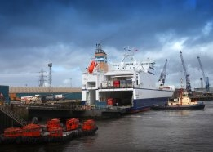
P&O Ferries has announced it will expand its North Sea freight routes, PD Ports reports, in a move that comes in contrast to recent announcements by other ferry operators that Emissions Control Area (ECA) rules are hitting business and leading to route closures.
P&O Ferries will add a new vessel to its freight route between PD Ports operated Teesport, in Northeast England, and Zeebrugge while it also expands capacity on its Teesport to Rotterdam route.
The company labelled the North Sea a key market and cited rail terminal improvements at Teesport and new vessel efficiency as elements in its decision.
"We are moving fast to capture the growth potential in the North Sea freight market and the new rail service complements our own market leading rail capability at our Zeebrugge hub.
"With our new daily service this exciting development allows us to provide customers with the opportunity to grow in a key geographical market in an environmentally-friendly way," said Janette Bell, commercial director for P&O Ferries.
The Mistral will supplement the current Teesport-Zeebrugge ferry, Boresong, meaning P&O Ferries will now run a daily service between the ports, up from 3 crossings per week.
In addition, the Estraden will replace P&O Ferries's current vessel serving the Teesport to Rotterdam route, increasing its capacity between the ports.
The new ships are said to have been chosen for their fuel efficiency, with an eye to new ECA regulations.
Guy Platten, UK Chamber of Shipping's CEO, said this month that "cack-handed implementation" of ECA rules was putting ferry companies at risk.

A major victory for short sea shipping in Norway
22/10/2014 http://www.shortsea.info/news.html?a=details&id=1658
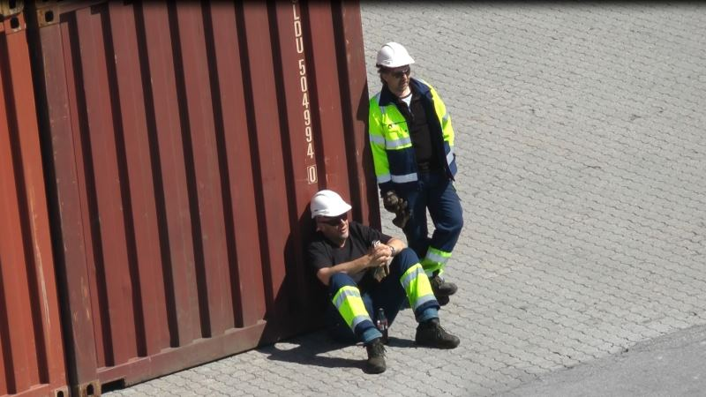
The unanimous and final verdict of a the Labour Court of Norway is that organized dock works do not have exclusive right to load and unload ships in Norway.
​This ruling is a major victory for shortsea shipping and will give more efficient transport! The rights of Norwegian dock workers in Norwegian container ports, is based on a misinterpretation.
Earlier this year the Norwegian Transport Workers' Union, where most loading and unloading workers are organized, decided to test their preferential right in the Labour Court of Norway ("Arbeidsretten"). On 8 October 2014, the court ruled in favour of the the defendant party, the Norwegian Logistics and Freight Association. The question in dispute was the interpretation of the "Framework Agreement for loading and unloading work."
Confusing exception
The text of the Collective Agreement reads:
"For vessels of 50 tons dwt and above that goes from a Norwegian port to a foreign port or vice versa, the loading and unloading work must be performed by organized dock workers. Excluded is all handling at a company's own facilities, where the company may use its own people for loading and unloading. "
The last sentence has been caused much disagreement. The Norwegian Transport Workers' Union has constantly argued that the exemption applies to businesses where loading and unloading is carried out in conjunction with the company's production. In other words - whenever the employees are located in the industrial terminal and loads and unloads for example raw materials for their own production.
The Norwegian Logistics and Freight Association, however, argue that if private companies are engaged in cargo handling at the dock, they can use their own employees. This is regardless of the company being engaged in production, or only operates cargo handling.
Welcome modern times
Transport Workers Union's people have been quite confident that they would win this case, where the judgment is final. There is no appeal option.
All seven judges decided againts the union's view. This will have a significant effect:
Future work accruing to union dock workers will most likely be much less than today. The position the dock worker's uion had - with the ability to paralyze Norway with strikes and blockades - has been weakened significantly.
The verdict is wide reaching. It clarifies not only the controversy related to loading and unloading in the port of Oslo.
The ruling makes it possible for a number of public ports to easily avoid using organized dock workers.
The union claims that emptive rights still apply on board vessels in ports of call, but there is indication that if the ship operator also operates the terminal, then this may not be the case. This remains to be seen.
Normalized port operations
Boycotts and actions by the union have cause trouble in many ports recently. The conflict related to Risavika Terminal in Stavanger has now lasted for 11 months. The dock workers in Tromsø has been on strike. This has led to delays, blockades, arrests and intimidation by the terminal worker that Nor Lines uses in Tromsø harbor. In Oslo, it is claimed that the dock workers have enjoy the world's most expensive lunches. They have six meal breaks per day, where union paralyze the entire terminal daily. These conditions will now be normalized.
Further exceptions
The Labour Court also states that it is negotiating parties, and not the Labour Court, which must draw the further boundaries of the exceptions in the agreement.

Indian feeder service launched between Goa and Nhava Sheva
JOC Staff | Sep 09, 2014 10:51AM EDT JOC
Shreyas Shipping and Logistics has expanded its coastal service network in India by launching a dedicated service between Mormugao Port (Goa) and Jawaharlal Nehru Port (Nhava Sheva), the country’s busiest container gateway.
“This is the first time a shuttle feeder service has been made available exclusively for the Goa trade. Unlike previous feeder services connecting Goa, in which Goa was one port in a rotation of many, this is a dedicated Goa-JN Port-Goa shuttle service,” the Mumbai-based feeder line said in a release.
The new service began with the M.V. Chowgule 7 departing from Mormugao on Sept. 6 for Nhava Sheva, after loading export containers scheduled to be relayed on to a CMA CGM mainline vessel operating in the trade between India and Africa. “The vessel will call Mormugao once every 5 days, thus offering 6 sailings a month,”
Mormugao, about 230 miles south of Mumbai, is one of India’s 13 state-owned major ports. The west coast port handled 11.74 million tons of cargo in fiscal year 2013-14, which ended in March.
Shreyas, which operates a fleet of six container vessels, last month introduced a fortnightly coastal service linking the ports of Mundra, Cochin (Vallarpadam), Goa and Kandla.

Mumbai-based line expands India feeder network
JOC Staff | Aug 15, 2014 6:28AM EDT JOC
Shreyas Shipping and Logistics has introduced a fortnightly coastal container service between West India and South India, adding capacity on the trade route the Mumbai-based feeder line already serves with a weekly service.
The new service began with the 1,700-TEU M.V. SSL Mumbai calling at DP World’s Vallarpadam Transshipment Terminal in Cochin Port on Aug. 13, port officials said.
The port coverage is as follows: Mundra, Cochin (Vallarpadam), Goa, Kandla and back to Mundra.
The feeder service comes as the Vallarpadam terminal, also known as DP World Cochin, tries to woo more ship calls to boost its transshipment business, which has seen virtually no significant growth in three years of operation. The $600 million terminal handled 351,000 TEUs in fiscal year 2013-14, which ended in March, up from 335,000 TEUs in the previous year.
Shreyas, which also provides a feeder connection from Cochin to Nhava Sheva Port (Jawaharlal Nehru), currently has a fleet of six container vessels. The company reported group revenue of $20 million in the first fiscal quarter, which ended on June 30, up from $18.3 million a year earlier.
Baltic short sea carrier reports best quarter in eight years
Bruce Barnard, Special Correspondent | Jul 29, 2014 11:06AM EDT JOC
Finnlines, a leading Baltic short sea shipping line, today posted its biggest quarterly profit in eight years as it sold surplus ships, axed loss-making routes and disposed of non-core operations.
The Finnish roll-on, roll-off carrier booked a profit of €14.7 million ($20 million) in the three months through June, compared with €900,000 a year ago, leading to the best first-half profit in eight years: €15 million, against a €10 million loss in the same period in 2013.
Revenue contracted 4.3 percent in the second quarter to €143.3 million and was down 4.8 percent in the first half at €270.1 million. Second-quarter operating profit grew to €19.8 million from €6.9 million in the same quarter last year, for a first-half total of €25.3 million, against €1 million in the first half of 2013.
The turnaround from years of poor results has almost doubled Finnlines’ market value on the Helsinki stock exchange.
The carrier’s financial revival dates from the acquisition of a majority stake by Italy’s Grimaldi Group, one of Europe’s largest ro-ro operators, which also owns Atlantic Container Line.
“Finnlines is fighting successfully against the [economic] cycle, but we have to analyze every line, every vessel, every function and every cost item whether there is room for further lowering of cast and therefore room for further improvement,” said Emanuele Grimaldi, president and CEO.
Finnlines’ investment in fitting fuel-cleaning “scrubbers” to 10 vessels to comply with new low-sulfur regulations that come into effect in north European waters in January “puts our fleet in the Baltic in the most competitive position,” Grimaldi said.
Finnlines operates on freight routes between Finland, Sweden, Germany and Russia.

DFDS confirms interest in sale of Turkish carrier UN Ro-Ro
Bruce Barnard, Special Correspondent | Jul 03, 2014 9:27AM EDT JOC
DFDS, northern Europe’s largest integrated shipping and logistics company, confirmed it is one of the companies participating in the sale of UN Ro-Ro, the Turkish roll-on, roll-off carrier.
But the Danish group said it has not yet put in a firm bid for the Istanbul-based carrier, which is being sold by KKR, a U.S. private equity fund.
DFDS said its involvement in the UN Ro-Ro tender is like several other sales processes it has participated in to support its “strategic goal of consolidation of the industry.”
Other potential buyers are reported to be Turkish infrastructure investor Global Yatirim Holding, which has a portfolio of ports, and a joint venture between local private equity firms Esas Holding and Acetra Partners.
The previous owner, truckers’ co-operative UND, is also said to be interested in buying back the company, which it sold to KKR for €910 million ($1.3 billion) cash in 2007.
KKR, which hired Goldman Sachs in December to sell its 97.6 percent stake in UN Ro-Ro, is not expected to recoup its purchase price for the short sea carrier, its first Turkish acquisition, which has debts of around $800 million.
UN Ro-Ro, established by Turkish truckers in 1994, deploys 12 vessels on routes between Turkey and Trieste in north east Italy, Toulon in southern France and Damietta in Egypt.
The Mediterranean service enables Turkish trucks heading for the European Union to bypass congested and underdeveloped roads in the Balkans.
UN Ro-Ro posted revenue of €222 million in 2012, according to the latest published figures, up from €165 million in 2007 when it was acquired by New York-based KKR.
UN Ro-Ro would be DFDS’s biggest acquisition since it paid around $425 million for Norfolkline, the short sea subsidiary of Maersk Group, in 2010. It has since bought several smaller shipping and logistics groups, but it pulled out of the bidding for Scandlines, a leading Danish-German ro-ro carrier, in May 2013.

UK orders Eurotunnel to axe service, sell ships
Bruce Barnard, Special Correspondent | Jun 27, 2014 12:55PM EDT JOC
The UK’s competition regulator today ordered Groupe Eurotunnel, the operator of the subsea rail link between Britain and France, to cease operation of its roll-on, roll-off shipping service within six months.
Eurotunnel said it would appeal against the “absurd” decision to ban its shipping line, MyFerryLink, from the Dover-Calais trade, saying it would increase prices for passengers and freight and cost 600 jobs.
The UK’s Competition and Market Authority (CMA) said the current level of competition on the route is unsustainable, with two shipping companies, Denmark’s DFDS and the UK’s P&O Ferries, operating a loss.
One of the lines could quit the route, leaving just two carriers, including MyFerryLink, which would drive up freight rates and passenger fares, the CMA argued.
Eurotunnel entered the shipping market in 2012 when it acquired three vessels from SeaFrance, a subsidiary of SNCF, France’s state-owned railway, which filed for bankruptcy.
Eurotunnel claimed the CMA’s ruling would create a “de facto monopoly” that would increase prices and reduce revenues for the ports of Dover and Calais.
The CMA’s decision has also created tensions between the UK and France, which argued there was ample traffic to support three operators on the route.
DFDS and P&O Ferries, which have lost significant freight traffic to Eurotunnel’s rail shuttle and MyFerryLink, welcomed the ruling.
The CMA ruling “is good news for DFDS and our 1,300 employees providing ferry services on the English Channel,” Neils Smedegaard, CEO of DFDS, said.” We hope the decision will be implemented as swiftly as possible.” DFDS says it is losing between $1.5 million and $1.85 million a month due to competition from MyFerryLink.

US private equity fund KKR set to sell Turkish short sea carrier — report
Bruce Barnard, Special Correspondent | Jun 24, 2014 10:07AM EDT
U.S. private equity fund KKR is reportedly mulling the sale of UN Ro-Ro to its previous owners for around half of what it paid for the Turkish roll-on, roll-off shipping line seven years ago.
The International Transporters Association of Turkey (UND), a trucker’s cooperative, which sold UN Ro-Ro to New York-based KKR for €910 million ($1.24 billion) in cash in late 2007, has offered to buy back the country’s largest short sea carrier for around €480 million ($653 million), according to the Hurriyet daily paper.
UND has teamed up with Ekol Lojistik, a Turkish logistics company with pan-European operations, for the acquisition.
KKR hired Goldman Sachs in December to find a buy for its 97.6 percent stake in Istanbul-based UN Ro-Ro, which was its first acquisition in Turkey and the biggest private equity investment in the country at the time.
UN Ro-Ro, which was set up by Turkish truckers in 1994, operates a fleet of 12 ships on routes between Turkey and Trieste in northern Italy, Toulon in southern France and the port of Damietta in Egypt.
The Mediterranean services enable Turkish trucks to bypass congested and underdeveloped roads in the Balkans and avoid long queues at the Bulgarian border crossing into the European Union.
UN Ro-Ro made its first foreign port investment in December, paying €8.5 million for a 60 percent stake in Samer Seaports terminal in Trieste.
The company generated revenue of €222 million in 2012, according to latest available figures, compared with €165 million in 2007 when it was acquired by KKR.

Hamburg hails $1 billion Kiel Canal funding, awaits Elbe river court ruling
Bruce Barnard, Special Correspondent | Jun 13, 2014 11:59AM EDT JOC
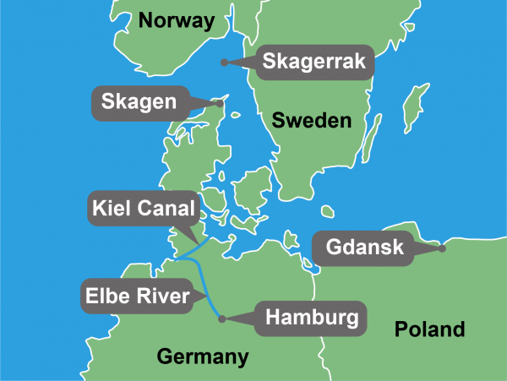
The port of Hamburg hailed the German government’s approval of a €750 million ($1 billion) investment to upgrade the Kiel Canal, which links the North Sea to the Baltic Sea, as a major competitive boost for the country’s largest container port.
The Berlin government has allocated €265 million to widen the eastern section of the waterway and €485 million to construct a fifth lock at the port of Brunsbüttel at the North Sea entrance of the waterway.
More than 130 feeder services use the canal because it is the shortest distance between Hamburg and ports in the fast-growing Baltic container market. Last year around two million 20-foot-equivalent units were transported on the 60-mile waterway.
“The advantage of the canal is immense,” said Axel Mattern, executive board member of the Port of Hamburg Marketing. “Between Hamburg and Gdansk [Poland], feeder ships save half the distance if they take the short cut through the canal and do not sail around Skagen in Denmark.
A total of 31,097 ships carrying 94.8 million tons of cargo passed through the canal last year.
Feeder services carrying deep-sea containers, mainly from Asia, to the Baltic are an increasingly important market for Hamburg that has helped it to continue increasing traffic while its Northwest European rivals are flat-lining.
Hamburg boosted first quarter traffic by 8 percent, helped by feeder traffic lured from Rotterdam, to 2.4 million TEUs to close the gap with the Dutch port, Europe’s top box hub, which grew just 0.3 percent to 2.9 million TEUs, and to pull further ahead of third-ranked Antwerp, which was up 0.9 percent at 2.1 million TEUs.
Hamburg could soon get an even more powerful competitive injection as Germany’s top administrative court is set to rule in July on whether to allow the port authority to go ahead with a long-stalled project to widen and dredge sections of the River Elbe, its 82-mile link to the North Sea.
The three federal states bordering the river approved the project in early 2012, but work was halted after an environmental group launched an appeal.
An enlarged river would allow Hamburg to handle the larger — and wider — container ships that are increasingly being deployed on its key Asia-Europe trade.
Hamburg can handled ships up to 16,000 TEUS, but at present they can’t sail fully loaded up the Elbe. Moreover, vessels with a combined width of 90 meters (295 feet) can’t pass each other along half of the river.
Ocean carriers have switched some services to nearby Bremerhaven, and more could follow if the Elbe isn’t deepened. Hamburg also suffers from growing hinterland congestion caused by a number of highway construction projects in the surrounding area.
If approved, the widening of the Elbe can be completed within two years.

‘Next generation’ short-sea ships ordered
12 May 2014 GreenPort
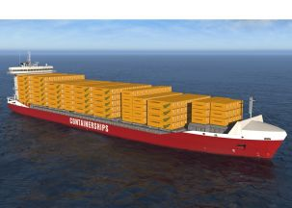
The company says the new vessels will offer efficient and environmentally-friendly option for transporting containers by sea.
Finland’s Containerships Ltd Oy, GNS Shipping/Nordic Hamburg and ARKON Shipping have ordered two ‘next generation’ dual-fuel container ships for the European short-sea trade.
The vessels, will use LNG but will also be able to burn conventional marine diesel oil, making Containerships Ltd the first short-sea container operator in Europe to run ships on LNG.
The company says the new vessels will offer efficient and environmentally-friendly option for transporting containers by sea, and will not just meet, but exceed environmental standards in the Sulphur Emission Control Area (SECA) in which Containerships operates.
“We are a short-sea operator that is in it for the long haul—and these state-of-the art ships are just one part of our long-term strategy,” said Kari-Pekka Laaksonen, CEO, Containerships. “In addition to offering the most ecologically sustainable solution, the intake capacity of these ships will allow us to keep meeting growing customer demand. And we’re confident that both of our partners on this project have the know-how and the experience to deliver.”
According to a recent survey, most shipping lines operating in the SECA will use gas oil when the regulations come into force, but industry studies indicate that investments in LNG technology or scrubber technology will dominate.
Containerships Ltd says using LNG “makes the best ecological sense” since it’s the cleanest fossil fuel on the market. Burning it emits no sulphur or particulate matters and using it in these new vessels will also allow Containerships to reduce emissions of CO2 by 25%, according to Gasum.
The new vessels will offer the highest flexibility for 45ft units among container ships operating in the North Sea and Baltic Sea. Each vessel will be able to accommodate up to 639 units of 45ft containers and have a total capacity of 1,400 teu.
Delivery is scheduled for 2016.
Outlook Brightens for Ro-Ro Carriers
Bruce Barnard, Special Correspondent | May 05, 2014 9:10AM EDT JOC
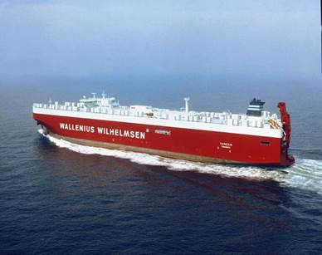
After suffering through the longest recession in the crisis-ridden eurozone since World War II, roll-on, roll-off carriers could use an injection of good news. With a long-stalled economic recovery gaining traction in Europe and the outlook improving for car and truck shipments, ro-ro carriers are finally getting it.
That’s not to say the industry is out of the woods. The last six years of economic ineptitude squeezed operating margins, drove weaker companies to the brink of collapse and stalled urgently needed consolidation, making the recovery all the more difficult.
And just as the outlook started to brighten, Japanese antitrust authorities in March slapped a $225 million fine on six companies, including market leaders Wallenius Wilhelmsen Logistics, “K” Line and NYK Line for their part in a price-fixing scheme on ocean freight rates on international routes.
Whether the accelerating trade growth will come in time for some carriers is an open question. Some ro-ro carriers are still in danger of failing and others will have to withdraw from routes in the key northern Europe market when tough environmental regulations take effect next year. The once-buoyant Baltic Sea routes face further volume declines as the Russian economy hovers near recession. Shipping lines also face a tough battle with Eurotunnel, the operator of the undersea link between the U.K. and France, which has captured almost 39 percent of truck traffic in the world’s busiest ro-ro market.
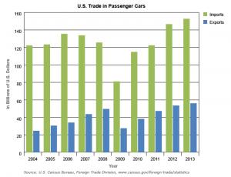
Further financial hits are possible. Several class-action lawsuits were launched in the U.S. last summer, and European antitrust authorities are investigating alleged cartel activities. There are also concerns that growth in global automobile exports will slow as production increasingly shifts to import markets.
For now, however, the industry is enjoying a mini-boom, with traffic climbing above pre-recession levels. Ro-ro traffic grew 3.5 percent year-over-year in 2013 at Rotterdam, Europe’s largest port, driven by recovery on key U.K. routes. Containerized volume, by contrast, slipped 2.1 percent in the same period. Scandlines, the Danish-German ferry operator that sold its freight arm in 2012, carried 700,000 trucks and trailers on its passenger vessels in 2013, up 3.2 percent from the previous year, while passenger numbers were down 1.8 percent.
Meanwhile, DFDS, one of North Europe’s largest ro-ro shipping and logistics groups, is prowling for fresh acquisitions following a largely slow period after it snapped up Maersk’s Norfolkline subsidiary for around $425 million in 2010. And Greece, a key ro-ro shipping hub that was widely expected to default and exit the euro two years ago, is showing signs of recovery.
The uptick is coming at just the right time as carriers take delivery of new, larger ships, most earmarked for intra-Mediterranean long-haul routes between Europe and West Africa and the east coast of South America. Naples-based Grimaldi is adding three multipurpose container/ro-ro vessels to its fleet this year; fellow Italian carrier Atlantica di Navigazione is phasing in five ro-ro ships it acquired from Hong Kong’s Pacific Basin for $200 million; and Ignazio Messia, also Italian, will deploy four new container/ro-ro units at the end of the year. Danish carrier Nordana will deploy a new ro-ro ship by the end of the year, boosting capacity of its Mediterranean-Americas service by 35 percent.
The major talking point in the industry centers on the prospects for five of the world’s biggest ro-ro/container vessels that Atlantic Container Line will introduce in the North Atlantic in 2015, replacing the workhorse vessels that have carved out a niche market between Europe and North America over the past 30 years. The Grimaldi subsidiary faces a tough challenge filling the new vessels, which — at 3,800 20-foot-equivalent units — have more than twice the container-carrying capacity of the outgoing ships, 45 percent more ro-ro space and 31 percent more auto capacity, in a trade that has traditionally posted sluggish, if steady, growth in recent years. It will likely launch a direct South Atlantic-North Europe service that will benefit from connections with its Italian parent’s extensive European short- and long-haul networks.
Ocean car carriers, meanwhile, are looking forward to another year of steadily improving market conditions, with global sales of new automobiles expected to increase about 5 percent, mirroring growth in 2013, as rising sales in the U.S., China and, to a lesser extent, Europe offset a slowdown in emerging markets such as Brazil, India and Russia.
The share of new cars shipped by sea has stabilized at 16 to 18 percent of global sales in recent years, with Japan and South Korea driving exports, but changes in key regional markets will increasingly influence demand for seaborne transportation.
The supply-demand math looks pretty healthy, too. Shipowners ordered 38 car carriers in 2013 and eight more in the first two months of this year. The order book stands at 65 vessels for delivery through 2017, representing 12.4 percent of the existing fleet of 671 vessels, according to Norwegian Car Carriers. Eighteen ships joined the fleet in 2013, while 16 were sold for scrapping, amounting to net capacity growth of around 1.3 percent. Net supply is expected to grow about 4.4 percent this year, assuming no further scrapping. These rosy numbers likely prompted J.P. Morgan Global Maritime Investment Fund to team up with Norway’s Klaveness Marine Holding to take over Norwegian Car Carriers in February.
Underscoring the industry’s confidence is the rising number of orders placed by carriers, including Wallenius Wilhemsen and Hoegh Autoliners, for ships capable of carrying the equivalent of 8,500 automobiles that will be able to transit the enlarged Panama Canal and operate more flexible pan-global services.
Despite growing global sales, car carriers must be prepared to keep pace with shifts in export patterns as automakers shift production in, or closer to, importing nations, thus reducing the demand for seaborne shipments.
Mexico has emerged as a major market that likely will replace Japan as the second-largest exporter of cars to the U.S. by the end of the year, according to consulting firm IHS Automotive. A Honda plant that opened in the state of Guanajuato in February will produce about 200,000 Fit hatchbacks a year, boosting Mexico’s exports to 1.7 million units in 2014, some 200,000 more than Japan. And a new Mazda plant that opened a few weeks later with an annual output of 230,000 cars will help Mexico overtake Canada as the largest automobile exporter to the U.S. by the end of 2015, IHS Automotive predicts.
Japan’s “K” Line, whose 100-strong fleet carries some 3.3 million cars a year, believes the move of production plants to importing nations will limit growth in seaborne automobile trade, and is diversifying its client base to carry more construction and mining vehicles, heavy trucks, agricultural equipment and static ro-ro cargoes.
“K” Line rival MOL is embracing the shift in production to drum up business for its car carriers. It just launched a weekly three-vessel service transporting new cars from the east and west coasts of Mexico to ports in the North American Free Trade Agreement region.
The Atlantic service, operated by MOL subsidiaries Nissan Motor and World Logistics Service (USA), will connect the Port of Veracruz, Mexico, with Jacksonville, Fla.; Brunswick, Ga.; Baltimore; Port Newark and Davisville, R.I. A second weekly service will sail from the Mexican Pacific port of Lazaro Cardenas to San Diego; Richmond, Va.; Portland, Ore.; Tacoma and the Canadian port of New Westminster.
Meanwhile, carriers continue to add services to keep pace with growing regional markets for cars, trucks and mining equipment. Wallenius Wilhelmsen expanded its service to South America’s west coast in April, adding a monthly call to San Antonio, Chile, and boosting a network spanning 13 ports in Europe, the U.S., Mexico and Latin America.
For now, the ro-ro sector’s most pressing problem is the potential fallout from new European Union environmental regulations coming into force in January 2015 that mandate fuel sulfur content of ships operating in the North Sea, the Baltic and the English Channel to be 0.1 percent, down from the current 1 percent.
DFDS Chief Executive Niels Smede-gaard has warned that the 40 to 50 percent higher cost of cleaner fuel will lead to bankruptcies and route closures. The Danish line expects to spend nearly $140 million to equip 20 vessels with “scrubbers” that remove sulfur from exhaust gases, but it already has stopped serving one Baltic route in response to the new regulations and another four to seven are at risk of being shut down.
Older vessels that can’t be fitted with scrubbers or don’t justify heavy investments likely will be switched to southern European routes where the regulations take effect in 2020. DFDS plans to impose a low-sulfur surcharge that will lead some shippers to switch to trucks and thus undermine the EU’s policy of encouraging more freight shippers to use greener sea and rail transport.
The industry could face a radical shakeup in its key North European market in early 2015, with weaker carriers calling it quits and stronger ones slugging it out in a fresh outburst of consolidation.
DFDS Axes Route Ahead of Tougher Environmental Rules
Bruce Barnard, Special Correspondent | Apr 30, 2014 9:33AM EDT JOC
DFDS today said it is shuttering a route between the U.K. and Denmark in response to tougher environmental regulations coming into force in January that will sharply raise the cost of ships’ fuel.
The closure of the Esbjerg-Harwich freight/passenger service by Europe’s largest short sea shipping and logistics group likely will be the first of several service shutdowns in the coming months as shipowners reassess their viability as costs rise in a highly competitive market.
DFDS is said to be mulling the future of up to seven routes ahead of the European Union regulations that will limit marine gas oil sulfur emissions to 0.1 percent from the current limit of 1.0 percent in three so-called Sulfur Emission Control Areas, or SECAs, covering the Baltic Sea, the North Sea and the English Channel, the Danish company’s main markets.
DFDS chief executive Niels Smedegaard has said the lower sulphur fuel will cost as much as 50 percent more than the bunker fuel used today, which will lead to bankruptcies, route closures and the loss of cargo to road transport.
DFDS said it expects most of the freight on the Esbjerg-Harwich route, due to close in September, will be transferred to its Esbjerg-Immingham service. Freight accounted for around half of the 190 million krone (about US$35.2 million) revenue on the route in 2013, but traffic between the southern U.K. and Denmark has been declining in recent years and the service would not be sustainable with higher fuel costs. The company will no longer carry passengers between the U.K. and Denmark.
DFDS plans to introduce a marine gas oil surcharge in 2015 and is spending 750 million kroner on fitting 21 of its vessels with scrubbers that remove sulfur from exhaust gases. It will also consolidate more services.
Older vessels that can’t be fitted with scrubbers or can’t justify the investment likely will be transferred to southern European routes where the new regulations don’t come into force until 2020. Shipowners are hoping that the 2020 implementation date will be pushed back until 2025.
The new regulations will also raise the cost of long haul trades, including Asia-Europe and the trans-Atlantic, as the main European container ports are located in SECAs.

EU ports enter LNG joint venture
28 Apr 2014 Green Port
The ports are joining forces to introduce LNG to inland shipping on the Rhine-Main-Danube corridor. Photo: Claudio.Ar/Flickr
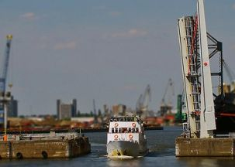
The port authorities of Antwerp, Rotterdam, Mannheim, Strasbourg and Switzerland are joining force to introduce LNG in the Rhine-Marin-Danube corridor.
The agreement involved co-operation in research, promotion, knowledge transfer, and legislation and bunker infrastructure.
It follows on from the LNG Master Plan of the Rhine-Main-Danube corridor in which all parties are involved. The aim of the plan is to put LNG to full scale use as a fuel for inland shipping on the Rhine-Marin-Danube corridor.
Keen to take advantage of the new offering, the Danser Group, supported by the LNG Master Plan, has begun refitting the engines of its Eiger-Nordwand tug boat.
To support the construction of the required LNG infrastructure in the region, the European Union is providing a €40m subsidy.
Rotterdam Port Authority says this co-operation agreement ties in with its aim to see the market for LNG as a fuel develop to its full potential, and to open an LNG hub in Rotterdam by the end of 2015.
The port already has a terminal dedicated to the storage and handling of LNG. Argonon and Greenstream are the first inland vessels powered by LNG which call at Rotterdam, after the regulations were amended last year to allow inland vessel to bunker.

EU Ports Join Forces to Introduce LNG
Port of Rotterdam Authority, April 28, 2014
On Friday 25 April, the port authorities of Antwerp, Mannheim, Rotterdam, Strasbourg and Switzerland signed a joint venture for the introduction of LNG. This involves cooperation in research, promotion, knowledge transfer, legislation and bunker infrastructure.
The agreements follow on from the LNG Master plan of the Rhine-Main-Danube corridor in which all participants are involved.The aim of this master plan is to put liquefied natural gas to full scale use as a fuel for inland shipping on the Rhine-Main-Danube corridor.
The European Union has provided a subsidy of €40 million to support an LNG infrastructure for the Rhine-Main-Danube area. The Danser Group, supported by the LNG Master plan, has commenced refitting its Eiger-Nordwand tow boat. The engines of this vessel will be powered by LNG for 99%.
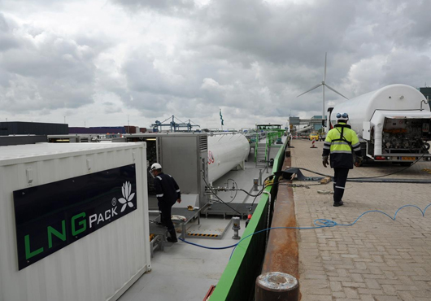
Rotterdam
The cooperation ties in with the Port of Rotterdam Authority’s aim to see the market for LNG as a fuel develop to its full potential, and to open an LNG hub in Rotterdam before the end of 2015. In order to realise this, the Port Authority invests in infrastructure, is closely involved in the formation of the necessary national and international policy and legislation, and invests in cooperation with relevant partners.
LNG in Rotterdam
There has been a special terminal for the storage and handling of liquefied natural gas in the port of Rotterdam since 2011: the Gate terminal. The Argonon and the Greenstream are the first inland vessels powered by LNG which call at the port of Rotterdam. The Municipality of Rotterdam amended the regulations last year so that inland vessels can now also bunker.
Commission clarifies EU rules on cabotage and reports on developments in this sector
by ER/EUROPA
Tuesday, Apr 22, 2014 19:07:27
Passengers from a cruiseship carry their luggage in the port of Piraeus
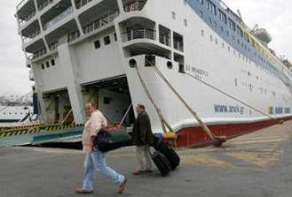
The European Commission has given new guidance on the interpretation of the regulation to provide cabotage within a Member State, thus providing an internal market for the provision of maritime transport services. With the new guidance competent authorities will have more legal certainty when awarding public service contracts and imposing public service obligations. Shipowners will also benefit from more legal clarity, allowing them to better organise their business in Europe.
European Commission Vice-President Siim Kallas, responsible for Mobility and Transport, said: "The internal market for maritime transport services is important to the performance of the European economy and for the quality of life and prosperity of maritime regions. Member States' authorities need clear rules on how to ensure adequate links to islands and peripheral regions that are particularly dependent on maritime transport. We have listened very carefully to where clarification was needed. These updated interpretative guidelines provide this clarity and will enhance legal certainty for all maritime cabotage actors in the EU."
The new guidance updates the previous Commission's guidance2 in order to align it to recent EU law and case-law of the Court of Justice. In future, there will be more flexibility in defining the duration of public service contracts. The new guidance is presented in the interest of transparency and legal certainty to help explain the EU rules to all actors that wish to make use of it.
Amongst other things the interpretative communication adopted today provides updated guidance on:
- the scope of the freedom to provide services in the maritime cabotage sector
- who enjoys that freedom and which services the Regulation covers,
- the award procedure for public service contracts,
- the duration of public service contracts,
- the manning rules on vessels providing maritime cabotage,
- the application of Regulation (EC) No 1370/2007 of the European Parliament and of the Council on public passenger transport services by rail and by road and repealing Council Regulations (EEC) No. 1191/69 and 1107/703 to maritime cabotage services,
- transitional arrangements for Croatia.
Member States and stakeholders were fully involved and consulted in the process of preparation of the report and the new interpretative guidelines.
Today, the Commission has also presented its fifth report on the freedom to provide services to maritime transport within Member States (maritime cabotage)4.
Almost all cabotage services in the EU have been liberalised from 1 January 1999. The Greek market, which was among the last to be partly protected, has been opened up to competition since 1 November 2002. Croatia is the only Member State that still can apply the temporary derogation from certain provisions of the Regulation, until 31 December 2014.
Regarding market developments, the Commission has reported that until 2007, the maritime cabotage market in the EU recorded a continuous increase in volumes of goods and numbers of passengers transported in several countries. Since 2008 it has experienced a considerable decline, due to the impact of the economic crisis.
Facts and figures
As in previous years, the greatest market for cargo traffic is that of the United Kingdom and Spain (each around 80 million tonnes a year), followed by that of Italy (around 60 million tonnes). Liquid bulk continues to lead in terms of cargo transported.
Regarding passengers, Greece has the greatest traffic (60 million passengers a year), followed by Italy (40 million passengers).
Finally, according to the available data the penetration of the national markets by vessels flying non-national flags has slightly increased in the cabotage of cargo in three Member States, while it remains limited in the cabotage of passengers.
Frequently asked questions
Council Regulation (EEC) No 3577/92 (hereinafter the 'regulation') applying the principle of freedom to provide services to maritime transport within Member States (maritime cabotage)1 is now over twenty years old. Since its entry into force on 1 January 1993, maritime cabotage has undergone gradual liberalisation.
Since 1993, the Commission has reported several times on the economic and legal progress of this liberalisation2. It has also addressed the problems of interpretation raised by the regulation in its interpretative communications of 2003 and 2006.
The Commission is now enhancing legal certainty for all actors in maritime cabotage sector by providing updated guidelines on key provisions of the regulation.
1. Why are new interpretative guidelines needed for Regulation 3577/92?
On the occasion of preparing the fifth report on the implementation of the Regulation, and in particular after having consulted Member States and stakeholders, the Commission has become aware of the need to further clarify and update certain aspects of its guidance on the application of this Regulation.
The present interpretative communication updates the previous guidance in order to align it to recent EU law, mainly on public procurement and service concessions, and case-law of the Court of Justice. It also better reflects the changes in the Commission's understanding of certain provisions of the Regulation.
2. What provisions do the Commission's interpretative guidelines cover?
The guidelines cover most of the provisions of the regulation that have been signalled to the Commission as being unclear. These points have been brought to the attention of the Commission for instance through questions from Members of the European Parliament and complaints, as well as through queries from shipowners and national authorities in Member States.
In particular, the updated guidelines provide further clarifications on
- the scope of the freedom to provide services in the maritime cabotage sector (who enjoys that freedom and which services the Regulation covers),
- the award procedure for public service contracts and the duration of these contracts,
- the manning rules on vessels providing maritime cabotage,
- transitional arrangements for Croatia,
the application of Regulation (EC) No 1370/2007 of the European Parliament and of the Council on public passenger transport services by rail and by road and repealing Council Regulations (EEC) No. 1191/69 and 1107/703 to maritime cabotage services.
3. What is the main change in the Commission's interpretation?
The main change in the Commission's interpretation relates to the duration of public service contracts.
Public service contracts should have a limited duration in order to allow regular and open prospecting of the market. With a view to complying with the principle of proportionality in any market intervention, Member States should choose the least distortional means, also in terms of duration, to meet the essential maritime transport needs.
In its interpretative Communication of 2003 the Commission allowed public service contracts of up to six years.
However, the Commission's experience since 2003 has shown that in some cases the six years limit puts shipowners off bidding as they consider this duration to be too short to recoup the investments in the operation of the service. Likewise, contracts of short duration might discourage shipowners from making more substantial investments, thus hampering innovation and possible improvements in the quality of the service.
For this reason the Commission decided to amend its earlier interpretation to allow for more flexibility in defining the duration of public service contracts. The new guidelines indicate that public service contracts with the duration of up to 12 years can meet the proportionality requirement provided that they are justified by objective criteria, such as the need to recoup the investments made in operating the maritime cabotage service under normal operating conditions (e.g. investments in vessels or infrastructure).
4. What is the impact of these guidelines?
The interpretative guidelines simply present the Commission's interpretation of the Regulation. They do not set out to revise the Regulation or to encroach on the Court of Justice's jurisdiction in matters of interpretation.
Therefore, they will not imply any costs to stakeholders as they will not - and cannot - create new obligations. In fact, they will only generate benefits in terms of increased legal certainty.

European Commission : Maritime transport: Commission clarifies EU rules on cabotage and reports on developments in this sector
European Commission Press release | Brussels, 22 April 2014
The European Commission has given new guidance on the interpretation of the regulation to provide cabotage within a Member State1, thus providing an internal market for the provision of maritime transport services. With the new guidance competent authorities will have more legal certainty when awarding public service contracts and imposing public service obligations. Shipowners will also benefit from more legal clarity, allowing them to better organise their business in Europe.
European Commission Vice-President Siim Kallas, responsible for Mobility and Transport, said: " The internal market for maritime transport services is important to the performance of the European economy and for the quality of life and prosperity of maritime regions. Member States' authorities need clear rules on how to ensure adequate links to islands and peripheral regions that are particularly dependent on maritime transport. We have listened very carefully to where clarification was needed. These updated interpretative guidelines provide this clarity and will enhance legal certainty for all maritime cabotage actors in the EU."
The new guidance updates the previous Commission's guidance in order to align it to recent EU law and case-law of the Court of Justice. In future, there will be more flexibility in defining the duration of public service contracts. The new guidance is presented in the interest of transparency and legal certainty to help explain the EU rules to all actors that wish to make use of it.
Amongst other things the interpretative communication adopted today provides updated guidance on:
- the scope of the freedom to provide services in the maritime cabotage sector
- who enjoys that freedom and which services the Regulation covers,
- the award procedure for public service contracts,
- the duration of public service contracts,
- the manning rules on vessels providing maritime cabotage,
- the application of Regulation (EC) No 1370/2007 of the European Parliament and of the Council on public passenger transport services by rail and by road and repealing Council Regulations (EEC) No. 1191/69 and 1107/70 to maritime cabotage services,
- transitional arrangements for Croatia.
Member States and stakeholders were fully involved and consulted in the process of preparation of the report and the new interpretative guidelines.
Today, the Commission has also presented its fifth report on the freedom to provide services to maritime transport within Member States (maritime cabotage) .
Almost all cabotage services in the EU have been liberalised from 1 January 1999. The Greek market, which was among the last to be partly protected, has been opened up to competition since 1 November 2002. Croatia is the only Member State that still can apply the temporary derogation from certain provisions of the Regulation, until 31 December 2014.
Regarding market developments, the Commission has reported that until 2007, the maritime cabotage market in the EU recorded a continuous increase in volumes of goods and numbers of passengers transported in several countries. Since 2008 it has experienced a considerable decline, due to the impact of the economic crisis.
Facts and figures
As in previous years, the greatest market for cargo traffic is that of the United Kingdom and Spain (each around 80 million tonnes a year), followed by that of Italy (around 60 million tonnes). Liquid bulk continues to lead in terms of cargo transported. Regarding passengers, Greece has the greatest traffic (60 million passengers a year), followed by Italy (40 million passengers).
Finally, according to the available data the penetration of the national markets by vessels flying non-national flags has slightly increased in the cabotage of cargo in three Member States, while it remains limited in the cabotage of passengers.

Scandlines’ Earnings Slip on Flat Revenue
Bruce Barnard, Special Correspondent | Apr 07, 2014 3:09PM EDT JOC
Scandlines, the Danish-German ferry operator, posted a 5.5 percent decline in operating profit last year as increased freight volume was offset by lower passenger and auto traffic.
The company, which is owned by U.K. private equity investor 3i, earned €172 million (about US$236.4 million) before interest, tax, depreciation and amortization, down from €182 million in 2012.
Revenue edged up to €505 million in 2013 from €504 million last year, and profit shrunk to €59 million from €119 million. “The financial result is considered to be satisfactory,” the company said.
Freight traffic was up 3.2 percent at 700,000 trucks and trailers, while passenger numbers were down 1.8 percent at 11 million and car traffic retreated 1.7 percent to 2.5 million units.
Scandlines, which operates nine ships and has two on order, sold its freight division, including ships and routes, in 2012 to focus on passenger ferries.
London-based 3i bought out co-owner, Germany’s Allianz Capital Partners, for €165 million in November, after the companies pulled an auction for the carrier because potential bidders were unwilling to meet their minimum asking price of €1.4 billion. TPG, the U.S. private equity group – the sole bidder after DFDS, the Danish shipping and logistics group pulled out – declined to raise its €1.3 billion offer.

UECC orders LNG pure car and truck carriers
www.americanshipper.com Friday, March 07, 2014
United European Car Carriers (UECC), which is jointly owned by NYK and Wallenius Lines, has signed a contract to construct two Pure Car and Truck Carriers (PCTCs) that can optionally use LNG or heavy fuel oil and marine gas oil as fuel.
UECC said they will be the first PCTCs to be fitted with an LNG-fuel propulsion system and will be able to complete a 14-day round voyage in the Baltic using solely LNG fuel for main engine and auxiliary power generation.
"LNG is recognized as the cleanest and most environmentally friendly choice of fuel suitable for marine transport. The use of LNG significantly reduces CO2 emissions, as well as almost eliminating sulphur oxide emissions and other particles," the company said in a press release.
“The LNG installation is a pioneering design and will be one of the largest employed on a commercial vessel and the largest yet of its kind on a pure car and truck carrier," said Glenn Edvardsen, the chief executive officer of UECC. Kawasaki Heavy Industries will build the ships at its joint venture NACKS shipyard in Nantong, China, and deliver them in the second half of 2016.
The vessels will be 181 meters long and have a 30-meter beam. They will be Finnish/Swedish ice class 1A Super vessels, thus allowing for full-year trading in the Baltic area. Each ship will be capable of transporting approximately 3,800 standard-sized vehicles over its 10 decks. A significant amount of the cargo capacity can also be used to transport high and heavy cargo, in addition to cargo loaded onto MAFI trailers. The deck configuration will be optimized for both current and expected cargo mixes.
UECC is a leading short-sea operator and logistics provider for the transportation of cars, vans, and high and heavy cargo in Europe. The company was established in 1990 and has a fleet of 23 purpose-built vessels. It transports around 1.5 million car equivalent units annually and also operates several vehicle terminals in major European ports.

Hamburg Bucks Container Traffic Trend
Bruce Barnard, Special Correspondent |Mar 07, 2014 10:21AM EST The Journal of Commerce
Feeder vessels at Hamburg’s Burchardkai terminal. Photo © HHM/Lindner.
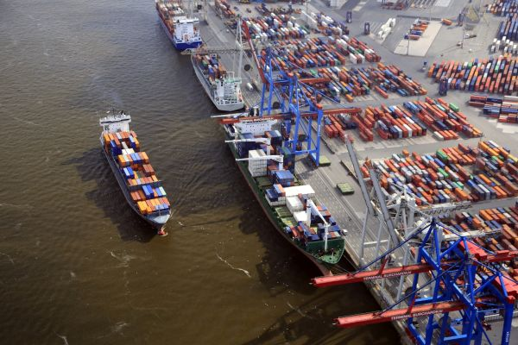
Hamburg increased container throughput by 4.4 percent in 2013, as surging Baltic traffic and a recovery on Asian services helped it to buck the downward trend across the North European port range.
Container traffic topped 9.3 million 20-foot-equivalent units, cementing Hamburg’s position as Europe’s second largest box hub, behind Rotterdam and ahead of Antwerp.
Hamburg’s closest rivals both posted declines in container traffic last year, Rotterdam down 2.1 percent at 11.62 million TEUs and Antwerp 0.7 percent lower at 8.57 million TEUs.
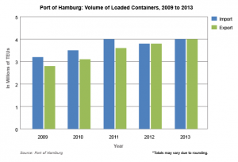
Hamburg boosted its share of containers handled by Northern Europe’s top four ports by 1.3 percentage points to 26.2 percent.
The port said higher container traffic was the key driver of a market-beating 6.2 percent increase in its overall throughput to 139 million tons.
The short-sea and feeder trades between Hamburg and Russia, Finland, Poland, Sweden, Denmark and the Baltic states surged 10.1 percent to 2.3 million TEUs. Rotterdam partly blamed the loss of feeder traffic to Hamburg for the decline in its 2013 throughput.
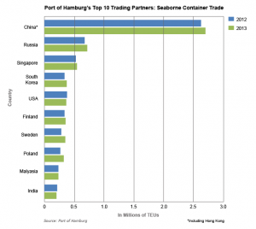
Hamburg’s traffic with Asia picked up in 2013 as well, rising 3 percent to 4.9 million TEUs. Exports jumped 5.1 percent to 2.2 million TEUs, outpacing a 1.4 percent rise in imports to 2.7 million TEUs.
Traffic with mainland China and Hong Kong grew 2.9 percent to 2.7 million TEUs to account for 29 percent of Hamburg’s total volume.
The Americas were the only region to post a decline in traffic, down 3.3 percent at 1.1 million TEUs.
The port’s marketing department said it expects a further “modest” increase in volume in the current year.

DFDS Eyeing Further Acquisitions
Bruce Barnard, Special Correspondent | Mar 03, 2014 9:52AM EST The Journal of Commerce
DFDS is eyeing further acquisitions to consolidate its position as northern Europe’s largest short sea shipping and logistics group following strong profit growth in challenging market conditions in 2013.
Operating profit grew 11 percent to 1.2 billion Danish kroner ($222 million), outpacing a 3 percent increase in revenue to 12.1 billion kroner ($ 2.24 billion).
Pre-tax profit jumped 36 percent to 367 million kroner, and cash flow from operations surged by 64 percent to 1.5 billion kroner.
“We have benefited from growth in the North Sea market, but declining activity in Russia has reduced volumes in the Baltic Sea region,” said CEO Niels Smedegaard. “We improved our result in the English Channel, but the area remains a major challenge.”
DFDS is strongly positioned both financially and strategically despite low market growth and persistent competitive pressure, Smedegaard said.
“In 2014, we will continue to work on creating synergies by expanding our European network through acquisitions,” he said.
DFDS has not made a major acquisition since it paid around $425 million for Norfolkline, the short sea subsidiary of A.P. Moller-Maersk, in 2010. It has since acquired several smaller shipping and logistics businesses, but it pulled out of the bidding for Scandlines, a leading Danish-German ferry operator, last May.
The Copenhagen-based company forecast revenue will rise by around 6 percent in 2014, and operating profit is expected to be 1.25 billion to 1.4 billion kroner before special items.

SECTION 10 - PAST EVENTS

Current Highlights:
- Jones Act Amendments Should Precede US Crude Oil Exports, February 3, 2014
- 2013 DOT Year in Review: MARAD puts its muscle behind freight, January 3, 2014

List of articles which follow:

- Jones Act Amendments Should Precede US Crude Oil Exports
- Is LIGTT legit?
- Short-sea shipping panel to meet at cookhouse
- Marad Chief: US-Flag Carriers at ‘Tipping Point’
- 2013 DOT Year in Review: MARAD puts its muscle behind freight

Jones Act Amendments Should Precede US Crude Oil Exports
Breaking Energy, By Roman Kilisek, February 03, 2014
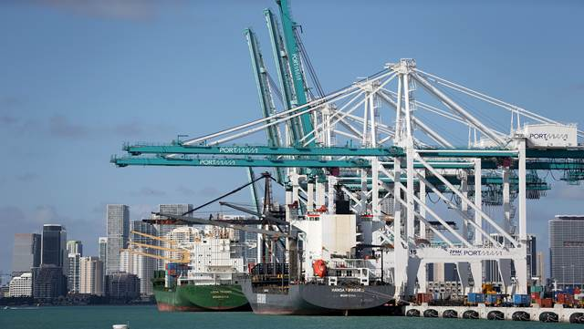
The Brookings Institution, a think tank in Washington D.C., recently published “Big Bets & Black Swans – A Presidential Briefing Book” with policy recommendations for President Obama in 2014. Among a plethora of issues addressed, Tim Boersma and Charles K. Ebinger also discuss lifting the ban on U.S. oil exports.
Let’s briefly assess the validity of some of their arguments. First, the authors argue that lifting the ban on U.S. crude oil exports would be consistent with supporting free trade in a global economy. They cite industry reports projecting substantial economic gains of “up to $15 billion annually” and not to mention the overall economic benefits along the entire oil production value chain: unrestricted oil exports would lead to increased investments in energy infrastructure and thus, in turn, to companies ramping up domestic oil production while generating income, jobs and taxes in the United States. However, these exports – they say – may not benefit everyone equally citing as an example that “some refineries may see a decline in revenues, because some domestically-produced oil will be exported without first being processed.” While the overall economic benefit is hard to quantify due to the volatility of commodity prices, the latter part of their argument is accurate because under current U.S. law, which does not impose export restrictions on refined products, the only way crude oil gets out of the U.S. – disregarding here the by law permissible small amount of oil exports to Canada – is in the form of refined products such as diesel, gasoline, and kerosene. Note, refiners’ profitability depends on the difference between crude oil input costs and refined low-margin product sales prices. According to the EIA, as of January 1, 2013 there are a total of 143 operable petroleum refineries in the U.S., while the ‘newest’ refinery began operating in 2008 in Douglas, Wyoming. The EIA, however, points out that the ‘newest’ refinery with atmospheric distillation capacity greater than 100,000 bpd began operating in 1977 in Garyville, Louisiana. This illustrates the fact that refineries today are more cost effective outside of the North American continent due to cheaper labor along with lower overhead costs and less stringent environmental regulations.
This leads right into the next argument. Most U.S. refineries are designed to process heavier crude oil from Canada, Venezuela or Mexico rather than light domestic crude oil. This mismatch between type of crude oil supply and existing absorptive refining capacity constitutes a major constraining factor with impact on domestic (WTI) oil prices. Basically, over-supply will lead to lower prices for domestic producers. Oil prices that are “too low”, in turn, will negatively influence both investment flows into the U.S. oil sector and oil output over the longer term. Now, this has to be viewed together with perhaps the most important argument for lifting the ban on U.S. crude oil exports the Brookings authors put forth. Domestic production of crude oil from shale rock formations continues to surge with projections foreseeing a peak in production by 2020 and a production plateau afterwards. The authors stress that “without export markets for domestic crude, there is only so much absorptive capacity in the United States.” On its face this two-fold argument is valid. However, the following chart illustrates how much crude oil the U.S. is still importing from abroad.
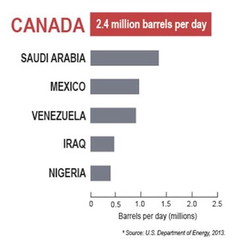
Major Oil Exporters to the U.S.
Source: U.S. Department of Energy; from realclearenergy.org
In this respect, T. Boone Pickens makes a valid point by charting a different course of action. Instead of lifting the ban on crude oil exports, the U.S. should focus on reducing its dependence on foreign oil imports, especially from the Middle East. “I am not too keen on exporting when we are importing 9 to 10 million barrels a day,” Mr. Pickens said, speaking at the World LNG Fuels 2014 conference in Houston. He went on to say that “when you are buying from OPEC, some of that money gets in the hands of the Taliban and Al-Qaeda,” referring to the political instability in those countries.
Meanwhile, as for national security, the Brookings authors do not see the lifting of the ban on U.S. crude oil exports as weakening U.S. energy security. They express the widely held view that “U.S. domestic supplies are large enough to make the country self- sufficient in the coming decades.” The premise here being that lifting the ban “would most likely incentivize further expansion of the pipeline network (Keystone or alternative pipelines) in order to facilitate a larger flow of oil from the upper Midwest and Canada to the Gulf Coast.” Given the slow progress on the Keystone XL pipeline with environmental concerns around it, the above premise is at least questionable. If the anticipated scenario plays out – ban on oil exports stays in place while U.S. domestic crude oil production continues to increase – U.S. light sweet crude oil will indeed become a “quasi-stranded commodity” leading to further downward pressure on the WTI price.
This would also have a severe impact on Canadian oil sands production, making it less profitable. As reported by the Canadian newspaper the Globe and Mail, Western Canada Select heavy blend crude for February 2014 delivery sold for $19.50 (U.S.) a barrel less than the U.S. benchmark West Texas Intermediate (WTI) light crude based on data from the oil broker Net Energy. Even though this compares with price spreads of more than $40 in 2013, Canada may be way better off to go ahead and both plan and build the necessary infrastructure in order to export their heavy crude oil to higher priced Asian markets. For Canada this may be the only way to stay ahead of the curve and allow Canadian oil sands producers to remain profitable, which, in turn, will generate revenues for Alberta. Even if Keystone XL were not to materialize, Canadian heavy oil would still reach the Gulf Coast refineries via rail for the time being, until perhaps Mexican production ramps up.
Overall, the above arguments – as valid as they may be – seem to overlook the fact that not all refineries can process both types of oil – heavy and light – and that reconfiguring a refinery to process light from heavy and vice versa would require huge capital investments as well as years to complete. The U.S. is currently a 17.7 million b/d market in terms of operable refining capacity with current domestic crude oil production of 7.5 mmb/d. It is important to understand that about half the overall U.S. refining capacity can be found in the U.S. Gulf Coast, with 4.7 mmb/d in Texas and 3.2 mmb/d in Louisiana. The following maps depict the major U.S. refining centers with their respective capacities. According to the EIA, refining capacity in the Gulf Coast has large secondary conversion capacity with hydrocrackers and desulfurization units. Those refineries are predestined to process heavy, high sulfur (sour) crude oils – from Mexico, Venezuela, Saudi Arabia and Canada. This type of oil typically sells at a discount to light, low sulfur (sweet) crude oils like Brent (Blend), the Bakken Blend and Louisiana Light Sweet. Therefore, as far as heavy crude oil is concerned, the biggest growth market is clearly PADD III. Due to the fact that East Coast refineries tend to have less secondary conversion capacity, they are predominantly geared towards processing lighter, lower sulfur crude oil.
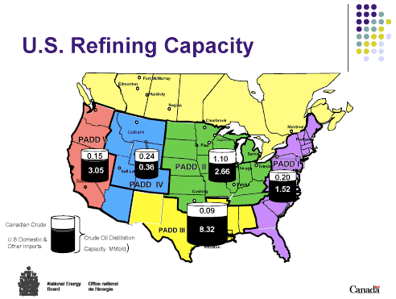
Source: National Energy Board, Canada
U.S. Refinery Map

Source: Ivey Business Review, 2013

Source: Intellectualtakeout
It is exactly at this point where any serious contemplation of lifting the ban on U.S. crude oil exports actually has to start. Given the steadily and rapidly growing inland crude oil production from the Bakken and Eagle Ford shale formations, these inland crude oils have been selling at a discount to U.S. waterborne imports of light crude oil on the Gulf Coast. Those waterborne crude oil imports command a premium price on world markets as reflected in the current spread between WTI and Brent. So this provided refiners in the region with a further incentive to switch to domestically-produced crude oil when available and, above all, whenever possible. Unfortunately, due to the fact that most refiners in the Gulf Coast are geared primarily towards heavier crude oil, there tends to be a glut of light sweet crude oil in the region. This over-supply is expected to worsen in the future. If we stop with our observation right here, the arguments for lifting the ban on U.S. crude oil exports would make absolute sense.
However, we cannot look at the Gulf Coast in total isolation from the East Coast with its existing refining capacity for light sweet crude oil, the major population centers in the Northeast and the fact – as Mr. Pickens pointed out – the U.S. is still importing between 9 and 10 mmb/d. In addition, there are no crude oil pipelines connecting the Gulf Coast to the East Coast. Consequently, the glut of light sweet crude oil should be shipped from the Gulf Coast to U.S. refineries in the Northeast by tankers in order to further reduce U.S. dependence on foreign oil imports. However, this is difficult due to another longstanding regulatory roadblock called the ‘Jones Act’- a section of The Merchant Marine Act of 1920. The Jones Act requires that any ship that carries goods or commodities in U.S. waters between U.S. ports be built and registered in the U.S., and owned and crewed by U.S. citizens or permanent residents. While the objective of the Jones Act was to restrict the activities of foreign-flagged vessels carrying goods between U.S. ports in the past, this Act cannot be regarded as timely in an age of globalization. Moreover, the Jones Act actually burdens the very same entity it set out to protect; namely, the United States and its citizens. What an irony that the U.S. with all its current and in the future projected crude oil production actually helps to keep oil revenue streams for countries like Venezuela, Nigeria and Saudi Arabia in place. And all this is in no small part also thanks to the Jones Act.
Instead of discussing the ‘all-out option’ of lifting the ban on U.S. crude oil exports, the U.S. would be well advised to repeal the Jones Act first and reduce its dependence on foreign oil imports further. Once East Coast refiners are able to eschew imported Brent-related crude oil and run domestically-produced light, sweet crude, the next logical step can be taken; namely, lifting the ban on crude oil exports.
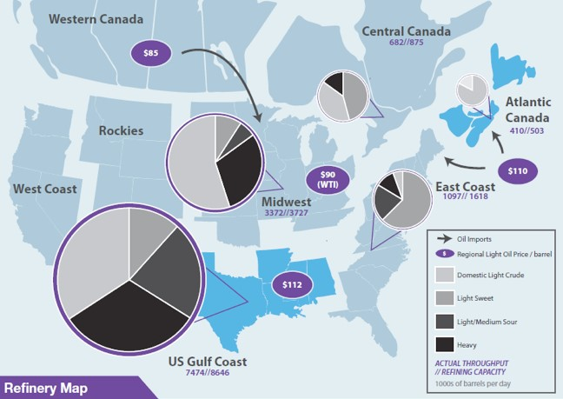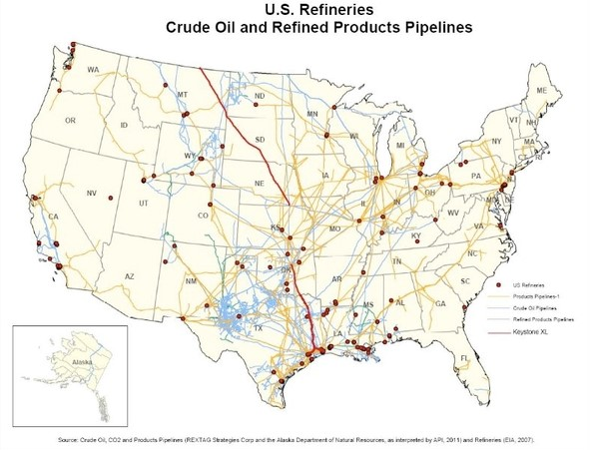

Is LIGTT legit? -- American Shipper February 2014
See “American Shipper, February 2014”.

Short-sea shipping panel to meet at cookhouse
The Times-Standard, Posted: 01/21/2014
The Humboldt Bay Harbor Working Group is hosting a panel discussion on short-sea shipping into Humboldt Bay Harbor. Panel members include: Patrick Higgins, Humboldt Bay Harbor, Recreation and Conservation District; Stas Margaronis, Trucking by Water, Humboldt-Stockton Connection; and Stephen Pepper, Humboldt Maritime Logistics. The discussion will take place at the Samoa Cookhouse on Wednesday, Jan. 29, from noon to 1:30 p.m.

Marad Chief: US-Flag Carriers at ‘Tipping Point’
Joseph Bonney, Senior Editor, Jan 16, 2014, The Journal of Commerce
The U.S. Maritime Administration’s top official said U.S.-flag carriers in international markets are “at a tipping point” and that helping them compete will be an important part of Marad’s effort to develop a national maritime strategy.
“We’re going to put pen to paper here very quickly,” Acting Maritime Administrator Paul “Chip” Jaenichen said at the end of a three-day Marad symposium that focused on U.S.-flag international carriers.
Jaenichen said the forum, which attracted approximately 200 attendees, was a first cut at developing a national maritime strategy. He said except for tweaks in 1970, the current one hasn’t been changed since the 1936 Merchant Marine Act.
Marad plans additional sessions, possibly in conjunction with industry events. Jaenichen said the process will emphasize transparency. The agency has opened a Federal Register docket for comments on development of the strategy. Webcasts of speeches at this week’s event are on Marad’s website.
Past attempts to overhaul U.S. maritime policies have run agound on bickering by industry factions. Jaenichen said the objective is to develop proposals that can be enacted, even if they don’t provide everything everyone wants.
“It might mean giving up something that you want in order to ensure the long-term health of the indusry,” he said.
Following this week’s discussion of U.S.-flag international shipping, Marad plans during the coming months to dive into issues affecting domestic offshore shipping; Gulf, inland and Great Lakes markets; and shipyards.
Any maritime strategy must cover all sectors, Jaenichen told the JOC. “Many of the policies that impact the maritime industry are overarching. If you tinker with one of them, you coiuld have an adverse secondary and tertiary impact on other sectors. We want to make sure we’ve worked all those things out,” he said.
Much of the discussion at this week’s symposium focused on seeking ways to increase commercial shipments by U.S.-flag international carriers. These carriers now are overwhelmingly reliant on government-impelled shipments of military cargo, food aid, and shipments with U.S. Export-Import Bank financing.
Military shipments are falling with the winding down of the Iraq and Afghanistan wars. Meanwhile, U.S.-flag guarantees of carriage of food aid shipments have been weakened by amendments to the last transportation funding bill and the recent budget compromise.
“There is no question that we are at a tipping point for the U.S.-flag fleet operating in international trade, and for some the conditions are already dire,” Jaenichen told the symposium.
“Before we can build the U.S. fleet we must hold what we have, and that means cargo,” he said. “There has to be the cargo, or a buildup of the fleet is going to be artificial and not sustainable.”
U.S.-flag presence in liner shipping is almost entirely limited to vessels in the Maritime Security Program, which provides $3.5 million annual subsidies to 60 ships whose operators agree to make them available for military needs along with commercial cargo.
MSP carriers say the subsidies don’t fully offset the higher costs of U.S.-flag operation. Carriers that continue to operate international services under the U.S. flag do so primarily to retain access to government-impelled shipments under cargo preference programs.
Domestic offshore carriers are shielded from non-U.S. competition by the Jones Act, which requires shipments between U.S. ports to be carried in U.S.-flag, U.S.-built vessels that are owned and crewed by Americans.
Jones Act supporters have beaten back repeated efforts to weaken the law, but are carefully watching efforts to permit exports of U.S. oil and gas. Coastwise petroleum shipments are a key source of cargo for Jones Act tanker operators and unions.
The U.S. energy boom has generated discussion of re-establishing a U.S. presence in construction and operation of LNG tankers. Proposals raised at the symposium included tax and financing incentives to encourage U.S. investment in these vessels.

2013 DOT Year in Review: MARAD puts its muscle behind freight
Posted by Paul "Chip" Jaenichen, MARAD, Jan, 3 2014
Here at the Maritime Administration (MARAD), we continue working tirelessly to improve our marine transportation system with innovative projects across the country. As our economy rebuilds and jobs are created, we are reminded just how much the maritime industry has contributed to these growing numbers and more importantly. . . Why Maritime Matters!
It has long been a vision in our industry to move more freight on our rivers, Great Lakes, and waterways, as well as through American river, lake, and sea ports. This year it became reality when one of the first major marine highway services began on the West Sacramento-Stockton-Oakland “Green Trade Corridor.” This flagship project takes freight off the congested Interstate 580 and moves it on the San Joaquin River. It is expected to remove 180,000 trucks from the highways and save more than 7 million gallons of fuel annually. What’s more, it’s helping to move more U.S. exports to Asia, a key market essential in the expansion of our nation’s trade and commerce.
Continued growth in America’s exports coupled with the widening of the Panama Canal requires the maritime industry and shippers to prepare for the most significant change in global trading patterns in the last century.
The wider and deeper locks that open in 2015 on the Panama Canal will create new opportunities and jobs across the country as transportation officials and port authorities prepare for larger vessels to call at Gulf and East Coast ports. Phase I of MARAD’s comprehensive, multi-phase Panama Canal study was released earlier this year and will help inform stakeholders on current and future infrastructure investments.
The Obama Administration clearly understands the importance of U.S. ports as the gateways to the national freight network and has already invested more in port infrastructure than any previous Administration. Additionally, more than $150 million has been invested in America's shipyards, which support over 402,000 jobs and produce $36 billion in annual GDP.
The continued expansion of our maritime industry is critical to our competiveness in the global market. That is one of the primary reasons why we're hosting the first ever National Maritime Strategy Symposium. This meeting will gather stakeholders industry-wide to help develop the foundation for a robust national maritime strategy. It is critical that we strengthen America’s maritime industry, with a focus on building the foundation for a 21st Century economy that will carry us far into the future.

SECTION 11 - APPENDICES

Articles on AMH can be provided in PDF format to DLacayo@portofhueneme.org

ADDITIONAL INFORMATION

American Association of Port Authorities (AAPA) – Maritime Economic Development Committee
Committee Mission - Shall monitor, collect and disseminate information pertaining to the role of ports as catalysts for maritime industrial development in their communities, including ongoing review of relevant laws, regulations, programs and initiatives; provide a forum for the exchange of innovative approaches to maritime industrial development, and raise public awareness about the role of ports in maritime industrial development ; and shall propose policy action to the Executive Committee or U.S. Legislative Policy Council as appropriate; and, at the request of the Executive Committee or U.S. Legislative Policy Council or the Chairman of the Board, shall represent the Association before entities concerned with legislation, regulations or standards.

Please contact Dona Toteva Lacayo at DLacayo@portofhueneme.org if you would like additional information on the content of this newsletter or if you would like to submit any information for an upcoming AMH Update.

Dona Toteva Lacayo
AAPA Maritime Economic Development Committee/America’s Marine Highway Work Group
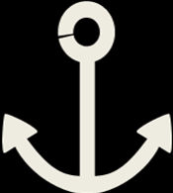
Port of Hueneme, Oxnard Harbor District
333 Ponoma Street, P.O. Box 608
Port Hueneme, CA 93044-0608
Office 805.488.3677 x2231
Cell 805.890.9772
DLacayo@portofhueneme.org

