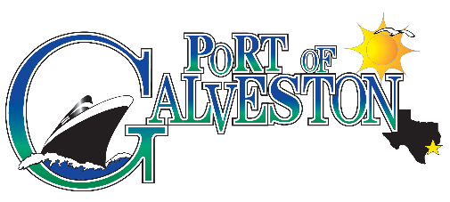

AAPA COMMUNICATIONS AWARDS PROGRAM

  - Port of Galveston
  - The Port of Everything
Classification: Advertisements
Port Category: 2

SUMMARY: Port of Galveston repositioned its message strategy to help support the local business owners of the community while it supports the overall image of Galveston as a destination for families, couples, and traveling friend groups. The goal was to complement the park board and city’s message of getting people to think of Galveston as more than just a day trip down from Houston (pre and post cruise).

What are/were the entry’s specific communications challenges or opportunities?
Port of Galveston had an opportunity to reposition themselves among the cruise consumer audience as a port destination that offered restaurants, retail, sights and sounds worthy of an extra night pre or post cruise. The message was designed to bring a fun, livelier, more colorful image of Galveston as it competed with other port destinations. The idea was to convey that Galveston offered something for everyone, brought to life in its new tagline: The Port of Everything.

How does the communication used in this entry complement the organization’s overall mission?
The Port’s Mission is elaborated as: “Port of Galveston management and staff will protect, preserve and enhance the assets of the City of Galveston’s waterfront property by continuing to rebuild and improve facilities to grow opportunities for existing customers and attract new businesses that will promote jobs and economic prosperity for the community.

Port of Galveston repositioned its message strategy to help support the local business owners of the community while it supports the overall image of Galveston as a destination for families, couples, and traveling friend groups. The goal was to complement the park board and city’s message of getting people to think of Galveston as more than just a day trip down from Houston. The ad campaign is used to remind cruise customers that there is an alternative to Florida and California for embarking on a cruise – a fun destination, an accessible destination, an affordable destination. Research showed us that consumers did not even have Galveston on their consideration list and we wanted to improve that.

What were the communications planning and programming components used for this entry?
Port of Galveston designed messaging around the fun things to do in Galveston that were brought to life with colorful images of real life in Galveston, not just when there was a festival. Overcoming a negative perception or a mindset that only Florida and California had a fun destination, we wanted to SHOW cruise guests and cruise lines (pre-post/port of call) and convince them to come to The Port of Everything. We used the key selling attributes of accessibility, affordability, and variety to build a compelling message that drew the audience in and motivated them to think Galveston.

What actions were taken and what communication outputs were employed in this entry?
The call to action for Port of Everything campaign was to drive people to the site where they could learn more and make their arrangements.
We knew we could measure response based on visits to the site and conversions off the site. We strategically let the ad serve as the lure and the site serve as the education.

What were the communications outcomes from this entry and what evaluation methods were used to assess them?
Port of Galveston experienced a rise in inquiries about pre and post stays as a result of the ad. The message resonated with the audience and we saw an increase in activity from our social media outlets.

