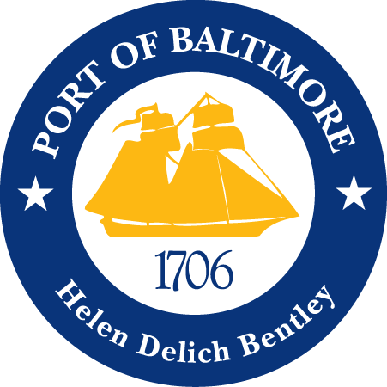

2018 AAPA COMMUNICATION AWARDS SUBMISSION
Port of Baltimore
Making Improvements
Classification 1: Advertisements
Port Category: 2
Summary:
In the time of mega container ships, record volumes and rapid expansion, seaports face fierce competition. This environment lends itself to transparency; recognizing needs for improvement, and delivering action plans to our customers to maintain a competitive edge. The Maryland Port Administration’s (MPA) submission is a single advertisement on behalf of the Port of Baltimore showcasing upcoming enhancements, providing a “what to expect” roadmap for our customers.
1. What are/ were the entry’s specific communications challenges or opportunities?
The Port of Baltimore experienced a record year in 2017, including an 11 percent increase in containers from the previous record set in 2016. With booming containers comes booming traffic, and with booming traffic comes long truck turn times. This has created a need for additional equipment and various improvements to ensure efficiency and customer satisfaction. The MPA saw this as an opportunity to develop an advertisement on behalf of the Port of Baltimore to provide a roadmap for our customers, highlighting the Port’s planned improvements.
As a state agency, the MPA reports to the Maryland Department of Transportation (MDOT) and Governor of Maryland’s Office. Additionally, we lease our public marine terminals, so at times this creates a multi-tiered communication challenge of having to work with several offices for approvals. For this specific advertisement we worked closely with Ports America Chesapeake, which leases our Seagirt Marine Terminal, on informative copy for our customers.
Another challenge we face as a state agency is budget constraints. While the MPA has direct control over its six public terminals, it is also responsible for promoting and communicating on behalf of all public and private marine terminals located in Baltimore as the “Port of Baltimore”. The cost savings measures taken with this advertisement were from the media buyer’s negotiations and the in-house graphic designer making MPA’s creative concepts a reality.
The internal and external factors associated with the creation of this ad were numerous. The external pressure from the competitive nature of the maritime industry paired with the 2017 record breaking success of the Port of Baltimore made for longer than normal truck turn times. That was the inspiration for this ad. The internal collaboration through discussion, data gathering, resourcing and design are what brought the concept to fruition.
2. How does the communication used in this entry complement the organization’s overall mission?
The MPA’s mission is to stimulate the flow of waterborne commerce through the ports in the State of Maryland in a manner that provides economic benefit to the citizens of the state. The MPA strives to capitalize on port business opportunities, provide, manage and promote competitive, secure, state-of-the-art terminals capable of efficiency handling diverse cargoes, leverage mutually supporting public and private sectors and act as a good steward of Maryland’s natural environment.
The Port of Baltimore wants to ensure shipping lines, cargo owners and others impacted by the port’s business and operations are aware of the port’s upcoming additions and improvements. In continuing with that effort, the Port revamped its website, distributes a bimonthly magazine, and shares the most up-to-date information via social media.
The “Making Improvements” advertisement was heavily influenced by the MPA’s mission as it is seeking to create awareness of improvements and enhancements, stimulating the flow of waterborne commerce and promoting future efficiencies, therefore providing economic benefit to Maryland citizens. The MPA, private companies and the State of Maryland has invested in our Port’s infrastructure with a goal of seeing a return on investment. Through disseminating this advertisement, the MPA hopes to attract new customers and to let existing customers know that we are becoming even more efficient.
3. What were the communications planning and programming components used for this entry?
The primary audience for the advertisement includes the trucking industry and cargo customers. The secondary audience for the advertisement includes shipping lines and maritime executives.
The goals of the advertisement were to:
- Generate awareness to both current and potential port customers of the Port of Baltimore’s improvement and enhancement roadmap. This includes an additional 50-foot deep berth, more Neo-Panamax cranes and Rubber Tired Gantry (RTG) cranes, expanded gates and enhanced gate technologies.
- To inform customers that the Port of Baltimore is working towards increasing efficiencies and expanding operations.
- To promote the Port’s contact phone number, website and Twitter, where those who are interested to learn more can speak with our sales staff.
The objective of this advertisement was to:
- Conceptualize and execute a paper advertisement to deliver important information to our customers in an eye-catching manner.
- The milestones to achieve our objective was:
  - Work with Ports America Chesapeake to determine what projects to highlight in the advertisement.
  - Schedule Photographer to shoot new RTG cranes in service for print.
  - Conceptualize how to showcase projects.
  - Design print advertisement based on concept.
  - Receive publishing approval from Ports America Chesapeake and MPA.
  - First Published March 19th in the Journal of Commerce Magazine.
4. What actions were taken and what communication outputs were employed in this entry?
As a state agency, we are allocated a limited amount of advertising dollars each fiscal year, and those funds are always subject to budget cuts due to the state’s budget constraints. Thus, we have an in-house graphic designer dedicated to creating and submitting advertisements, along with a media buyer to negotiate and secure appropriate media placements. Input was used from other MPA department’s, such as Planning, Marketing & Sales as well as external companies like Ports America Chesapeake.
The “Making Improvements” ad was placed in publications based on their specific topics to be discussed as well as cost effectiveness, in order to effectively reach our target audience. This particular advertisement has run/ is scheduled to run in the following publications:
- Journal of Commerce
- American Journal of Transportation
- Maryland Motor Truck
- Intermodal Association of North America
- Maritime Logistics Professional
- American Shipper
- Transportation Intermediaries Association
- DC Velocity
- Global Trade
5. What were the communications outcomes from this entry and what evaluation methods were used to assess them?
The Maryland Port Administration’s Trade, Marketing and Sales Department’s travel the country and globe to meet with both current and potential customers. On these visits, the Port’s representative highlight’s the upcoming improvements and enhancements that are coming down the pike. From what they have gathered, almost every time they meet with a company, the customer commends them on an exceptional, attractive looking, and informative ad. The Sales & Marketing Department has also received positive emails and phone calls mentioning the ad.
Based on when the ads were placed in the specified media publications, our website visitation spiked per our Google Analytics.

