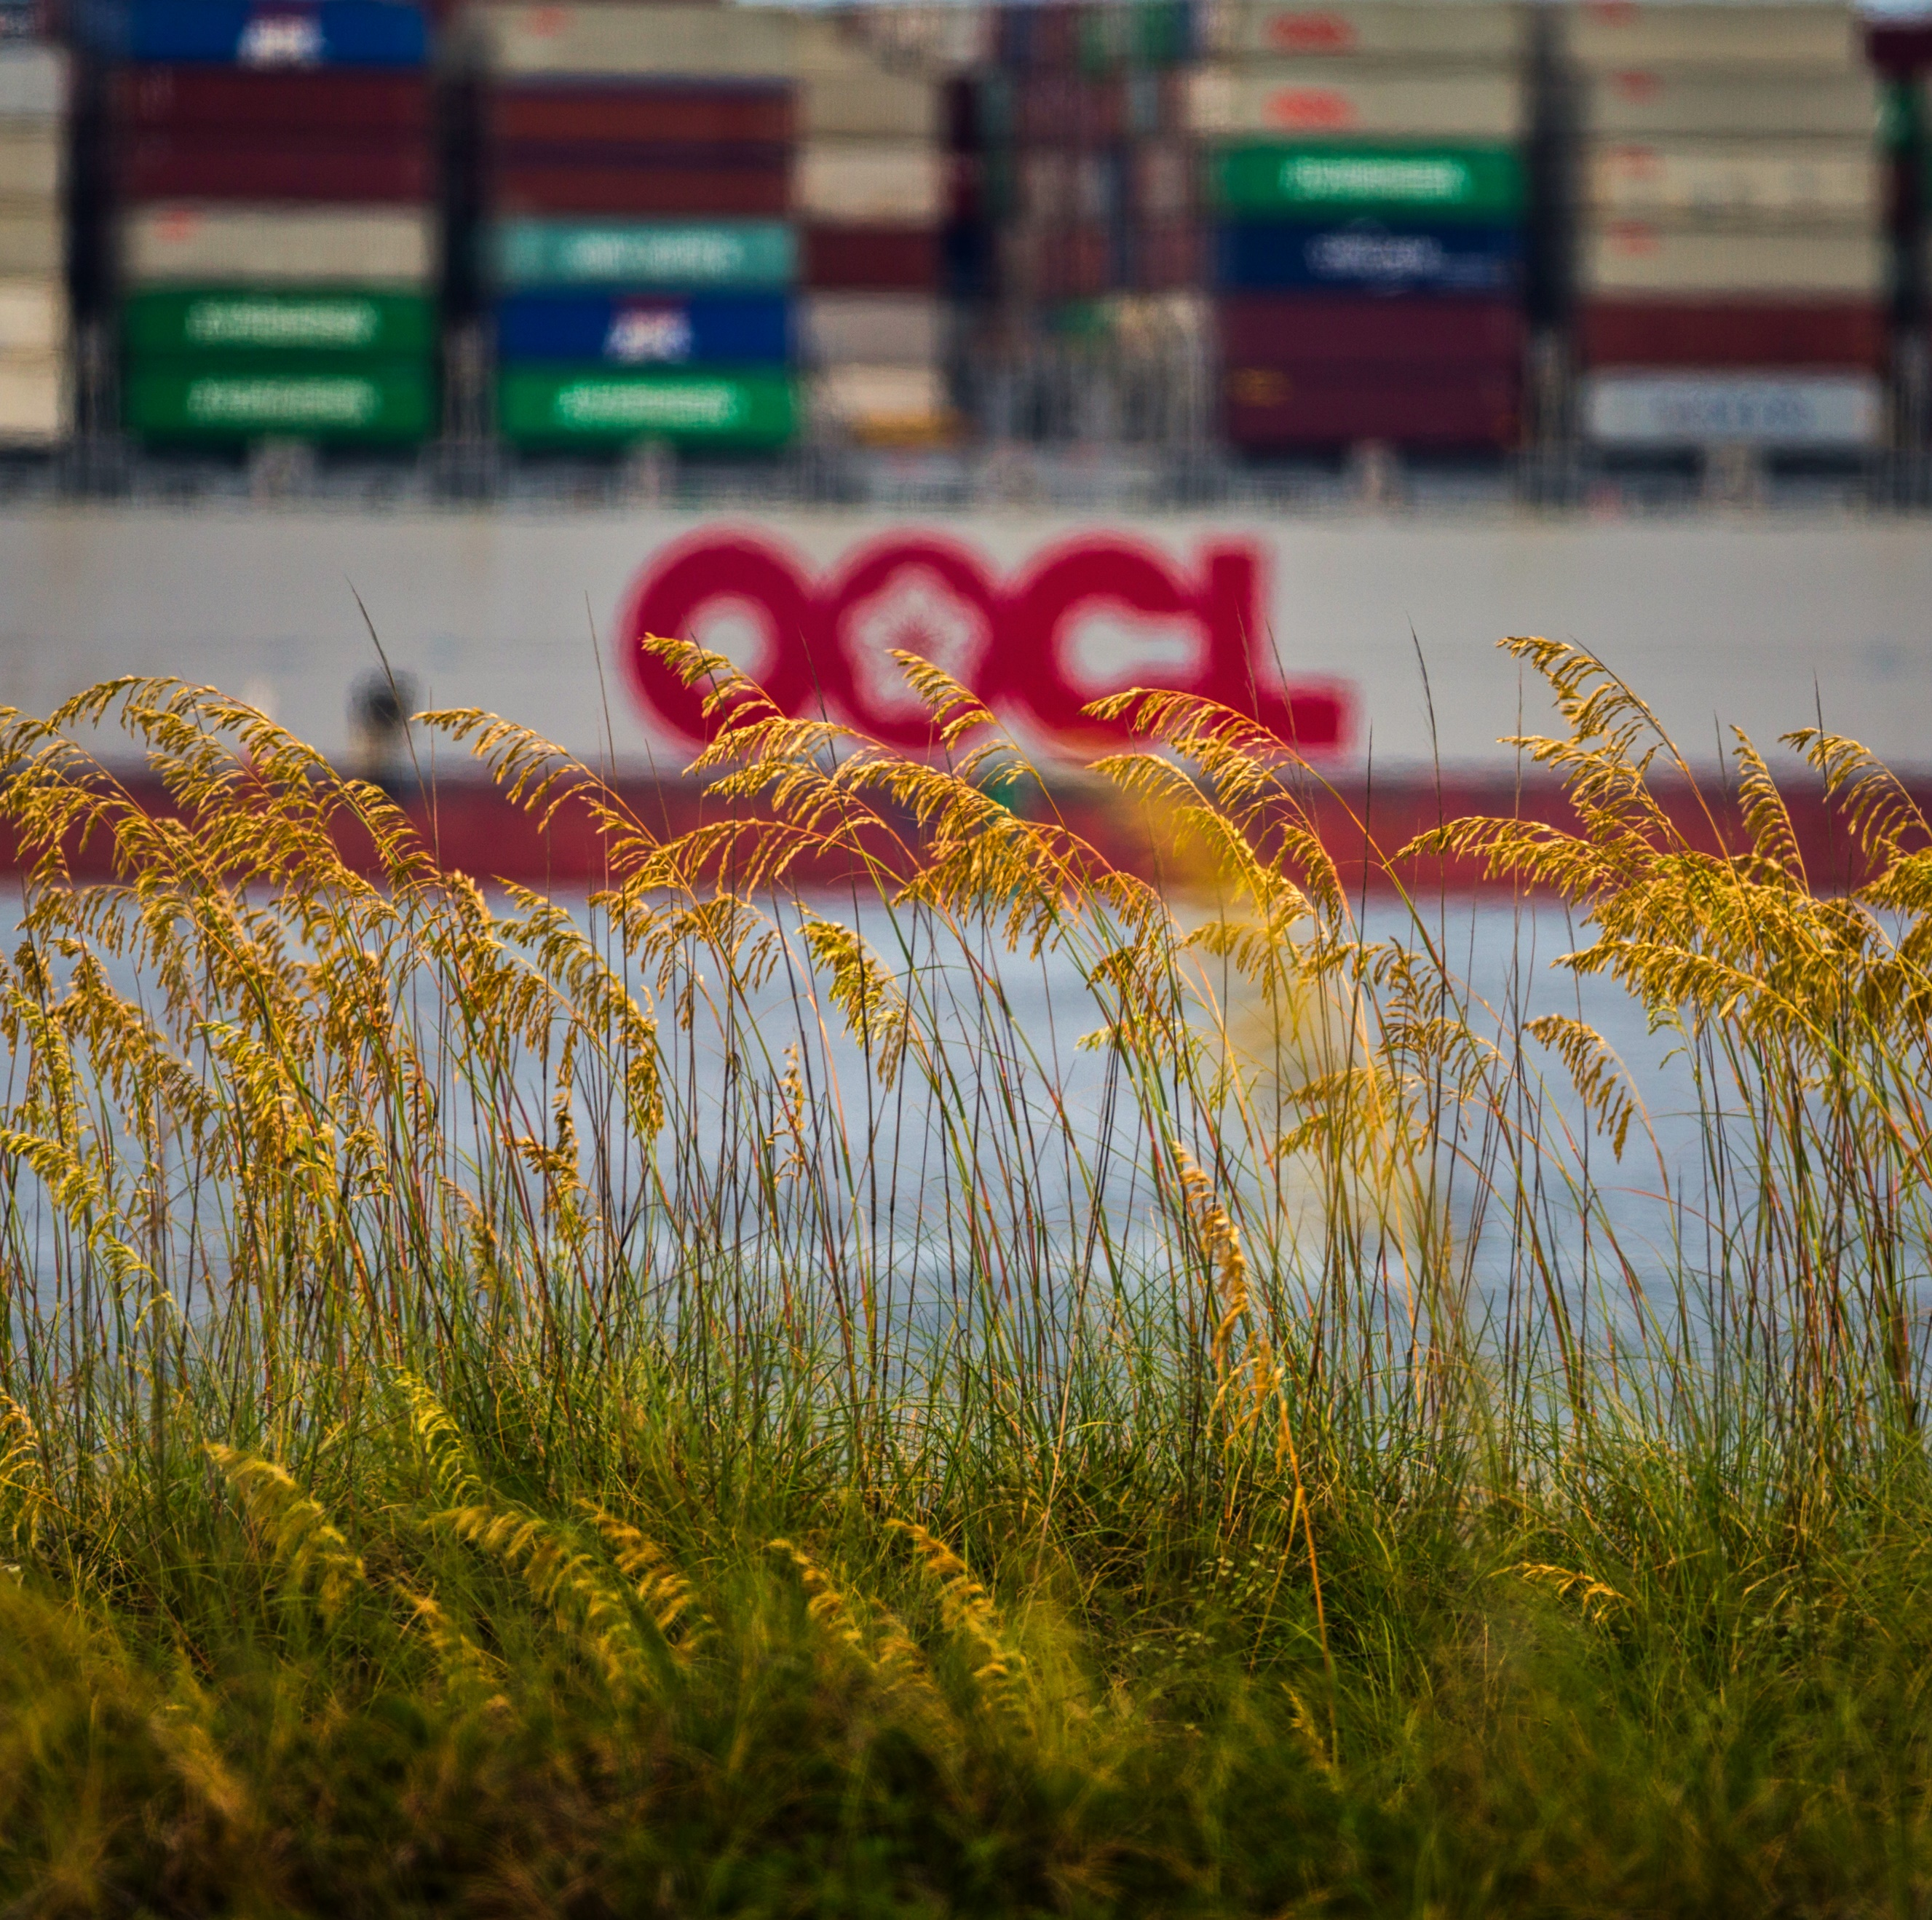
CY18
Ports Guide
and Directory

SUMMARY
The Georgia Ports Authority’s CY2018 Ports Guide and Directory provides helpful information for port users. It explains the capabilities at each GPA terminal, lists contacts for GPA and other maritime professionals, and contains articles detailing the Authority’s major infrastructure initiatives.
1) CHALLENGES & OPPORTUNITIES
The primary challenge for this publication is to provide not only a resource for existing port users, but an informative sales tool for GPA’s Trade Development team, who need to convey to new customers the scope and efficiency of GPA operations.
Another consideration is the need to conduct a thorough review of the contact listings each year, to ensure any changes in titles or personnel are reflected in the final product. Internally, that requires the cooperation of each department as administrative staff review the listings and provide updates that the GPA communications team then tabulate and share with contracted designers.
In Fiscal Year 2017, the year preceding publication of this book, the Port of Savannah moved a record 3.85 million twenty-foot equivalent container units, an increase of 6.7 percent. Most of that growth came in the last half of FY17. Savannah’s Garden City Terminal is the fourth busiest container port in the nation.
Meanwhile, the Port of Brunswick handled more than 600,000 units of cars, trucks and tractors in FY2017, making it one of the busiest Ro/Ro ports in the nation. Savannah and Brunswick’s combined fiscal year 2017 performance resulted in total tonnage of 33.4 million tons of cargo for the year, an 8.3 percent increase and another all-time high.
This publication gives GPA an opportunity to let all port users know what services are offered and provides correct contacts needed for any area of port-related business. Giving port users a comprehensive guide makes their port transactions smooth and efficient.

2) GEORGIA PORTS MISSION
The mission of the Georgia Ports Authority is to empower entrepreneurs, strengthen industries, sustain communities, and fortify families by relentlessly striving to accelerate global commerce. The CY18 Ports Guide and Directory details the efforts GPA made in FY2017 to carry out those priorities.
The directory also provides current and potential port users with a handy resource to put customers directly in touch with the best GPA representative to provide targeted service.
Specific articles in the publication cover topics such as:
• The Port of Savannah’s growing crane fleet, demonstrating GPA’s ability to stay ahead of current and future market demand.
• The amount of industrial space surrounding the Port of Savannah, which serves as a model for the logistics and transportation industries.
• GPA’s long-term plans to fully develop the south side of Colonel’s Island at the Port of Brunswick, increasing the annual throughput capacity to 1.4 million vehicles.
• A profile on chilled cargo coming through the Port of Savannah, which utilizes GPA’s unmatched refrigerated cargo infrastructure.
• A basic how-to guide for new customers getting started in the import/export trade.
• Sections listing the specifications of each terminal in Savannah and Brunswick include aerial photos, to help new customers visualize the services they will receive from GPA.

3) PLANNING & PROGRAMMING
Goal: To take a phone and specs list and make it far more useful, readable, and attractive than a standard directory. GPA uses this directory as a vehicle to communicate our larger mission as a company, which is to grow business in Georgia and cargo movement through Georgia’s ports efficiently.
Objective: To share the importance of Georgia’s deepwater ports to Georgia’s economy as a whole, while sharing our commercial advantages with industry professionals.
Target Audiences:
• Local and regional community members and government leaders
• Port customers
• Maritime logistics partners
To make the guide visually attractive, GPA hired professional photographers, and used high quality pictures and diagrams throughout. Georgia Ports Authority rebranded in 2017, and the Ports Guide was designed to complement the company’s new guidelines. The team worked to carry a clean, fresh design through this updated print product. Designed in tandem with GPA’s Annual Report, the two publications appear as companion pieces with consistent branding throughout.
The 98-page GPA CY2018 Ports Guide and Directory offers a balanced mix of feature articles touting the competitive strengths of Georgia’s ports, with quick-hit stats and facts for current port users, a beginner’s guide for new importers/exporters, and terminal specifications. The guide also features a GPA phone and email directory, as well as listings for maritime commercial services operators in Georgia.
Sections:
• A photo spread on GPA Board members and the executive team
• Descriptive feature articles on GPA infrastructure improvements and maritime services
• Port User’s Guide
• Key data in GPA’s trade
• Detailed terminal specifications

4) ACTIONS & OUTPUTS
The GPA CY2018 Ports Guide and Directory is issued as a print publication. However, it is also available online. The online edition is updated with new contacts throughout the year, which is beneficial to new companies or those who missed the publication deadline. Port users have the option of downloading the CY2018 Ports Guide and Directory as a PDF.
The Journal of Commerce published the directory and sold ad space. GPA provided creative direction, project management, research and writing. A graphic design firm produced the layout. New and archive photos were used.
GPA’s Corporate Communications team arranged for the directory’s release to coincide with the Georgia Foreign Trade Conference, a conference hosted by GPA which brings multiple regional and national groups in the maritime and logistics industry together for two days in early February.
Preparation begins in July, at the start of GPA’s new fiscal year. Staff determines which strengths and successes are most important to highlight in articles. Once a direction is determined for the overall message, stories are written and the GPA Trade Development office is tapped for specific statistics.
Thousands of directories are shared with current and potential clients throughout the year, and mailed to nearly 800 representatives of the Georgia Department of Economic Development and development authorities across the state.

5) OUTCOMES & EVALUATION
Goal: To take a phone and specs list and make it far more useful, readable, and attractive than a standard directory. We use this directory as a vehicle to communicate our larger mission as a company, which is to grow business in Georgia and cargo movement through Georgia’s ports efficiently.
Result: The GPA sales team regularly uses the Port Guide & Directory when meeting with customers to easily show them the benefits of Georgia’s ports versus other East Coast and West Coast ports. This easy-to-navigate guide is an essential tool for GPA’s sales team, providing answers to customers’ frequently asked questions.
Objective: To share the importance of Georgia’s deepwater ports to Georgia’s economy as a whole, while highlighting our commercial advantages with industry professionals.
Result: The featured profiles in the Port Guide are an outlet to demonstrate GPA’s importance to Georgia’s economy. GPA’s growing ship-to-shore crane fleet, industrial space availability, Colonel’s Island expansion and chilled cargo infrastructure are just a few examples of the advantages offered by the Georgia Ports Authority.
The GPA is one of the largest economic drivers for the state’s economy, accounting for 11 percent of Georgia’s total sales in FY2017, reaching $106 billion. Georgia ports now account for 9 percent of total state employment, or one out of 11 jobs. Personal income derived from port-supported jobs totaled $25 billion statewide in FY2017.
Anecdotal feedback gathered by GPA sales and government relations staff found that the most common use of the Ports Guide & Directory by port users is as a phone book for service vendors in Savannah and around the state of Georgia, as well as a resource to look up terminal specifications.
Stacy Watson, General Manager, Economic & Industrial Development said, “Containing an extensive Port Services Directory composed of port vendors and supporters, the Ports Guide is an invaluable resource for all port users.”

