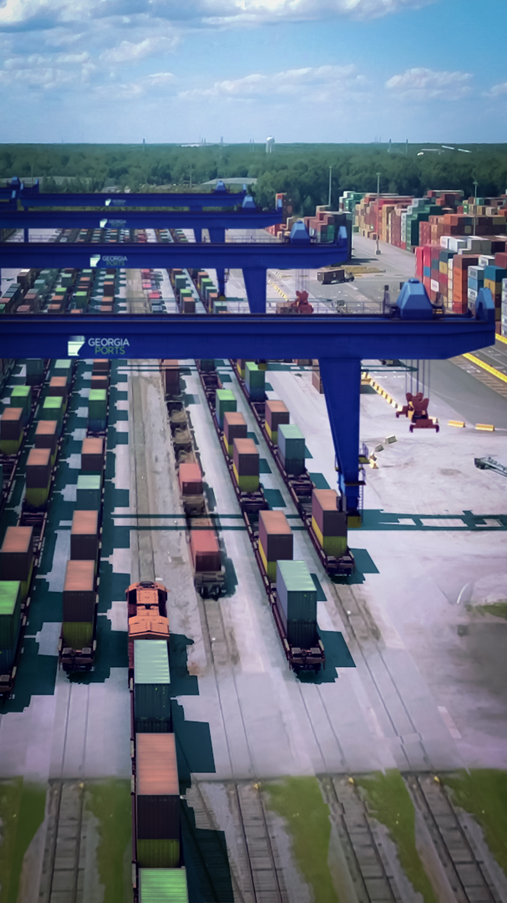
Mason Mega Rail
Campaign

SUMMARY
The Georgia Ports Authority broke ground on its $126.7 million Mason Mega Rail Terminal on March 27. The expansion will increase the Port of Savannah’s rail lift capacity to 1 million containers per year, and open new markets spanning an arc of cities from Memphis to St. Louis, Chicago to Cincinnati.
The project will take trucks off the road and bring products to market with greater efficiency, while opening a new corridor for American commerce to and from the Midwest. It will double GPA’s rail lift capacity while reducing impact on the local community and throughout the supply chain.
Garden City Terminal is already the South Atlantic region’s busiest intermodal gateway, handling 38 trains per week of import and export cargo. Once the Mason Mega Rail terminal is complete, the Port of Savannah will have a state-of-the-art facility, unique to the U.S. East Coast.
Because of the importance of the message and the different audiences GPA needed to reach, the Corporate Communications team created a comprehensive campaign to promote the start of the Mason Mega Rail project. The plan included an event, a press release, an e-newsletter, a social media program, two videos, and several collateral sales pieces among other things.

1) CHALLENGES & OPPORTUNITIES
Market environment:
As the battleground for ports moves inland, and cargo owners continue to diversify their logistics streams to include ports on the East Coast as well as the West Coast, it is imperative that Georgia Ports show customers and stakeholders how we will meet their needs and continue to grow with them.
The amount of international cargo moving through Georgia’s deepwater ports continues to grow. Last year total cargo moved was up eight percent. Because of this incredible continued growth, GPA needs to communicate clearly to customers how they will handle current and future cargo as the volume steadily increases.

The Savannah Harbor Expansion project is more than half-way complete. With the completion of that project, GPA is likely to see an increase in cargo as vessels calling the Port of Savannah can transit the Savannah River more heavily laden. This increase will have a domino effect on inland transportation infrastructure. In order to reduce the likelihood of highway traffic congestion, the Port of Savannah needs to increase reliance on rail. The amount of cargo moved by rail currently at the Port of Savannah is about 18 percent. At other ports on the East Coast it is as much as 35 percent.
Internal and external factors:
Because the Mason Mega Rail project is large and complicated, the Corporate Communications team worked closely with the engineering team as well as the contractors tasked with the first phase of work. This strategy ensured what was communicated about the Mason Mega Rail project was technically accurate.
Beyond communicating the technical details of the project, the more important communication effort was explaining to stakeholders why they should care about this massive infrastructure project. It is imperative for GPA to communicate the new capabilities this project provides and what it will mean for current and future customers as related to GPA’s ability to take on new business and capture greater market share in the Midwest.

2) GEORGIA PORTS MISSION
The mission of the Georgia Ports Authority is to empower entrepreneurs, strengthen industries, sustain communities and fortify families by relentlessly striving to accelerate global commerce.
This Mason Mega Rail project is the perfect illustration of GPA’s mission. It is a capital infrastructure investment that will benefit current and future customers by moving cargo to world markets with greater speed and efficiency.
It will improve the lives of near-port neighbors by reducing rail traffic impacts, while expediting cargo handling for customers and stakeholders. This includes large and small companies that use the port to send their products around the world, as well as companies that employ thousands in the logistics industry and stock the shelves of stores in the U.S.

3) PLANNING & PROGRAMMING
Goal:
Communicate the benefits of the Mason Mega Rail project including the ability of GPA to take on more cargo, offer better service in new territories and improve traffic flow around the port.
Objectives:
- Earn media coverage from national sources including the Associated Press, as well as regional and local publications.
- Attract at least 50 near-port neighbors to a community meeting about the project and earn positive media coverage to magnify the message of the local benefit.
- 50,000 social media impressions
- 2,500 online views of the animated Mega Rail video
- 1,000 online views of the event video
- 20 percent open rate for the customer targeted e-newsletter
- 100 attendees for the groundbreaking event, along with speakers from the federal and state level.
- 10,000 views of the press release between email and GaPorts.com
- 1,000 unique visitors and 2,000 page views for MasonMegaRail.com
Primary Audiences:
Current customers
Potential customers
Near-port neighbors
Secondary Audiences:
State and federal stakeholders

4) ACTIONS & OUTPUTS
Strategy
GPA’s strategy is to capitalize on notable milestones of the Mason Mega Rail project, focusing on showing stakeholders how it benefits them, while keeping project details easily accessible at all times.
Tactics
Background Information
The communications team worked with the engineering team and contractors to compile technically accurate information to share with GPA leadership and sales teams as they made presentations and met with customers.
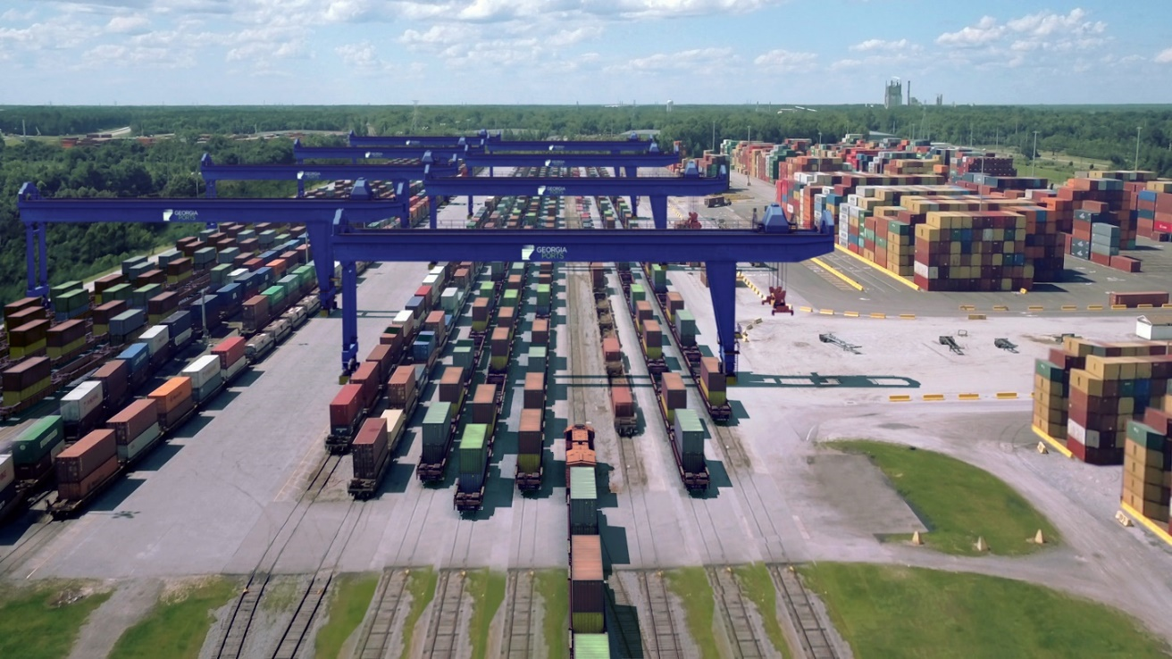
Community Meeting
The GPA held a public meeting in February 2017 where representatives from Garden City, Chatham County and the Georgia Ports Authority discussed how the Mason Mega Rail project will greatly reduce the use of rail crossings around Garden City Terminal, while increasing capacity and jobs for the local community.
Mega Rail Animated Video https://www.youtube.com/watch?v=tkzNWsmsZks
This was the first piece released to stakeholders announcing the benefits of the project. It was shown to more than 1,300 industry and local business leaders at GPA’s annual State of the Port event and then shared through online channels. This video took several months to produce and was a combination of animation, ground video, drone footage and still images.
Mason Mega Rail Groundbreaking Event
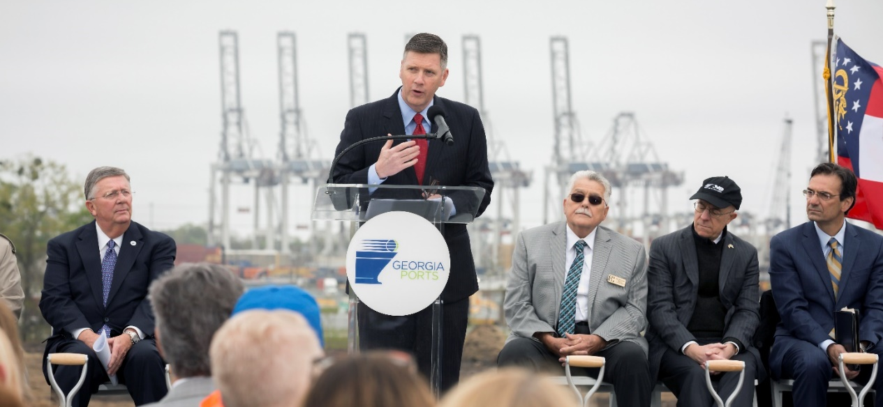
Visual: A top priority of this event was creating more than one inspiring visual. This strategy helped to give the dozens of media in attendance several options and encouraged them to give more prominence to GPA’s story because of the strong accompanying visuals. This prompted GPA to hold its event on top of a hill more than three stories high. The hill provided a view of not only the entire project site, but also a working terminal in the background, and distantly the Savannah River lined with working cranes. We worked with partners at both CSX and NS, notoriously known not to work together well, to have engines from both railroads there and arranged for a photo op.
Banners: Another aspect of creating an interesting visual and helping facilitate the event were two massive banners, one 3’ x 25’ that included the Mason Mega Rail logo and tag line. It was used to designate where people should enter the event site. The other was a 10’ x 30’ rendering of the finished project secured at the top of the hill. Both requires specialized rigging and to be printed on mesh because of the wind on the hill.
Speakers: A key to attracting a broader media audience was to engage speakers known more than just locally. We secured a variety of impressive speakers including the Federal Maritime Administrator, Rear Admiral Mark Buzby, the Governor of Georgia Nathan Deal (although he had to bow out at the last moment because of funeral services for former Georgia Governor Zell Miller,) officials from both CSX and Norfolk Southern, as well as local elected officials.
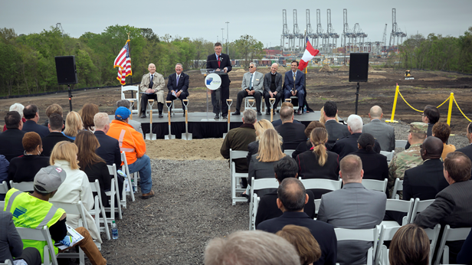

Brand Ambassadors: With the acknowledgement that employees are also our best ambassadors to the local community, GPA made it a priority to invite more than 50 employees from all levels of the company who will be involved in the project or the resulting rail work.
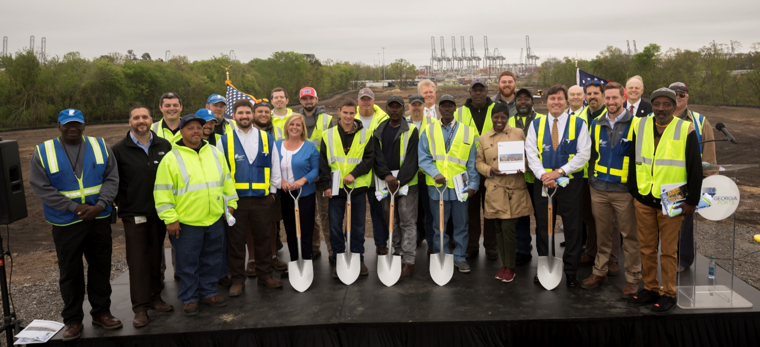
Give Away: To keep the Mega Rail project top-of-mind for both the officials present as well as the local community, we used the event as an opportunity to give several mementos. Custom shovels were designed for the groundbreaking as well as custom wall hangings that included a rendering of the finished project and a commemorative mini shovel for the officials. All guests received a fun super-hero themed Mega Rail T-shirt.
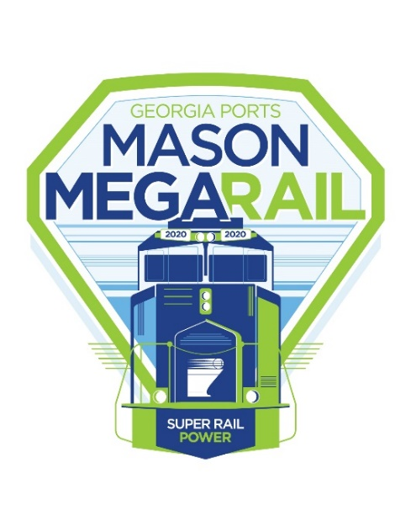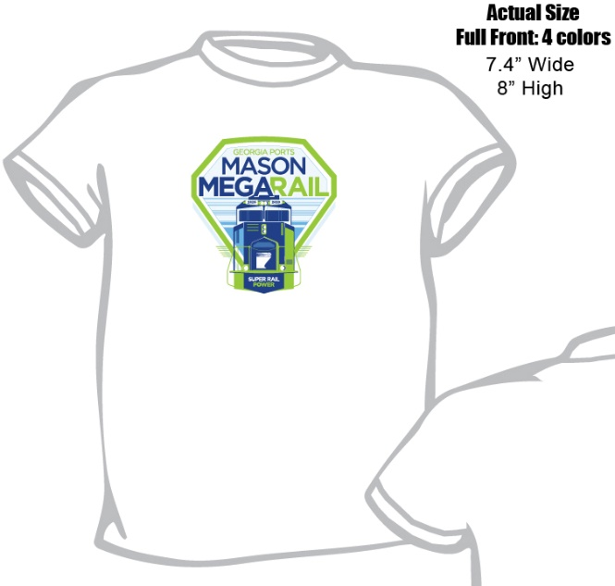
Volunteers: Dozens of GPA volunteers were recruited to man information and T-shirt tables, drive those who couldn’t walk up the hill, and transport media to the site. Also, the senior director of engineering was on hand with a wall-sized schematic of the project to answer questions and facilitate discussion about the benefits of the project.
Collateral Material: Three printed pieces were produced in support of the Mega Rail Campaign. One was a brochure intended for use by the sales team that focused on the benefits of the project for customers. The second was a visually compelling piece focused on the project’s timeline that was targeted to groundbreaking event attendees. The third was a detailed schematic of the project for use both during the event and for the sales team.
Press release:
http://www.masonmegarail.com/news/2018/3/27/mason-mega-rail-breaks-ground
A press release quoting key stakeholders including the federal maritime administrator and governor was sent to GPA’s media and customer email lists following the groundbreaking event. The next day, the GPA sent the release to targeted media in the specific markets that will receive improved service because of the Mega Rail project, including the Midwest.
Event Video:
https://www.youtube.com/watch?v=e6ew9wKV_Gc
GPA commissioned a video news release from the groundbreaking as a way to follow-up with customers after the big event. It was released as part of the e-newsletter from the executive director about a week after the groundbreaking. Because of the dramatic drone footage, powerful soundbites and interviews, it performed well with those who had received the event press release as well as those who didn’t.
Newsletter: http://campaign.r20.constantcontact.com/render?m=1102555025937&ca=8581d911-9f96-4147-b11e-9ea2f30208fa
About a week after the event, the GPA followed up with current and potential customers via an email newsletter from the executive director. The newsletter reiterated the benefits of the Mega Rail project, but also included a new video news release based on the groundbreaking event.

Social Media: GPA social media channels were used before and during the groundbreaking. Messages were targeted to segments of GPA’s audience on each channel. Messages about commercial advantages were used mostly on Twitter and LinkedIn where we find our business partners and elected officials while messages about community traffic improvement were aimed at Facebook, where many of our near-port neighbors choose to interact with us.
Prior to the Mason Mega Rail groundbreaking, Georgia Ports Authority’s Corporate Communications team drafted posts for all social media channels to complement multimedia content generated from the event. This included text to accompany GPA’s press release, photos of dignitaries and links to the event-specific website, www.masonmegarail.com.
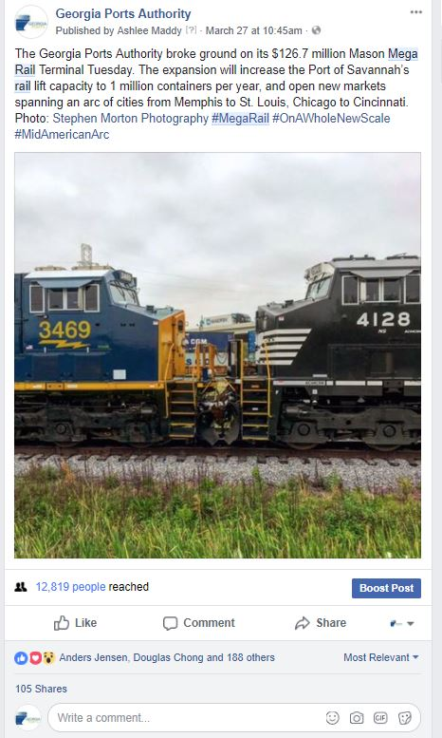
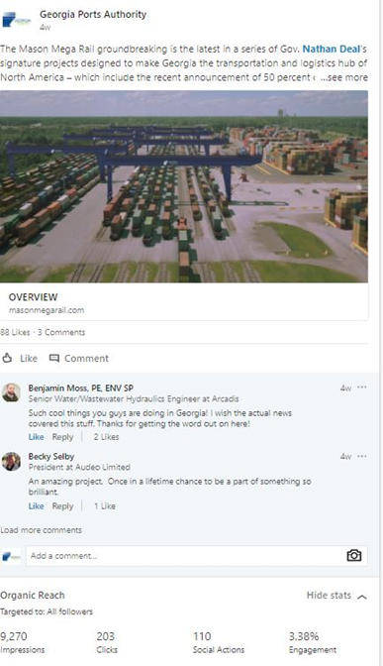

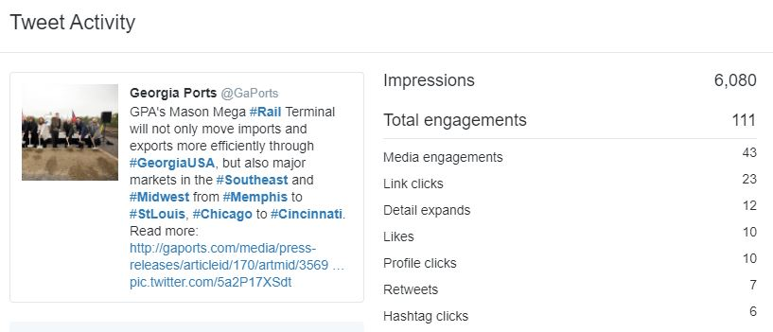
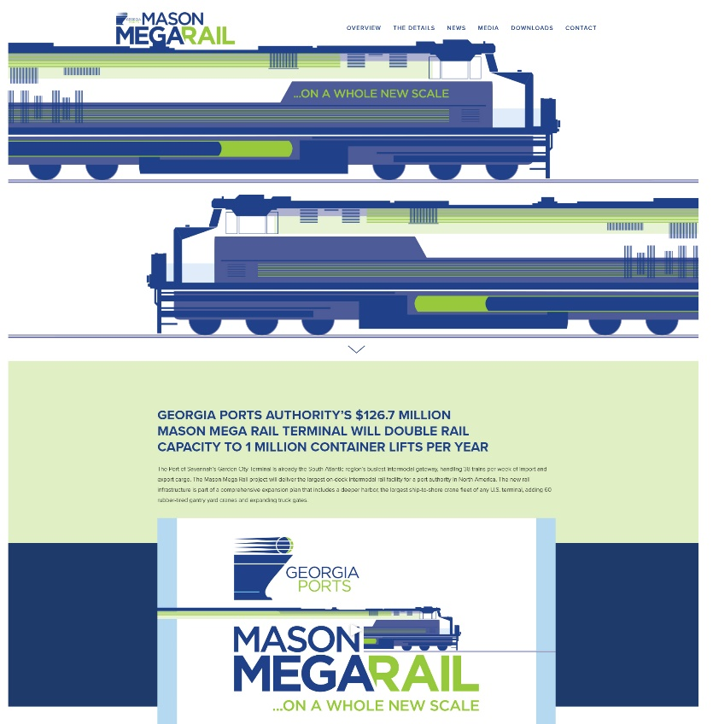
MasonMegaRail.com: The Mason Mega Rail web page was created as a home base for all information GPA shares about the project. The page continues to be used and will be updated throughout the project.

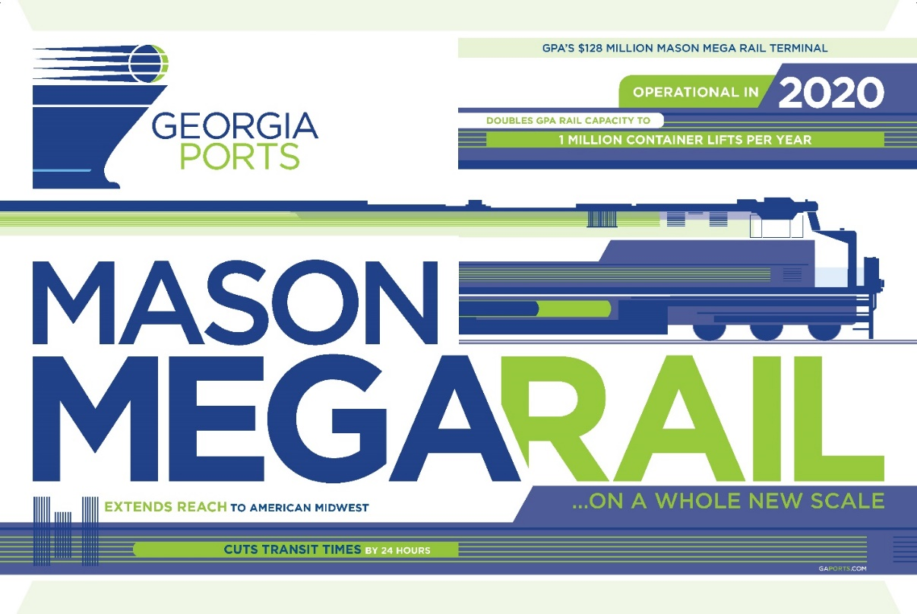
Advertisement
Ads were created in both online and print formats to be included in a variety of publications such as Site Selection Magazine, Journal of Commerce, Inbound Logistics, Atlanta Business Chronicle, Maritime Logistics Professional, Expansion Solutions and DC Velocity.

Implementation
Timeline
July 2016: Georgia Ports receives Federal FASTLANE Grant
February 2017: Community Meeting
May 2017: Campaign brainstorming and consensus building
June 2017: Production of video animation of project
September 2017: State of the Port, unveiling of project and video
November 2017: Production of collateral material
December 2017: Groundbreaking event planning
March 2018: Groundbreaking event
Continually
Video will be shot for a time-lapse style production to be used at the opening of the Mason Mega Rail Project. The web page will be updated with construction information throughout the project. Press releases will be distributed to targeted stakeholders as milestones are reached and customers begin to see benefits. In 2020, there will be a grand opening event for the Mason Mega Rail Terminal.
Brainstorming and consensus building
To kick off this massive campaign, the GPA communications team met to come up with a general direction for the visual Mason Mega Rail message. The design objectives included creating a cohesive look that fit into GPA’s brand but was recognizable as its own entity. Concepts of fluid motion and bold text illustrating the concrete benefits of the project were the basis for the design. At this time, the group also brainstormed a tagline, settling on Mason Mega Rail …On a whole new scale.
As staff developed the campaign branding, they also worked building consensus and excitement among the leadership team to encourage them to take ownership of the benefits of the project and talk about them during meetings, interviews and presentations.
Planning
After the creative direction of the campaign took shape, the group decided on target audiences, important messages, and specific tactics to employ along with a timeline.
Staffing
The Mason Mega Rail team includes five principal GPA employees. The senior director of Corporate Communications provided creative direction and liaison to GPA’s leadership team. The manager of communications handled copy for press releases, collateral brochures and website as well as media relations. GPA’s digital and social media manager handled all social media. The manager of commercial communication handled launching the web components. The manager of port relations managed the project, coordinated the vendors and planned the groundbreaking event.
Outsourcing
A contracted production firm handled all video production including drone and animation work. A contracted photographer captured the groundbreaking event. A contracted designer created the look of the campaign and all of the visual pieces including logo, brochures, banners, T-shirts and web components.

5) OUTCOMES & EVALUATION
Objective:
Earn media coverage from national sources including the Associated Press, as well as regional and local publications.
Result:
Between March 27 and March 31, GPA received coverage in 92 news outlets including The Associated Press, The American Journal of Transportation, American Shipper, The Atlanta Business Chronicle, The Charlotte Observer, The Kansas City Star, the Washington Times and U.S. News & World Report, attracting 128.9 million unique visitors.
GPA attracted a visit from a business reporter at the Atlanta Journal Constitution and facilitated interviews and tours the day before the event. This netted a story in the widely-read regional publication.
Objective:
Attract at least 50 near-port neighbors to a community meeting about the project and earn positive media coverage to magnify the message of the local benefit of the Mason Mega Rail project.
Result:
A community meeting held to discuss the project attracted about 35 people and garnered overwhelming positive feedback, including from the mayor of Garden City.
“While this project is important to the port’s business, it will greatly improve the safety and flow of traffic on major thoroughfares like Highway 21 and Main Street in Garden City,” said Mayor Don Bethune. “Moving rail switching onto Garden City Terminal will drastically reduce rail-related traffic delays for commuters and local residents.”
A story quoting positive comments from near-port neighbors appeared in the Savannah Morning News the next day.
http://www.savannahnow.com/news/2017-02-28/agencies-map-out-new-look-ga-25-garden-city-terminal
Objective:
50,000 social media impressions
Result:
GPA used a comprehensive social media strategy for the Mason Mega Rail project, releasing 11 posts across Facebook, Twitter and LinkedIn the day of the groundbreaking event. This resulted in 65,585 impressions and 4,692 interactions in the 24 hours following the event.
Objective:
2,500 online views of the animated Mega Rail video
Result:
The GPA Mega Rail video garnered more than 4,200 views on YouTube since being posted in September. It was first shown at the State of the Port event to 1,300 industry and business leaders.
Objective:
1,000 online views of the event video
Result:
Since the Mason Mega Rail groundbreaking video was released on March 27 it has already garnered more than 600 views on YouTube. We anticipate that number to continue to grow. Feedback about the video was positive including this comment that was received via email:
“That groundbreaking video is IMPRESSIVE!,” said port stakeholder Zeb Treece.
Objective:
20 percent open rate on the customer targeted e-newsletter
Result:
GPA’s goal for all e-newsletters is a 20 percent open rate which is an accepted measure of success for an email campaign. We work to keep our email list updated and targeted to an audience interested in GPA news. This particular newsletter garnered a 22 percent open rate which means more than 3,200 people opened it.
Objective:
100 attendees for the groundbreaking event, along with speakers from the federal and state level.
Result:
More than 200 people attended GPA’s Mason Mega Rail Groundbreaking event, staged on top of a large hill with a view of both the current rail yard, area for future expansion and a working Garden City Terminal. The event was standing room only. The agenda included the federal maritime administrator, the governor of Georgia (who at the last minute could not attend because of the funeral services for former Georgia Governor Zell Miller), the local mayor, along with officials from GPA’s two Class I rail providers, CSX and Norfolk Southern.
Objective:
10,000 views of the press release between email and GaPorts.com
Result:
The press release sent the same day as the groundbreaking event earned more than 7,100 views on GaPorts.com and was opened at a rate of 22 percent.
Objective:
1,000 unique visitors and 2,000 page views for MasonMegaRail.com
Result:
In the first 30 days after GPA launched MasonMegaRail.com, the page received 1,169 unique visitors and 2,289 page views. The most popular section was the Overview section, followed by the Details section. Most traffic came directly to the site, but nearly 500 visitors accessed via social media and 100 through search.

Summary
GPA’s executive director and sales team deemed the ongoing Mason Mega Rail campaign valuable and successful. The communications department received a string of emails from both teams telling of specific instances where new customers were interested in using the GPA because of the improved connection the Mason Mega Rail will provide to the Midwest including the Chicago market.
All feedback GPA has received in-person, via email and through the media from the local community has been positive and encouraging.

