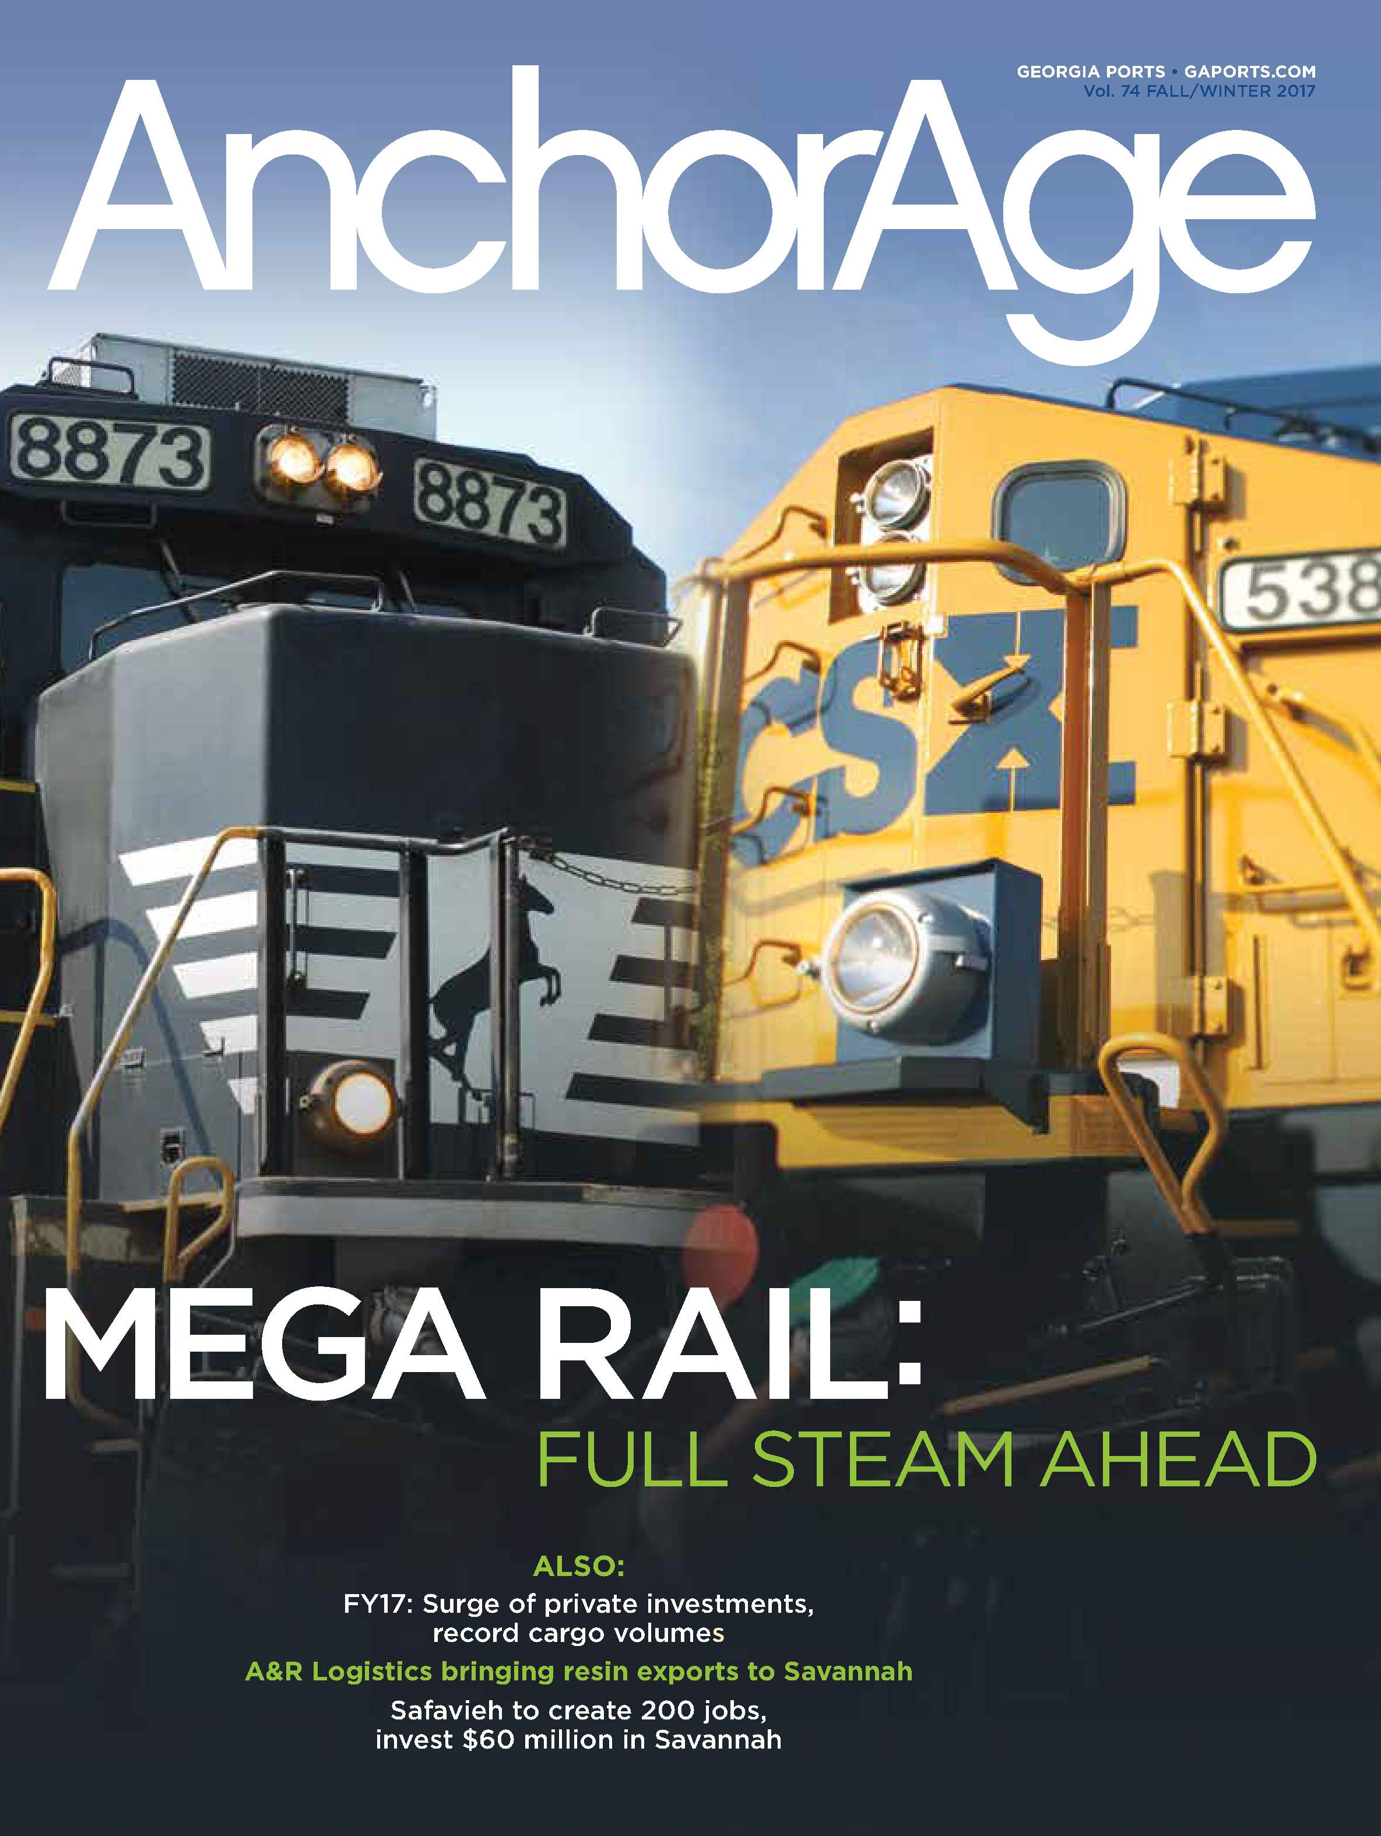
AnchorAge
Magazine

SUMMARY
Georgia Ports Authority’s AnchorAge magazine communicates with current and potential clients about GPA’s commercial advantages, while highlighting customer service, economic development and sustainable practices, with an eye toward winning new business.
AnchorAge has been an integral part of GPA’s communication effort since 1959. Of the 10,500 printed each issue, 9,500 are mailed worldwide. The remainder are distributed in person. It can also be downloaded from GaPorts.com.
The publication focuses on relevant industry information and dramatic photographs that illustrate the scope and grandeur of port infrastructure, and provide an easy entry into the text.

1) CHALLENGES & OPPORTUNITIES
The Georgia Ports Authority is one reason the state of Georgia has been named the top state for business five years in a row. Fostering international trade and industry for state and local communities, the Georgia Ports Authority operates deepwater ports in Savannah and Brunswick. The Port of Savannah is the fourth busiest port in the U.S. GPA’s deepwater ports support more than 440,000 jobs in Georgia and contribute $25 billion in income.
The challenge is to constantly create an inspiring and useable tool for the GPA to communicate business trends and other relevant information, to support the mission of increasing cargo movement through Georgia and supporting economic development throughout the state.
Because of several factors affecting the shipping industry, communication with key stakeholders is becoming more and more important. The expanded Panama Canal has allowed larger and larger vessels to call the East Coast.
Other ports are suffering congestion issues caused by the delivery of larger and larger shipments of cargo. With many issues of supply chain in flux, AnchorAge is one tool GPA uses to instill confidence in operations in current and potential clients.
AnchorAge helps to set GPA up as the source of information and an industry thought leader while strengthening relationships with a wide variety of stakeholders.
2) GEORGIA PORTS MISSION
The mission of Georgia’s deepwater ports is to support economic development in Georgia. The stories highlighted in AnchorAge demonstrate to business and government leaders in each region the vital role the ports play in the state’s economy.
By highlighting the success of businesses that partner with GPA and the jobs they provided, AnchorAge helps to share the message of GPA as a statewide economic engine and acts as a sales tool for GPA, in demand by GPA’s Trade Development staff.
AnchorAge instills confidence in customers and potential customers by focusing on infrastructure investment, business growth across Georgia, available land, as well as GPA’s decisions to operate in a sustainable way.

3) PLANNING & PROGRAMMING
OVERALL GOAL: To grow the movement of cargo through Georgia’s ports and support economic development.
ANCHORAGE OBJECTIVE:
• Build relationships with economic development entities.
• Inform current and potential clients of GPA’s continued infrastructure investments, commercial advantages and new business wins.
AUDIENCE
• AnchorAge’s primary audience includes more than 10,000 subscribers worldwide including current and future GPA clients and economic development officials who receive the magazine via direct mail.
• Secondary audience includes federal, state and local legislative officials, along with community leaders and business partners.
4) ACTIONS & OUTPUTS
Planning begins with story selection from recent GPA developments. The magazine starts with an impactful lead story, usually about a port infrastructure development such as the Mason Mega Rail Terminal. Secondary stories consist of maritime business briefs, GPA’s economic and environmental efforts, commercial agreements and developments in logistics in relation to port clients.
GPA’s team provides creative direction, project management, research and writing. A graphic design firm creates the layout. Photography from GPA’s image archive is used along with portraits and other photos commissioned for specific stories.
Of the 10,500 printed each issue, 9,500 are mailed worldwide. The remainder is distributed to secondary audiences. It is also available for download from gaports.com.
5) OUTCOMES & EVALUATION
AnchorAge is one tool that helped to bring 6,400 new port-related jobs to Georgia and support the GPA’s moved more than 4 million twenty-foot equivalent container units in 2017. A focus group of AnchorAge users, including people in government relations, sales and economic development were surveyed about the use and effectiveness of the magazine.
In general, the feedback was that the magazine, which has been a part of GPA’s communications outreach since 1952, is a valuable tool for many audiences including legislators and policy makers, potential clients and potential economic development partners.
Sample comments from AnchorAge users:
• “By delivering updates on Georgia Ports’ business wins and the major infrastructure investments we are making on terminal, AnchorAge reassures our clients on the health of our business and the reliability of our service, which makes them more comfortable with their decision to use the Georgia Ports Authority,” said Mark Troughton, GPA global accounts executive.
• “When we are recruiting new prospects to locate or expand in the state, it’s vital for us to have the necessary tools to communicate Georgia’s advantages in terms of logistics and economic development. AnchorAge distribution to economic development partners, and professionals in the logistics and manufacturing sectors keeps them aware of the growing supply chain ecosystem in Savannah and across the state,” said Stacy Watson, GPA’s general manager of economic and industrial development.
• “While GPA enjoys strong support from Georgia lawmakers on both the state and national level, publications like AnchorAge are helpful, not only to remind the legislators themselves about the positive economic impact GPA has throughout the state’s 159 counties, but also to provide them with talking points so that they can act as ambassadors for the ports. Our magazine is a tool that helps me to solidify support and inform elected officials about the exciting things going on at GPA,” said Lee Beckmann, manager of governmental affairs.

