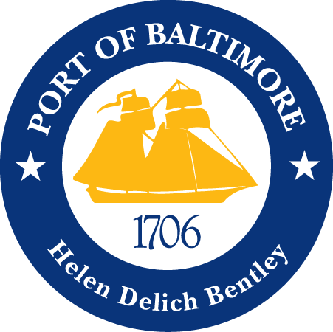

2018 AAPA COMMUNICATION AWARDS SUBMISSION
Port of Baltimore
Grande Baltimore Christening
Classification 12: Special Events
Port Category: 2
Summary:
Grimaldi Group, an Italian ocean freight company, and the Port of Baltimore have been working together for the last 50 years. Through the years of working together, the Grimaldi Group and the Maryland Port Administration (MPA) have established a thriving professional relationship. The Grimaldi Group developed a series of three sister Pure Car and Truck Carrier ships, the first of which was named after Baltimore, The Grande Baltimora. The MPA held a ship naming ceremony event at our Fairfield terminal on October 31, 2017.
1. What are/ were the entry’s specific communications challenges or opportunities?
The Port of Baltimore handles more cars than any other U.S. port. The MPA’s auto quality program, four on-dock auto processors and our geographic advantage have largely contributed to our success. One of our long-time auto shipping partners is the Grimaldi Group, who ordered a series of three ships designated to be auto carriers. The first ship in the series was named after Baltimore due to the 50-year business partnership between the Port of Baltimore and the Grimaldi lines. In celebration of this occasion, the MPA planned a ship christening ceremony. There were many pieces to consider while planning this event, among them: budget, security and environmental factors.
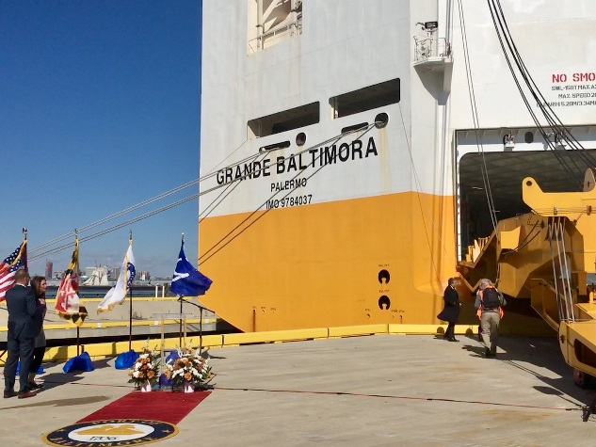
As a state agency, we are allocated a limited annual budget while supporting local businesses. We have an internal event planner who has an approved list of local approved vendors. To have an event such as this one, we rented various equipment to set up an attractive stage that was sufficiently audible at a distance for our audience. We, quite literally, rolled out the red carpet for this event! At the stern of the Grande Baltimora, we set the stage with a red carpet, Port of Baltimore logo at the end and a clear podium to start, flanked with flower bouquets. The backdrop was set with the United States, Maryland State, Port of Baltimore and Grimaldi Group flags, and the Baltimore City skyline.
When it comes to events of this size with 40+ attendees, security on the terminals can challenging to operate around. Prior to the event we gathered attendee and press information to submit into our security software. There was an additional hurdle in that the Grande Baltimora, being a working vessel, was unloading vehicles on dock. We arranged for shuttle vehicles with terminal escorts to bring large groups in at a time, including the press. The timing of the event versus unloading the vehicles was seamless. As our guests were shuttling in, the wind picked up, knocking over the one of the speakers from the PA system and several flags. The event team worked efficiently to rectify the situation, adding sand bags to the base of the flags and fixing the speaker that had disconnected. The speeches commenced, and the godmother of the ship christened it with the traditional champagne bottle.
After the christening, we adjourned to the bow of the ship for refreshments and additional speeches. Shuttling our attendees up into the seventh floor of the ship, then two at a time up the elevator to the decks. The view was of the Baltimore city skyline, the magnificent Pride of Baltimore II, and a fire boat spouting water into the air. Talk about a view! Guests were shuttled out as the event ended, and the event tear down went quickly with all hands-on deck.

2. How does the communication used in this entry complement the organization’s overall mission?
The MPA’s mission is to stimulate the flow of waterborne commerce through the ports in the State of Maryland in a manner that provides economic benefit to the citizens of the state. The Grimaldi Group has been helping us towards our mission for 50 years. This event was to celebrate our partnership and the naming of the Grande Baltimora.
3. What were the communications planning and programming components used for this entry?
The primary audience for this event were Grimaldi Group and Port of Baltimore stakeholders. The secondary audience was the Baltimore community.
The goals of this event was to:
- Hold a ship christening ceremony and celebration.
The objective of this event was to:
- Have a memorable ship christening event to let our customers know we appreciate our partnership.
- The milestones to achieve our objective was:
  - Secure event date
  - Determine guest list
  - Acquire event equipment
  - Set catering order
  - Schedule shuttling services
  - Event setup
  - Event monitoring
  - Event teardown
4. What actions were taken and what communication outputs were employed in this entry?
From a strategic communications standpoint, the MPA’s Communications Department wanted to ensure the key messages from holding the event were streamlined through the appropriate media channels which could be measurable. The key messages we wanted to communicate were:
- Maryland and the Port of Baltimore are open for business
- The Port of Baltimore is number one in the U.S. for auto shipping
- Celebrating the MPA’s relationship with Grimaldi Lines
Through disseminating a media advisory to local media and maritime trade publications to attend the event, our key messages seemed to resonate with these selected media channels.
5. What were the communications outcomes from this entry and what evaluation methods were used to assess them?
This event was covered in local and trade publications such as:
- Heavy Lift
- Baltimore Sun
- Global Trade Magazine
- The Motorship
- Hellenic Shipping News
In addition to the coverage, we received verbal and written positive feedback from all our event attendees.

