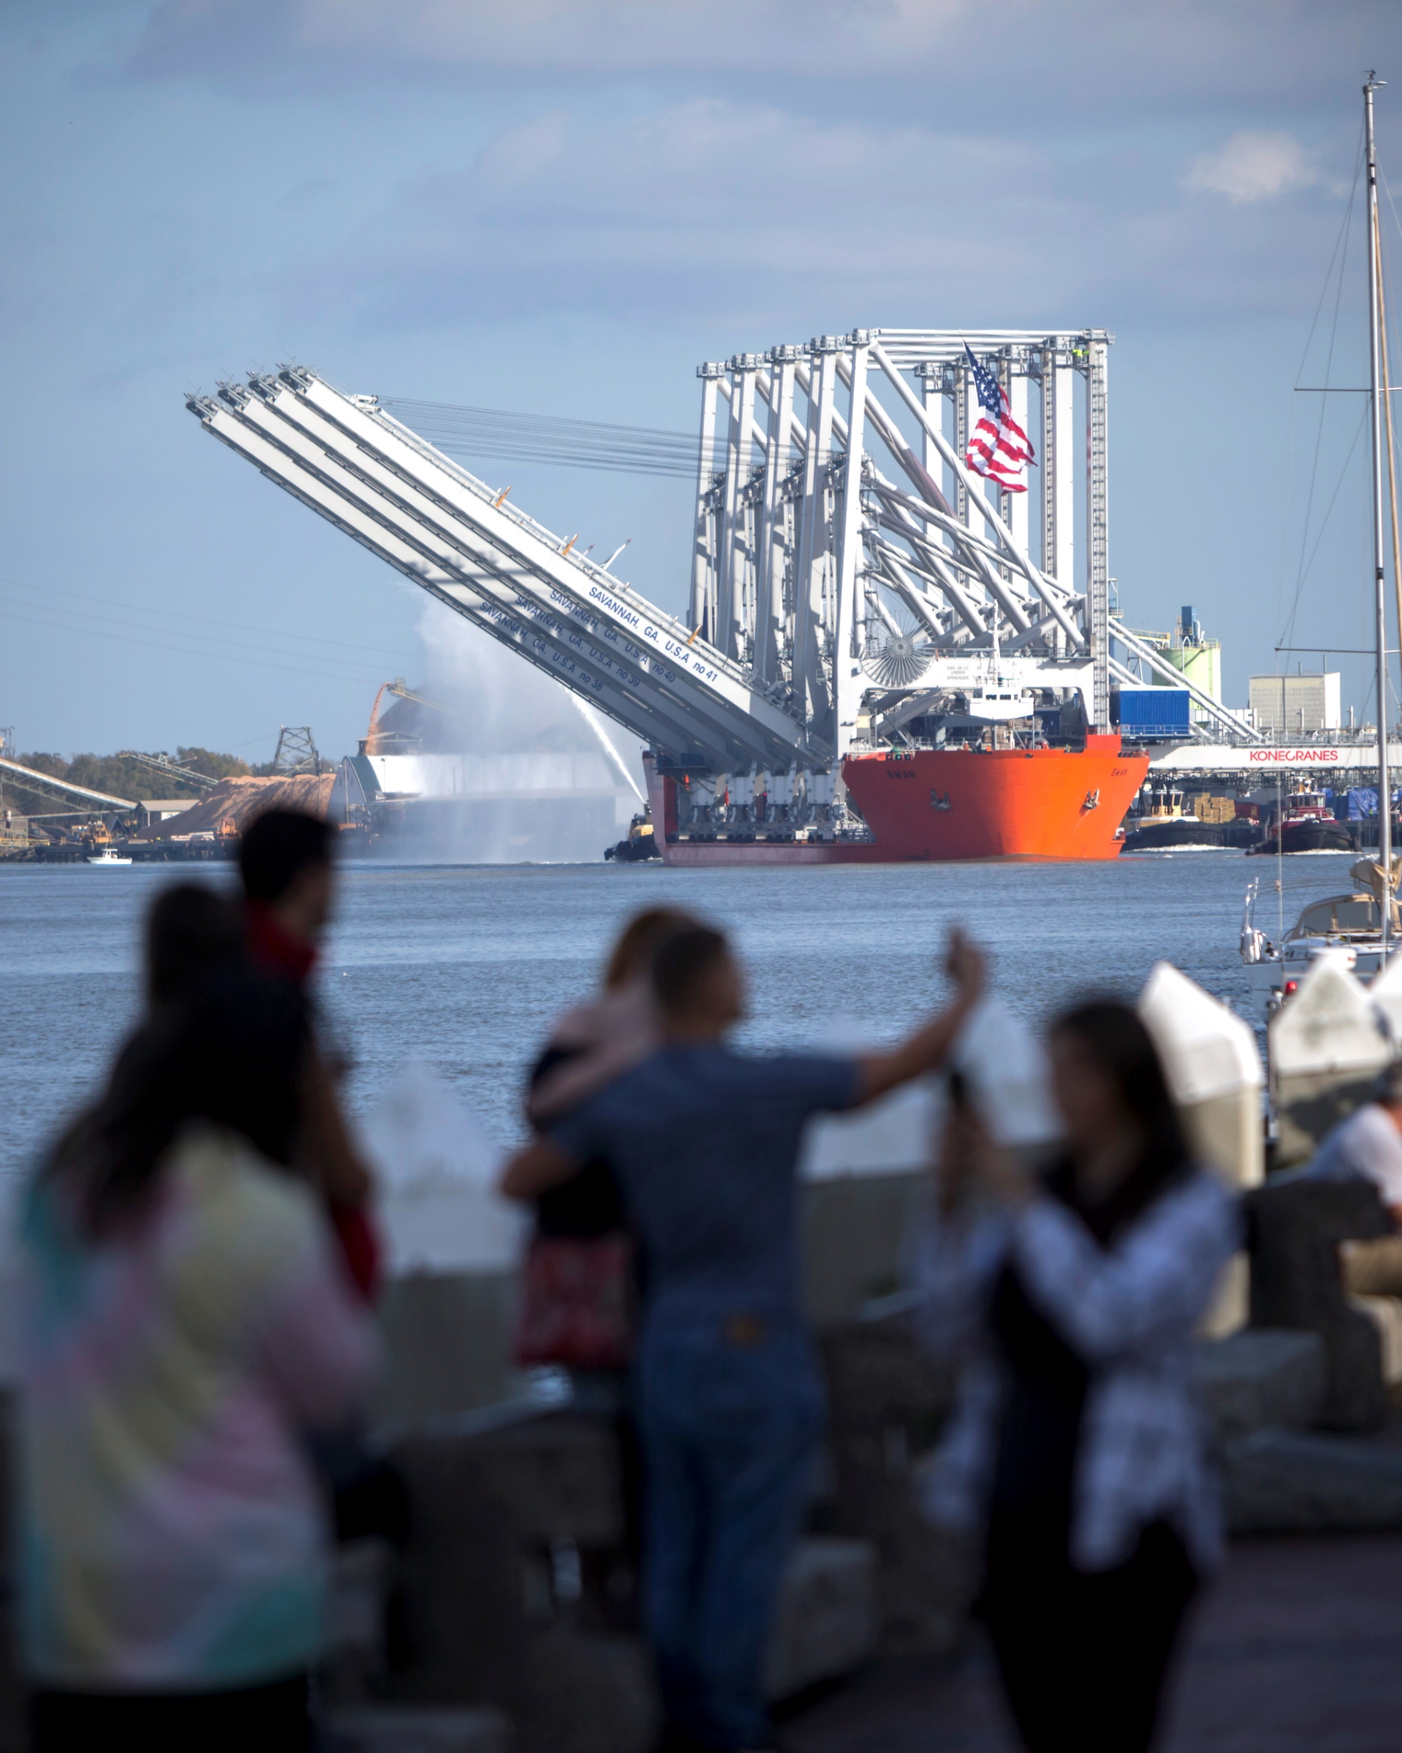
Super-Sized Cranes Arrive in Savannah

SUMMARY
Super-sized cranes arrive in Savannah – Run time: 1:57
https://goo.gl/ZrmcxU
The Georgia Ports Authority welcomed the arrival of four massive ship-to-shore cranes Wednesday, Nov. 22, 2017, at the Port of Savannah’s Garden City Terminal. Once commissioned, the new cranes will bring Savannah’s fleet to 30. Six additional cranes will arrive in 2020.
This video illustrates the massive infrastructure the Port of Savannah has been investing in for more than a decade. Informing stakeholders about the number of ship-to-shore cranes the Port of Savannah operates, as well as their capabilities explains how Savannah can continue to handle larger and larger vessels exchanging more and more cargo during each call.
1) CHALLENGES & OPPORTUNITIES
As vessel sizes continue to grow, so does the amount of cargo loaded and unloaded during each call. In order to handle these massive influxes of cargo GPA has been investing in cranes and yard infrastructure over the last decade, and continues its commitment to improving the flow of cargo.
The arrival of the newest four Neo-Panamax ship-to-shore cranes was a wonderful reason to reach out to GPA stakeholders and remind them of GPA’s commitment to growth and service.
The Savannah Harbor Expansion project is now half complete, but still dependent on receiving federal funding to be completed on time. This was also the perfect time for GPA to remind the delegation in Washington of the importance of this project and the things Georgia is doing to support it.
2) GEORGIA PORTS MISSION
The mission of the Georgia Ports Authority is to empower entrepreneurs, strengthen industries, sustain communities, and fortify families by relentlessly striving to accelerate global commerce.
One way GPA completes its mission is by providing customers with the infrastructure and space to efficiently move their cargo to and from the Southeast. This video explaining the benefits of the new ship-to-shore cranes is a perfect reminder of Georgia’s commitment to accelerating global commerce.
3) PLANNING & PROGRAMMING
GOAL: To inform stakeholders about the number of ship-to-shore cranes the Port of Savannah operates, as well as their capabilities, explaining how Savannah can continue to handle larger and larger vessels, while completing larger cargo exchanges during each call.
OBJECTIVES:
• Surpass 1,000 views on YouTube
• 5,000 impressions on social media
4) ACTIONS & OUTPUTS
The GPA communications team coordinated crews from an outside production firm to capture the arrival of GPA’s newest four ship-to-shore cranes. The team met to discuss the desired message of the video.
The team learned that a 50- by 100-foot American flag would be rigged on the lead crane as they entered the Savannah River. We worked with the GPA team that was accompanying the vessel upriver with the local rive pilot on the specifics of how the flag would be placed, then relayed that to the video crews so they could play it up.
Text was developed to include that highlights the stats about the new cranes and reinforces their main impact. The larger story we wanted to drive home was how the new cranes help GPA move more cargo, 1,300 moves per hour to be exact.
Bullets:
- The Neo-Panamax cranes are tall enough to lift containers 152 feet above the dock
- Lift capacity for each crane is 72 tons
- The booms reach out 192 feet from the dock face
- With the booms up, the cranes are 412 feet tall
- The new cranes will bring Savannah’s fleet to 30.
- Six additional cranes will arrive in 2020
- When all are commissioned, the upgrade will allow the nation’s largest single container facility to move nearly 1,300 containers per hour
The filming required several crews. One crew went out with the tug to meet the vessel before the mouth of the Savannah River. They were on the tug for about eight hours.
Another crew, including a cameraman, drone pilot and drone camera operator, recorded the cranes as they passed Historic River Street and went under the Talmadge Memorial Bridge. That same crew then made its way to Garden City Terminal to capture the cranes as they neared the dock and the single largest container terminal in the nation.
The entire video was shot in about eight hours and edited in five days. The new cranes arrived the day before Thanksgiving so the editorial decision was made to hold the press release until Nov. 27 so it wouldn’t be buried under holiday news. This also gave GPA a chance to include a link to the video when the press release was sent.

5) OUTCOMES & EVALUATION
RESULTS:
The video was deemed a success because of the creative way it told a commercial message. Not only did it surpass all goals for reach, it also garnered 100 click throughs from the press release.
Another key indicator of the video’s success, although a challenge to measure, is the amount of ongoing use it is getting from GPA sales people, partners and customers.
David Porter, GPA regional sales manager, said this and other GPA videos help to create a two-way conversation during sales meetings, instead of a one-way presentation. Often the team will show one or two videos, and then field questions from potential clients instead of bogging them down with stats and figures.
Objective:
Surpass 1,000 views on YouTube
Result:
The video has 2,100 views and counting.
Objective:
5,000 impressions on social media
Result:
Social Media Reach
Facebook: 1,043
Twitter: 2,853
LinkedIn: 4,019
Total = 7,915

