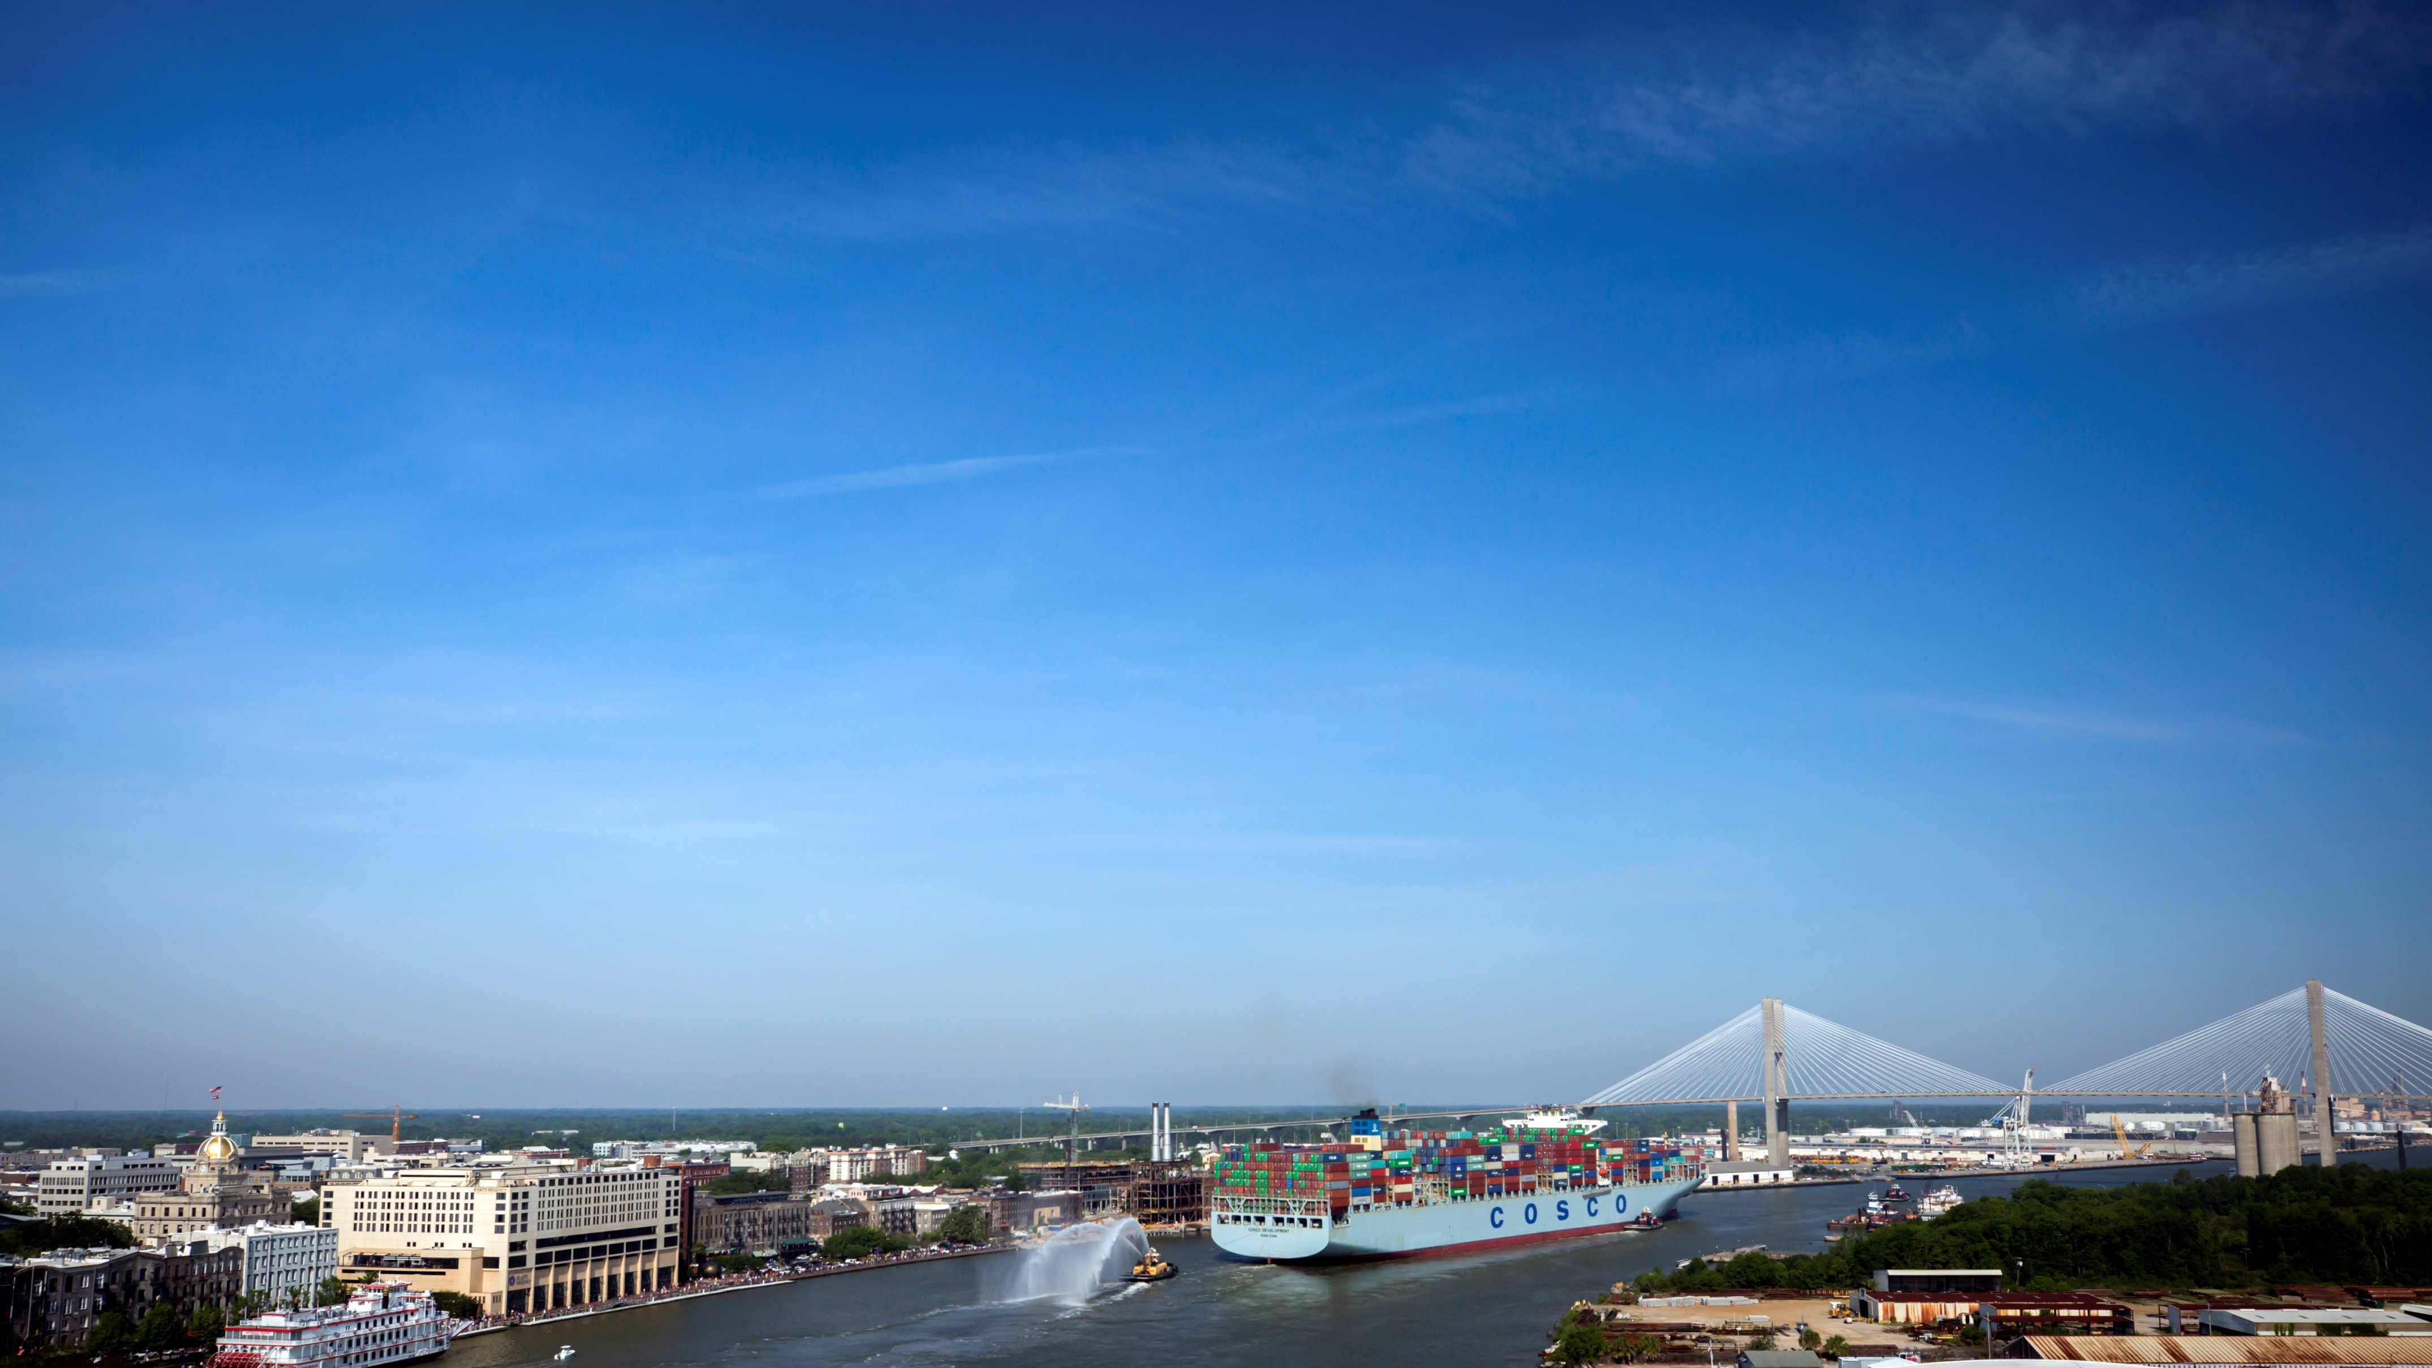
Port of Savannah Sizzle Reel

SUMMARY
Port of Savannah Sizzle Reel – Run time: 2:05
https://goo.gl/edkZJU
This Port of Savannah Sizzle Reel includes fast-paced highlights of Georgia Ports’ FY2017 accomplishments. The two-minute video featuring massive ships and non-stop cranes is balanced by the faces that make it all work.
This video debuted in September at the 2017 State of the Port address to an audience of more than 1,300 business leaders, customers, elected officials and media. It is now used as the beginning of almost every presentation given by the executive and sales teams among others.
1) CHALLENGES & OPPORTUNITIES
The communications team was tasked with creating a video that would start GPA’s State of the Port Presentation on a note of excitement and anticipation. GPA Executive Director Griff Lynch wanted to make people want to stand up and cheer, like they were part of something exciting. GPA also wanted to remind customers the reasons they choose to move cargo through GPA, including big ship capacity, sufficient infrastructure and unmatched customer service.
This was a tall order for what at times has been a staid business lunch and PowerPoint. People come to the State of the Port expecting a review of stats and facts. This year we wanted them to get that valuable information, but to also have an emotional connection to it.
This tall order required months of planning, shooting, coordination and revisions.

2) GEORGIA PORTS MISSION
The mission of the Georgia Ports Authority is to empower entrepreneurs, strengthen industries, sustain communities, and fortify families by relentlessly striving to accelerate global commerce.
This video perfectly illustrates the acceleration of global commerce while highlighting the nearly 440,000 jobs GPA supports both directly and indirectly across Georgia.
3) PLANNING & PROGRAMMING
GOAL: To set an exciting and positive stage for GPA’s executive director to open the 2017 State of the Port event, as well as to give the sales and executive teams a tool to engage audiences when they give presentations or attend meetings.
OBJECTIVES:
• 1,000 in-person views from local business leaders at the Savannah State of the Port
• Surpass 1,000 views on YouTube
• 5,000 impressions on social media
TARGET AUDIENCE: Business Partners and Stakeholders
The video was created to be shown in front of GPA’s most influential stakeholders at the annual State of the Port address. The concentration of the video was to make every partner in the room, from longshoreman to customer to port employee, excited to be a part of the economic driver that is the port.
4) ACTIONS & OUTPUTS
The team coordinated drone and video shoots throughout the fiscal year of milestones as they happened. These included the arrivals of the largest vessels to ever call the East Coast, a visit from Georgia’s governor as well as highlighting the economic impact of the ports by featuring different jobs.
Two themes were used to weave the video together: A focus on the visual of hands at work, and a second of acknowledgement to the camera from the people who were featured.
Another overarching theme is the highlighting of massive port infrastructure, different commodities and large business partners.
Shoots:
Arrival of the COSCO Development
Shot list:
- Drone footage as the vessel passes historic River Street.
- Ground level footage of crowd as vessel passes historic River Street, including shots of community members viewing the event.
- Helicopter footage: entering the mouth of the Savannah River at Tybee Island, as the vessel passes Historic River Street, as the vessel docks at Garden City Terminal.
- Footage shot from the boom of a ship-to shore crane, and ground level as the vessel docks at Garden City Terminal.
- Ground level footage of Georgia Gov. Nathan Deal during a ceremony in front of the COSCO Development.
- Footage shot from ground level as the vessel departed.
This was shot by a crew of six from the video production company including camera operators, assistants, a producer and a drone operator. Other personnel included a helicopter pilot, GPA escorts on terminal, and crane operations personnel.
Arrival and Departure of the CMA CGM Theodore Roosevelt
Shot list:
- Drone footage as the vessel passes historic River Street.
- Ground level footage of crowd as vessel passes historic River Street.
- Footage shot from the boom of a ship-to-shore crane, and ground level as the vessel docks at Garden City Terminal.
- Footage shot at Garden City and River Street as the vessel departed.
- A three-person team captured the story of the CMA CGM Roosevelt in Savannah over two days.

Transiting the Savannah River on a vessel
This was by far the hardest shoot to coordinate. We worked with the shipping line as well as the Coast Guard to have a GPA video crew board with the river pilot just outside of the mouth of the Savannah River for the three-hour trip to Garden City Terminal. It was shot for time lapse as well as regular use. It is one of the main elements of this video that carries the action.
Other shots:
Jockey truck driver
Equipment operator
Crane operator x2
Port Police officers x2
Welder
Control center
ILA partners on the dock
General loading and unloading of cargo on the dock
Time lapse of traffic circle
Rubber-tired gantry cranes in action (day and night)
Business Highlights:
The video concludes by highlighting dozens of GPA’s biggest partners, recognizing their role in Georgia being named #1 State in the Nation to do Business for the fifth year in a row.
Music:
Much thought and effort was put into finding the ideal piece of music, one with a driving beat that really pushed the momentum along. Once the music was chosen, the editors used it to punctuate transitions from image to image.
Production:
The communications team managed and directed the project’s creative. A contracted video company executed GPA’s team vision. Planning began in May for the September roll-out and video production ran June-August with editing throughout.
Following the debut, the video was shared through social media channels targeting stakeholders and partners who were not able to attend the State of the Port.
5) OUTCOMES & EVALUATION
RESULTS: The desired effect — to cue up an excited audience of viewers for the State of the Port address — was achieved. Anecdotal feedback from stakeholders called it the best address ever. Viewers were excited about the video and many immediately requested the link to share with their own audiences.
Another key indicator of the video’s success, although a challenge to measure, is the amount of ongoing use it is getting from GPA sales people, partners and customers.
Objective:
1,000 in-person views from local business leaders at the State of the Port
Result:
The sold-out event reached 1,300 people, including local media
Objective:
Surpass 1,000 views on YouTube
Result:
The video has 1,340 views and counting.
Objective:
5,000 impressions on social media
Result:
Social Media Reach
Facebook: 3,900
Twitter: 732
LinkedIn: 2,691
Total = 7,323

