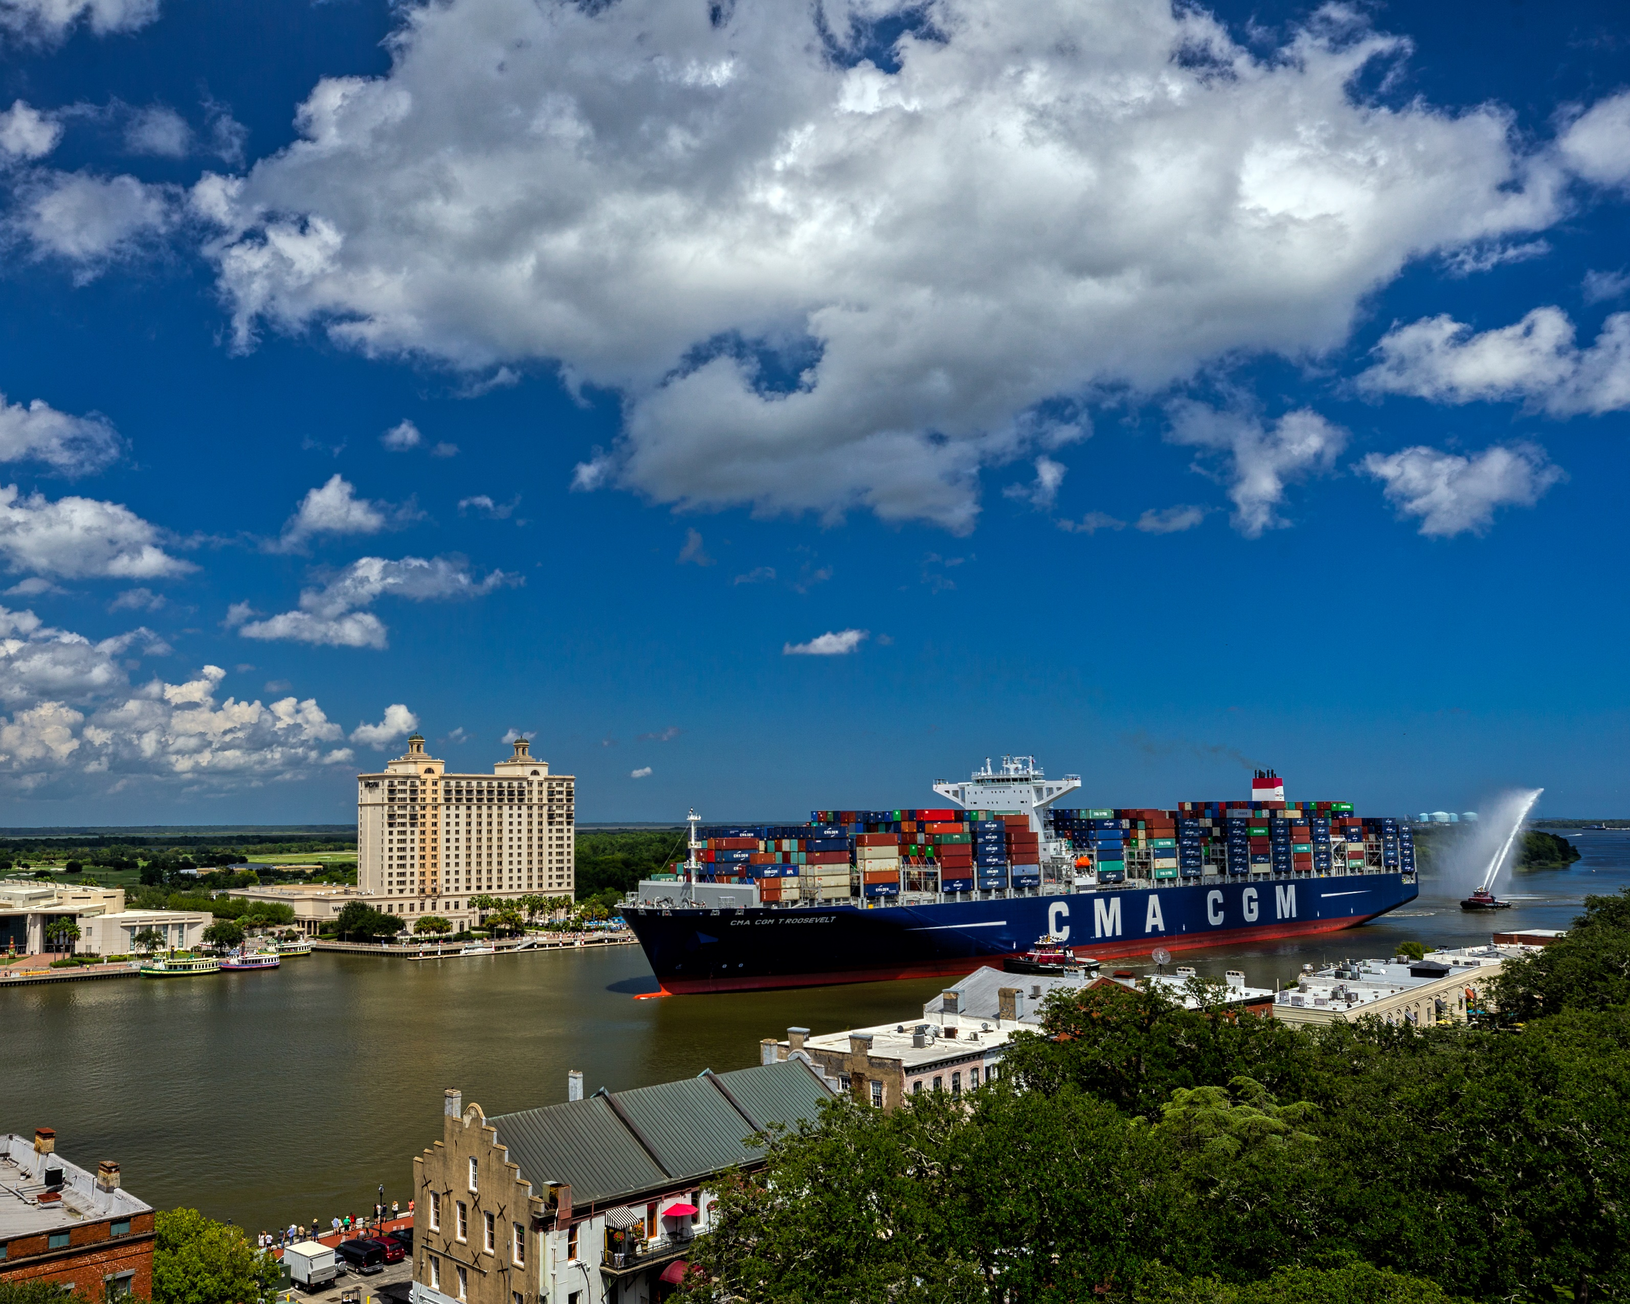
CMA CGM ROOSEVELT
PHOTOGRAPHY

SUMMARY
The CMA CGM Theodore Roosevelt, the largest container ship ever to serve the U.S. East Coast at 14,414 twenty-foot equivalent container units (TEUs), called the Port of Savannah in September.
Working the vessel with seven cranes at the 1,200-acre Garden City Terminal, the Port of Savannah moved 4,500 containers (approximately 8,000 TEUs) on and off the ship. The GPA worked six other vessels simultaneous to the Roosevelt.
The GPA team knew that images of this historic moment would be useful in communicating the capabilities of the Garden City Terminal, to not only handle the largest ships calling the East Coast, but simultaneously handling half a dozen other vessels. This particular opportunity also illustrated GPA’s infrastructure that can handle the massive number of exchanges that come with these monster vessels without congestion.
1) CHALLENGES & OPPORTUNITIES
With the expansion of the Panama Canal, vessels carrying more than 10,000 TEUs have become regular sights at the Port of Savannah. As the size of vessels continue to grow, GPA must communicate to customers how it will handle the influx of cargo brought on the massive vessels.
The Savannah Harbor Expansion project is more than half-way complete. With the completion of that project, GPA is likely to see an increase in cargo as vessels calling the Port of Savannah can transit the Savannah River more heavily laden.
The amount of international cargo moving through Georgia’s deepwater ports continues to grow. Last year, total cargo moved was up eight percent. Because of this incredible continued growth, GPA needs to communicate clearly to customers how they will handle current and future cargo as the volume steadily increases.

2) GEORGIA PORTS MISSION
The mission of the Georgia Ports Authority is to empower entrepreneurs, strengthen industries, sustain communities and fortify families by relentlessly striving to accelerate global commerce.
The visuals created of the CMA CGM Roosevelt, the largest vessel to ever call the East Coast, help to illustrate the acceleration of global commerce and GPA’s ability to grow along with it.

3) PLANNING & PROGRAMMING
Goal:
Create compelling images of a historic moment for the Georgia Ports Authority for use across all channels and to communicate that GPA can handle the largest vessels calling the East Coast and the cargo volume that comes with them without congestion.
Objectives:
- Document the arrival of the CMA CGM Roosevelt, from entrance channel through docking.
- Highlight how the Georgia Ports is an integral part of historic Savannah by including recognizable landmarks.
- Capture images that can be used across all channels to inspire awe.
- Illustrate the sheer size of the vessel by shooting it in context to its surroundings.
- Illustrate GPA’s infrastructure that make it possible for seven cranes to work a vessel at one time.
Primary Audiences:
Current customers
Potential customers
Near-port neighbors
Secondary Audiences:
State and federal stakeholders
4) ACTIONS & OUTPUTS
Strategy
The communications team began planning for the photo shoot several weeks before the arrival. The first decision was on the message these images were to convey. We discussed the importance of the size of this vessel and what it means to our customers. It was decided that the message we needed to share with our customers was one GPA’s ability to serve the more and more massive vessels headed our way.
“Not only do these massive ships play to Savannah’s strengths, they actually make us more efficient,” said Georgia Ports Authority Executive Director Griff Lynch. “When neopanamax vessels call on the largest single container terminal in North America, it maximizes the attributes that set Savannah apart: more space, more cranes and better landside connections.”
Savannah’s Garden City Terminal features 26 ship-to-shore cranes and 146 rubber-tired gantry cranes. The GPA will add four ship-to-shore cranes in 2018 and another six in 2020, to bring the total to 36 cranes operating over nearly 10,000 feet of contiguous berth space.
Once the message was clearly defined, the communications team contracted a photo journalist whose background and training are in telling the larger story through images. We chose this particular photographer for several reasons. He has a history of creating compelling images, a knack for finding creative ways to shoot stories, as well as the ability to turn photos around immediately for a press release.
One GPA team member acted as driver and escort for the contracted photographer the day of the shoot. A shot list of locations and must-have shots was decided before-hand.

Images
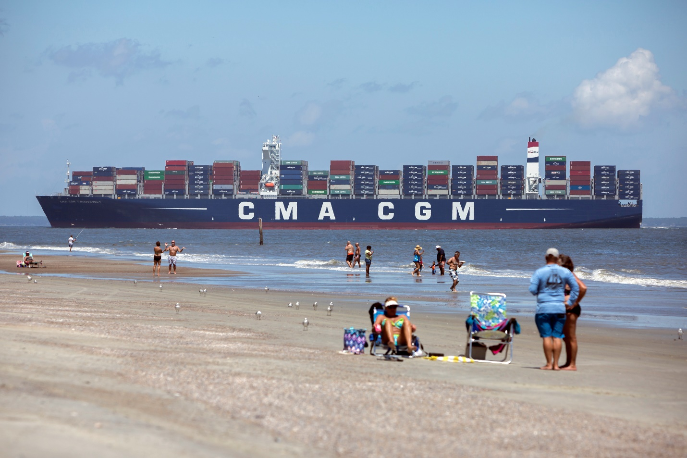
GPA_Roosevelt-201
This image was shot from the mouth of the Savannah River at Tybee Island and was the first stop of the shoot. From here the vessel takes about three hours to transit the channel to the Garden City Terminal docks.

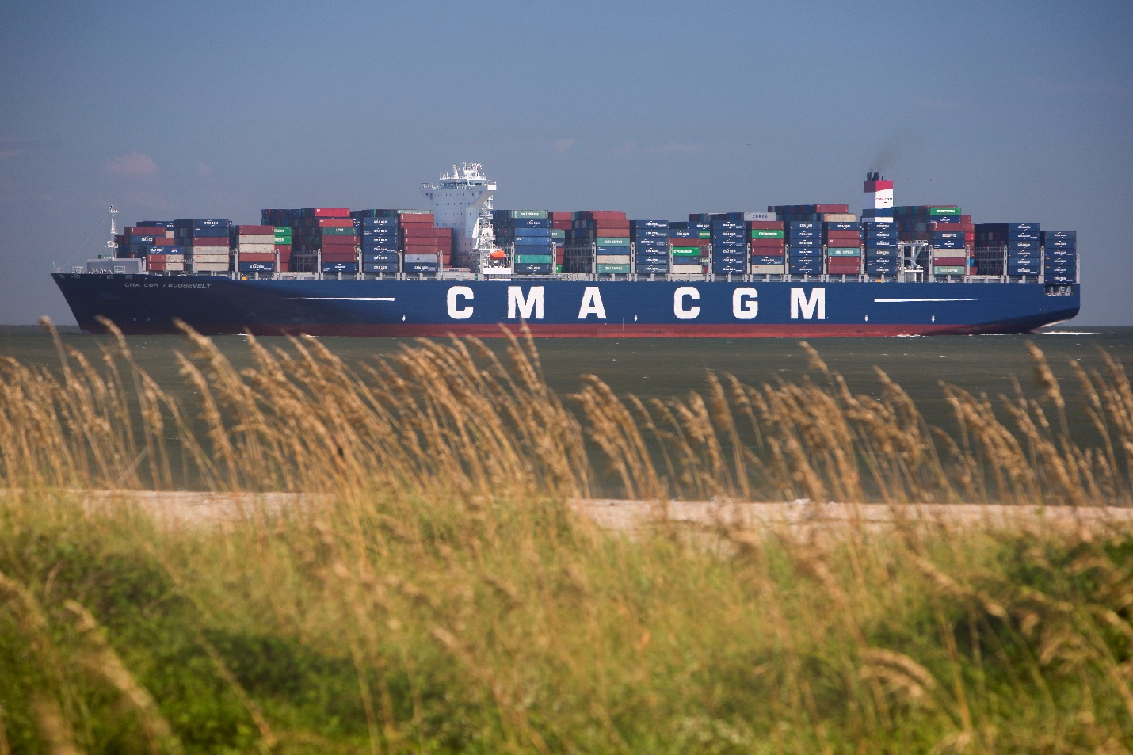
GPA_Roosevelt-301
This was the second stop on the shoot and shows marsh grass in the foreground with the vessel in the background as the ship makes its way up the Savannah River parallel to a walking path. This was the shot used on the press release that was sent while the vessel was still in the channel. The photographer shot at these first two locations, then edited and submitted photos while riding back from Tybee Island so the press release could be sent quickly.

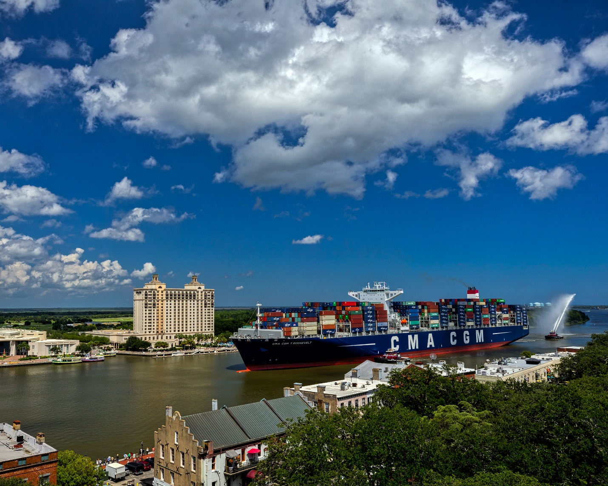
GPA_Roosevelt-401
This image was shot from stop number three while following the vessel up the Savannah River. It is shot from the rooftop of a local hotel and shows the magnitude of the vessel in comparison to the historic buildings and the Savannah International Trade and Convention center.

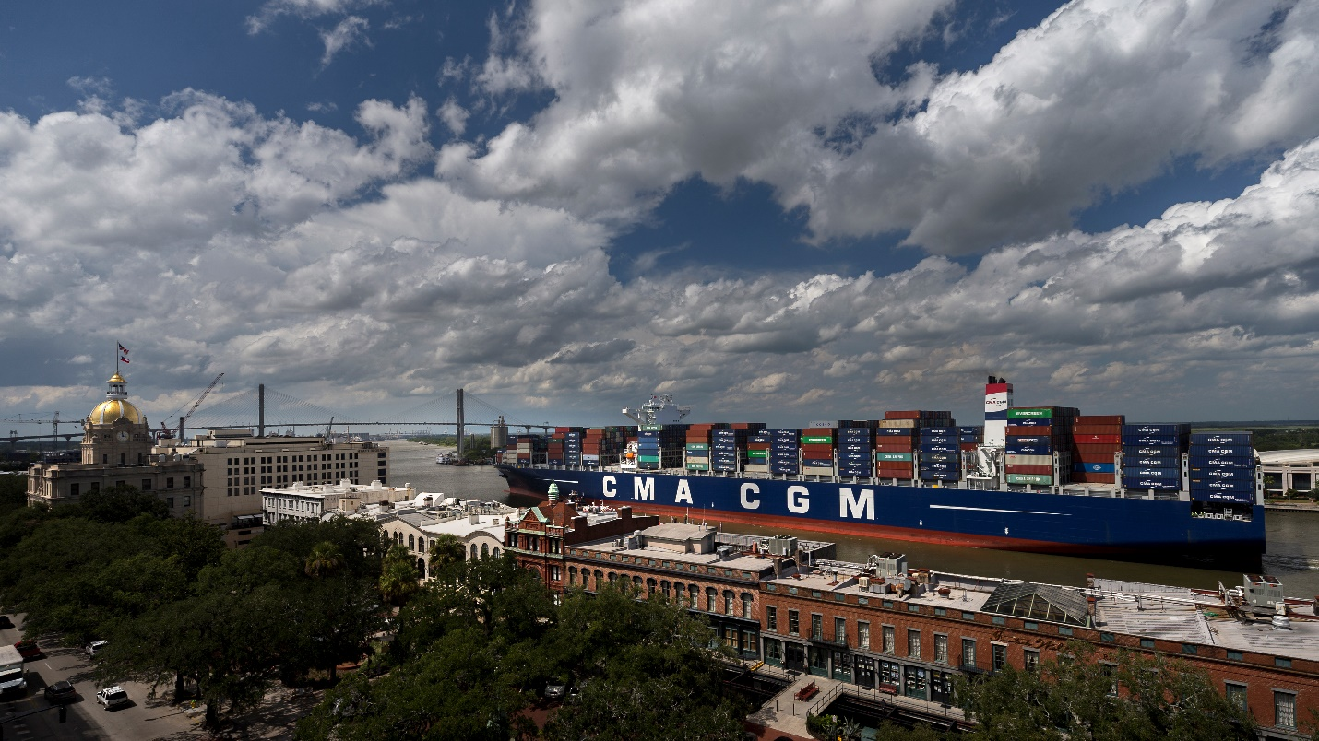
GPA_Roosevelt-501
This was one of the must-have shots. It shows the CMA CGM Roosevelt along with Savannah’s city hall and the Talmadge Memorial Bridge. This was also taken from the photographer’s third stop and the roof of a local hotel. This is one of our most requested images still.

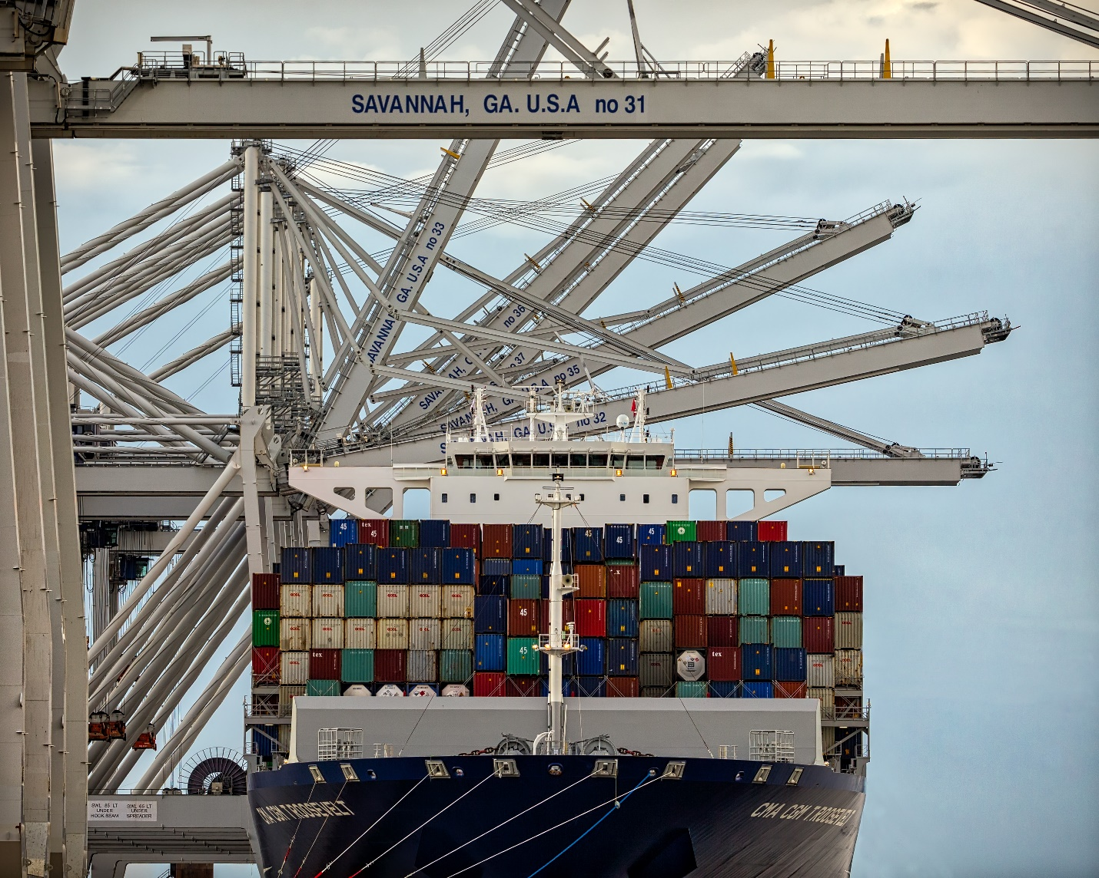

GPA_Roosevelt-601
The fourth location for our photographer on this big vessel shoot was the Garden City Terminal itself. It was here that he could incorporate the massive infrastructure available to customers through the Garden City Terminal including 26 ship-to-shore cranes, seven of which worked this vessel at one time.

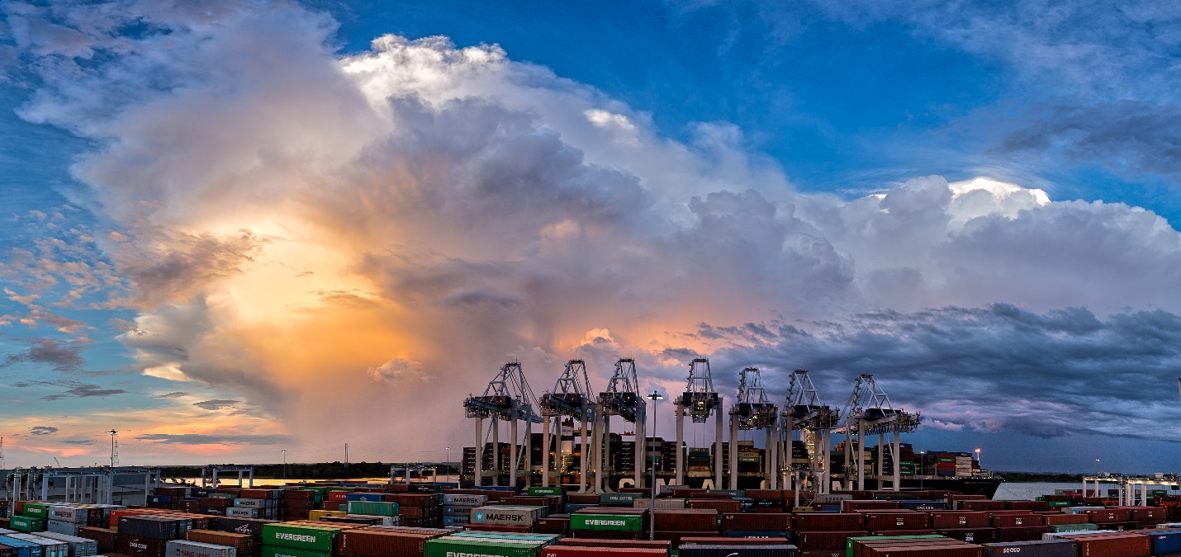

GPA_Roosevelt-701
This image has become iconic to port stakeholders. The photographer not only shot from ground level at the Garden City Terminal but also from the top of a rubber-tired gantry crane (about three stories tall). This was what we call the “money shot.” It perfectly illustrates the message we were trying to convey that not only can we handle 14,000+ TEU vessels, but GPA can also handle the huge influx of cargo that they bring. This image was shot at sunrise as seven cranes worked the Roosevelt. Working the vessel with seven cranes at the 1,200-acre Garden City Terminal, the Port of Savannah moved 4,500 containers (approximately 8,000 TEUs) on and off the ship. The GPA worked six other vessels simultaneous to the Roosevelt.

5) OUTCOMES & EVALUATION
Objectives:
Document the arrival of the CMA CGM Roosevelt, from entrance channel through docking.
Result:
The photoshoot covering the arrival of the CMA CGM Roosevelt produced a library of unique images that will be used for at least a year in marketing materials and across online channels.
Objective:
Highlight how the Georgia Ports is an integral part of historic Savannah by including recognizable landmarks.
Result:
Several images were captured that included historic buildings along the waterfront as well as Savannah’s City Hall and the Talmadge Memorial Bridge.
Objective:
Capture images that can be used across all channels.
Result:
The images captured during this shoot have been used in press releases, in social media, on the website as well as supplied to the media and supplied to port stakeholders who have requested framed prints for their offices. Used as cover of Annual Report.
Objective:
Illustrate the size of the vessel by shooting it in context to its surroundings.
Result:
Shooting the vessel from different angles, especially from ones that included people as well as ones more than three stories high helped to illustrate the vessel’s massive size.
Objective:
Illustrate GPA’s infrastructure that make it possible for seven cranes to work a vessel at one time.
Result:
The extra effort put into coordinating a sunrise shoot as well as securing access to a strategically placed three-story tall rubber-tired gantry crane perfectly illustrates GPA’s infrastructure capability.

