GUILLERMO RUIZ DE TERESA
General Coordinator of Mexican Ports and Merchant Marine

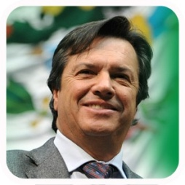

Mr. Guillermo Ruiz de Teresa is a public servant with over 30 years of experience. Most notably, he was the first National Coordinator of Civil Protection (Against natural disasters), and has been Director of Mexico’s Airports and Auxiliary Services (ASA) on two different occasions, allowing him to accumulate substantial experience in the transport and logistics arena. Currently, he is the General Coordinator of Mexican Ports and Merchant Marine, a sector that will see a total investment of over 76,000 million pesos (around 5 billion USD) before 2018.
With this investment, Mr. Ruiz de Teresa’s main goal is to contribute to the instruction of President Enrique Peña Nieto, of transforming Mexico into a global logistics platform. To this end, Mr. Ruiz de Teresa is working on several fronts. First, he is consolidating two port systems, one in the Pacific Ocean and one in the Gulf of Mexico. Second, he is playing a key role in the development of Mexico’s three interoceanic economic and logistics corridors. Third, he is actively seeking the consistent expansion and modernization of Mexico’s oil industry oriented ports, in order to prepare them for the Energy Reform. Fourth, he is promoting Mexico as a touristic cruise destiny mainly in the ports of Ensenada and Cozumel. Fifth, he is tasked with cultivating relations between labor unions and port operators, so that the Mexican port sector will continue to operate without strikes. Finally, he is duplicating Mexico’s ports installed capacity, so that in 2018 they will be able to efficiently handle over 500 million tons of yearly cargo.

